
THE JERRY SONGBOOK
Version 4.5 (January 2026)

Conventions Used In This Book

This songbook is primarily geared towards the intermediate Deadhead picker who knows these songs fairly well and just needs the chords and lyrics to keep them honest.
To ensure all songs fit on a single page, this songbook maximizes real estate by only notating unique sections. Typically, this includes the intro, first verse, and chorus, unless subsequent sections vary. Additionally, if a verse has four lines of a repeating chord progression, only the first line is notated.
All songs are in 4/4, unless time signature is provided top right of page.

Song titles have the key of the song in parenthesis, like After Midnight (E).

Less common chords are notated like this F^{maj7=xx3210} (low E string is left most digit)

G D C G
Chords are provided above the word where chord is first struck
Italic font, when it appears in a line of lyrics, indicates the singer is accompanied by other voices. For example, you will see italics in When I Paint My Masterpiece when Jerry sings segments of the verse with Bob. It can also represent backup singers' parts that are "secondary." Italics are also used for vocalizations like whoa-oh.

An underlined word shows when the chord changes for non-notated parts.
Arrow between chords, like G ¢ Em, signifies a chromatic ascending or descending transition of single notes to the next chord. So, for the example above that would express a G G^{/F#} Em.
Feedback and corrections
Please email corrections and questions to kieran.mcmanus@gmail.com
Cover Art: Taylor Swope @ (littlehippie.com)

Table of Contents (225 songs)

After Midnight (E)
Ain’t No Bread in Breadbox (E)
Alabama Getaway (A)
Althea (A)
Always Late With Your Kisses (A)
And We Bid You Goodnight (A)
Around and Around (A)
Attics of My Life (E)
Beat It On Down the Line (C)
Been All Around the World (C)
Believe It Or Not (C)
Bertha (G)
Big Railroad Blues (A)
Big River (A)
Bird Song (A)
Black Muddy River (A)
Black Peter (D)
Black-Throated Wind (A)
Blow Away (Bb)
Box of Rain (G)
Bright Morning Stars (C/4)
Brokedown Palace (F)
Broken Arrow (G)
Brown-Eyed Women (E)
Built to Last (C)
C.C. Rider (A)
California Earthquake (G)
Candyman (C)
Casey Jones (C)
Cassidy (E)
Catfish John (A)
Cats Under the Stars (C)
China Cat Sunflower (G)
China Doll (Dm)
Cold Rain and Snow (A)
Comes A Time (A)
Cosmic Charlie (A)
Crazy Fingers (G)
Cryptical Envelopment (E)
Cumberland Blues (G)
Dancing In the Street (A)
Dark Hollow (A)
Dark Star (D)
Days Between (G)
Deal (D)
Dear Mr. Fantasy (C)
Death Don’t Have No Mercy (Em)
Deep Elem Blues (E)
Desolation Row (E)
Dire Wolf (C)
Don’t Ease Me In (E)
Don’t Let Go (A)
Don’t Need Love (D)
Dreadful Wind and Rain (E)
Drifting Too Far From the Shore (G)
Drink Up and Go Home (A)
Dupree’s Diamond Blues (E)
Easy to Love You (G)
El Paso (D)
Estimated Prophet (Bm)
Eyes of the World (A)
Far from Me (D)
Feel Like a Stranger (Bm)
Fire on the Mountain (E)
Foolish Heart (A)
Forever Young (D)
Franklin’s Tower (D)
Freight Train (C)
Friend of the Devil (G)
Frozen Logger (C)
Get Out of My Life (C)
Gimme Some Lovin’ (C)
Going Down the Road (E)
Golden Road (D)
Gomorrah (G)
Gone Home (G)
Good Lovin’ (C)
Goodnight Irene (C)
The Great Pretender (G)
Greatest Story Ever Told (C)
Hard to Handle (B)
Harder They Come (C)
He Ain’t Give You None (A)
He’s Gone (E)
Help On the Way (Fm)
Here Comes Sunshine (C)
Hey Pocky Way (D)
High Time (E)
How Sweet It Is (C)
Hurts Me Too (A)
I Know You Rider (G)
I Need a Miracle (E)
I Second That Emotion (A)
I Shall Be Released (G)
I Will Take You Home (B)
I’ll Be With Thee (E)
I’ll Take a Melody (A)
I’m Troubled (D)
If I Had the World To Give (C)
If I Lose (A)
Iko Iko (D)
It Must Have Been the Roses (A)
It Takes a Train To Cry (A)
It’s All Over Now (G)
It’s All Over Now, Baby Blue (D)
Jack Straw (E)
Jack-a-Roe (Am)
Jams (Mind Left Body)
Jenny Jenkins (D)
Johnny B. Goode (A)
Just a Little Light (Am)
Just Like Tom Thumb’s Blues (E)
Keep Your Day Job (A)
Knockin’ On Heaven’s Door (G)
Last Time (E)
Lazy River Road (G)
Let It Grow (Am7)
Let It Rock (A)
Let the Good Times Roll (A)
Liberty (E)
Like a Road (G)
Little Red Rooster (A)
Lonesome and Long Way from Home (C)
Long Black Veil (D)
Looks Like Rain (E)
Loose Lucy (E)
Loser (Am)
Louis Collins (C)
Love in the Afternoon (C)
Maggies Farm (G)
The Maker (E)
Mama Tried (D)
Man of Constant Sorrow (D)
Me and Bobby McGee (D)
Me and My Uncle (G)
Mexicali Blues (D)
Midnight Hour (D)
Midnight Moonlight (A)
Might As Well (C)
Mighty Quinn (C)
Mission In the Rain (A)
Mississippi Half-Step (C)
Mister Charlie (A)
Monkey and the Engineer (G)
Morning Dew (G)
Music Never Stopped (E)
My Sisters and Brothers (A)
Mystery Train (E)
New Minglewood Blues (A)
New Speedway Boogie (E)
Next Time You See Me (A)
The Night They Drove Old Dixie (C)
Not Fade Away (E)
Off to Sea Once More (Dm)
Oh Babe It Ain’t No Lie (C)
On the Road Again (C)
Operator (F)
One More Saturday Night (C)
The Other One (E)
Peggy-O (A)
Pig In a Pen (A)
Playing In the Band (D)
Positively 4th Street (G)
Promised Land (C)
Queen Jane Approximately (D)
Race Is On (G)
Ramble On Rose (D)
Reuben and Cherise (B)
Ripple (G)
Road Runner (E)
Rosa Lee McFall (E)
Rosemary (E)
Row Jimmy (A)
Run For the Roses (A)
St. Stephen (A)
Samson and Delilah (G)
Scarlet Begonias (E)
Shady Grove (Dm)
Shakedown Street (G)
She Belongs to Me (C)
Shenandoah Lullaby (D)
Shining Star (B)
Ship of Fools (Bb)
Short Life of Trouble (E)
Simple Twist of Fate (D)
Sing Me Back Home (A)
Sitting in Limbo (C)
So Many Roads (F)
Stagger Lee (G)
Standing on the Moon (G)
Stealin’ (G)
Stella Blue (E)
Stop That Train (G)
Struggling Man (C)
Stuck Inside of Mobile (E)
Sugar Magnolia (A)
Sugaree (E)
Tangled Up In Blue (A)
Tears of Rage (G)
Tennessee Jed (C)
Terrapin Station (G)
That’s All Right, Mama (E)
That’s What Love Will Make (F)
They Love Each Other (G)
Think (C)
Thrill Is Gone (Am)
Throwing Stones (A)
To Lay Me Down (G)
Tore Up Over You (C)
Tom Thumb Blues (E)
Touch of Grey (B)
Tough Mama (D)
Truckin’ (E)
Turn On Your Love Light (E)
Two Soldiers (G)
U.S. Blues (A)
Unbroken Chain (C)
Uncle John’s Band (G)
Valerie (E)
Viola Lee Blues (G)
Visions of Johanna (A)
Waiting for a Miracle (E)
Walkin’ Blues (A)
Way You Do the Things You Do (C)
We Can Run (A)
Weather Report Suite (E)
The Weight (A)
Werewolves of London (G)
West L.A. Fadeaway (Am)
Wharf Rat (D)
What a Wonderful World (F)
The Wheel (C)
When First Unto This Country (E)
When I Paint My Masterpiece (G)
Whiskey In a Jar (C)
White Dove (E)
Wild Horses (G)
Women Are Smarter (E)
You Win Again (G)
After Midnight (E)
Intro E
Verse 1 E G A E⁷
After midnight, we're gonna let it all hang out
After midnight, we're gonna chug-a-lug and shout
Chorus E G
Gonna cause talk and suspicion, give an exhibition
A B⁷
Find out what it is all about
E G A E⁷
After midnight, we're gonna let it all hang out

Lead=Verse (solo in E Minor Pentatonic)
Verse 2 After midnight, we're gonna shake your tambourine
After midnight, it's gonna be peaches and cream (Chorus)
Lead=Verse
Verse 1
Chorus

Lead=Verse
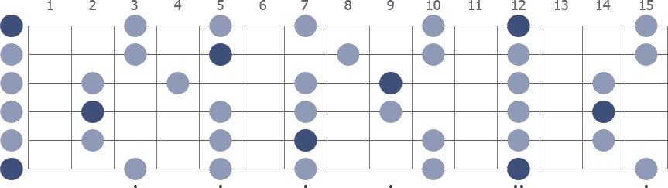
E Minor Pentatonic
Ain't No Bread in the Breadbox (E)
Intro Riff E A (x8)
Chorus E
There ain't no bread in the breadbox 'cause we ain't got no dough
And it seems like we ain't got enough time to go fooling around no more
E A
I've been working so hard for oh so long, whatta you got to show?
Open up your eyes, little darling, let's pack up your things and go
Open up your eyes, little darling, don't want to live here no more
Open up your eyes, little darling, been here for far too long
E A B E
Open up your eyes, little darling, it's time to move along

Verse 1 E
Late into December on a cold winter day
I'd just finished bringing wood into the kitchen
A B
When I heard my Amanda say
F^{#m} G^{#m}
She said, “Elijah, you better look around”
F^{#m} G^{#m}
Things ain't like they used to be
A G^{#m}
Times getting hard for you and me
F^{#m} B
Come on, daddy, it's time to shake things down (Chorus)
Lead (jam in E for a while, and then begin playing intro riff)
Verse 2 Later head down in the middle of the city and I went up to her flat
Trying to make it through life with my child and my wife
And the world upon my back
I said, “Sweet thing, you better hold me tight”
Things ain't like they used to be
Times are hard for you and me
Come on, baby, it's time to make things right (Chorus)

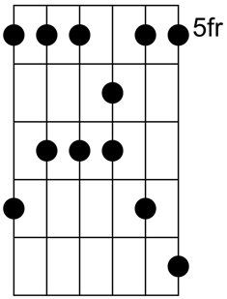
Alabama Getaway (A) A Mixolydian Pentatonic

Intro E D C A
Verse 1 A
Thirty-two teeth in a jawbone, Alabama's trying for none
E D C A
Before I have to hit him, I hope he's got the sense to run
Reason the poor girls love him, he promises them everything
Why they all believe him, he wears a big diamond ring
Chorus A D
Alabama getaway, getaway, Alabama getaway, getaway
E D C A C A
Only way to please me just sit down and leave and walk away
Lead=Chorus (solo in A Mixolydian Pentatonic)
Verse 3 Majordomo Billy Bojangles, sit down and have a drink with me
Say what about Alabama which keeps coming back to me
Verse 4 I heard your plea in the courthouse, witness box began to rock and rise
Forty-nine sister states had Alabama in their eye (Chorus)
Lead=Chorus
Verse 5 Major said, “Why don't we give him rope enough to hang himself?”
No need to worry the jury, they'll probably take care of themselves
Verse 6 23rd Psalm, Majordomo, reserve me a table for three
Down in the valley of the shadow, it's just you, Alabama, and me
Chorus (x4)
Lead=Chorus
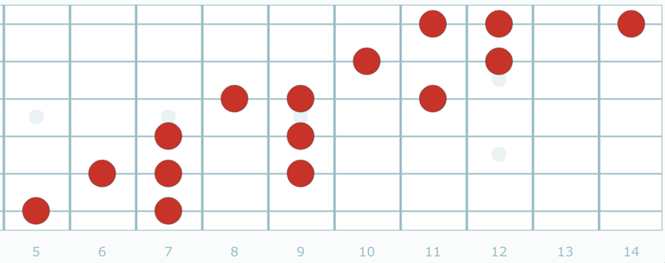
A Mixolydian Pentatonic (1,3,4,5,b7)

Althea (A)
Intro Bm A E A Bm A E A E (x2)

Verse 1 Bm A E A Bm A E A E
I told Althea I was feeling lost, lacking in some direction
Althea told me upon scrutiny that my back might need protection
A C^{#m} D A
I told Althea that treachery was tearing me limb from limb
C^{#m} E Bm A E
Althea told me better cool down boy, settle back, easy Jim
Lead=Intro (solo in E Mixolydian)
Verse 2 You may be Saturday's child all grown, moving with a pinch of grace
You may be a clown in the burying ground or just another pretty face
You may meet the fate of Ophelia, sleeping and perchance to dream
Honest to the point of recklessness, self-centered to the extreme
Lead=Intro
Verse 3 Ain't nobody messing with you, your friends are getting most concerned Loose with the truth, baby, it's your fire, baby I hope you don't get burned
When the smoke has cleared she said, that's what she said to me
Gonna want a bed to lay your head and a little sympathy (Lead=Intro)
Bridge D G E
There are things you can replace and others you cannot
The time has come to weigh those things, this space is getting hot
Bm A E
You know this space is getting hot (Lead=Intro)
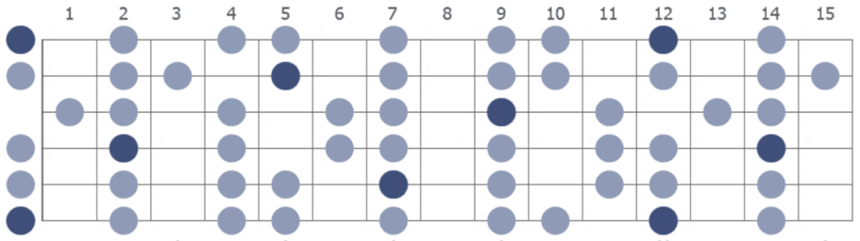
Verse 4 I told Althea I'm a roving sign and I was born to be a bachelor
Althea told me, “Okay, that's fine.” So now I'm trying to catch her
Can't talk to you without talking to me, we're guilty of the same old thing
Thinking a lot about less and less and forgetting the love we bring
Lead=Intro E Mixolydian

Always Late With Your Kisses (A)
Chorus A D A
Always late with your kisses
E
Won't you come to my arms, sweet darlin', and stay?
A D A
Always late with your kisses
E A
Why, oh why, do you want to do me this way?

Verse 1 D A
How long do you think I can wait
B E
When you know you're always late?
A D A
Always late with your kisses
E A
Why, oh why, do you want to do me this way? (Chorus)
Verse 1

Chorus

And We Bid You Goodnight (A)
Sung acapella typically in Key of A, sometimes in Key of G (2/13/70). Note: they never sing "we" bid you, always "I"
Verse 1 A
Lay down my, dear brothers, lay down and take your rest
E
Oh, won't you lay your head upon your savior’s breast
A D A
I love you, oh, but Jesus loves you the best
Chorus D E A
And I bid you goodnight, goodnight, goodnight (x2)

Verse 1

Chorus

Jerry Rap (Jerry varied the words every time, but generally based on these phrases)
A D E Tell "A" for the ark, that wonderful boat (bid you goodnight, goodnight)
Tell "B" for the beast at the ending of the wood (bid you goodnight, goodnight)
Well, it eat all the children that would not be good (bid you goodnight, goodnight)
Walking in Jerusalem just like John (bid you goodnight, goodnight)
I remember right well, I remember right well (bid you goodnight, goodnight)
His rod and his staff shall comfort me (bid you goodnight, goodnight)
Goodniiight

Verse 1

Chorus

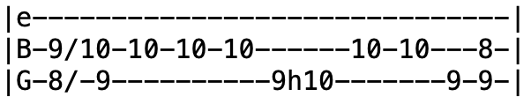
Around and Around (A) Intro Riff
Intro Riff
Verse 1 A
Well, the joint was jumpin', going 'round and 'round
D A
Hey now reelin' and a-rockin', what a crazy sound
E A
And though they never stopped rockin' till the moon went down

Verse 2 Well, it sounded so sweet, I had to take a chance
Rose out of my seat now 'cause I had to dance
Started moving my feet, oh yes a-clapping my hands

Chorus You know they never stopped rockin', going 'round and 'round
Hey reelin' and a-rockin', what a crazy sound
Though they never stopped rockin' till the moon went down

Lead=Verse (A Major Pentatonic)

Verse 3 Well, at twelve o'clock now, the whole place was packed
The front doors were locked, the whole place was packed
When the police knocked, them old doors flew back (Chorus)

Lead=Verse (at conclusion of lead, transpose up to Key of C for remainder of song)
Verse 2
Chorus (in Key of C)
Jam=Chorus (double-time in C Major Pentatonic)
Chorus
A Major Pentatonic
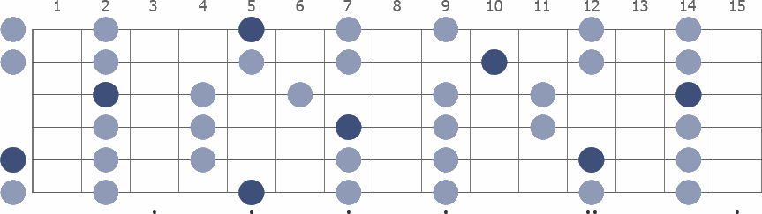

Attics of My Life (E)

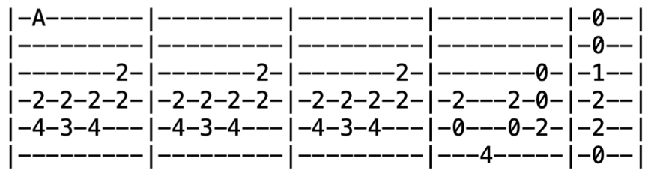
Intro Riff

Verse 1 E^{sus4} E A E A E B A E
In the attics of my life, full of cloudy dreams unreal
Full of tastes no tongue can know and lights no eye can see
E G^{#m} A G^{#m} F^{#m} E A (riff) E E^{sus4} E E^{sus4}
When there was no ear to hear, you sang to me

Verse 2 I have spent my life seeking all that's still unsung
Bent my ear to hear the tune and closed my eyes to see
E G^{#m} A G^{#m} F^{#m} E A (riff) F^{#m} F#
When there were no strings to play, you played to me

Bridge B A D A E A
In the book of love's own dream where all the print is blood
D B E
Where all the pages are my days and all my lights grow old
A D A E
When I had no wings to fly-y-y
D B A E D A E
You flew to me, you flew to me-ee, to me

Verse 3 In the secret space of dreams where I dreaming lay amazed
When the secrets all are told and the petals all unfold
When there was no dream of mine (riff) you dreamed of me

Outro=Intro
Beat It On Down the Line (C)
Intro F (pulse the beat x7, though this regularly varied between 3 and 16 times, or none)
Verse 1 C F C
Well, this job I've got is just a little too hard, uh huh huh
G
Running out of money, Lord, I need more pay
C C7 F
Gonna wake up in the morning, Lord, gonna pack my bags
C A D G C F C
I'm gonna beat it on down the line
Chorus F C
I'm going down the line (going down the line), going down the line (going down the line)
G C C7
Going down the line (going down the line), going down the line (going down the line)
F
Going down the line (going down the line)
C A D G C F C
Going down the line (going down the line), beat it on down the line
Verse 2 Yes, and I'll be waiting at the station, Lord, when that train pulls on by
I-i-i, I'm-a going back where I belong
I'm going back to that same old used to be, down in Joe Brown's coal mine

Chorus Say coal mine (coal mine), oh coal mine (coal mine)
Say coal mine (coal mine), ayy-ayy coal mine (coal mine)
Say coal mine (coal mine), ayy-ayy coal mine, down in Joe Brown's coal mine
Lead=Verse (solo in C Major)
Verse 3 Yes, I'm going back to that shack, way across that railroad track, uh huh huh
That's where I think I belong
Yes I got a sweet woman she's waiting there for me
And that's where I'm gonna make my happy home
Chorus Say happy home (happy home) (x5)
That's where I'm gonna make my happy home
Been All Around This World (C)
Intro =Verse
Verse 1 C
Up on the Blue Ridge Mountains, there I'll take my stand
C⁷ F C
Up on the Blue Ridge Mountains, there I'll take my stand
F C
A rifle on my shoulder, six-shooter in my hand, oh Lord
G C
I've been all around this world
Verse 2 Lulu, my Lulu, come and open the door (x2)
Before I have to walk on in with my old '44
I've been all around this world
Lead=Verse (solo in C Major)
Verse 3 Hang me, oh hang me, so I'll be dead and gone (x2)
I wouldn't mind your hanging, boy, but you wait in jail so long
I've been all around this world
Lead=Verse

Verse 1

Believe It Or Not (C) 3/4 Time
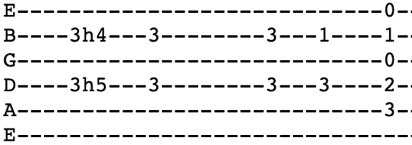
Intro Riff C G Bb^{sus4} Bb F C

Verse 1 C
One or two moments, just a piece of your time
D G
Is all I am asking and I'll give you mine
F^{maj7=xx3210} C Am
One or two moments out of all you have got
C G F^{maj7=xx3210}
To show how I love you, believe it or not
C G B^{bsus4} B^{b} F C
To show how I love you, believe it or not

Verse 2 I know I'm no angel, my prospects are high
As the floodlines in summer when the river's run dry
But I'll roll up my shirtsleeves and give my best shot
To show that I love you, believe it or not (x2)
Bridge Em Em^{maj7=021000} E^{m7=020000} A C
Done time in the lockup, done time on the street
G F^{maj7} D D^{#dim7=xx1212}
Done time on the upswing and time in defeat
Em Em^{maj7=021000} E^{m7=020000} A C
I know what I'm asking, I know it's a lot
G ¢ C G F^{maj7} C
When I say that I love you, believe it or not, believe it or not
Lead =Verse
Verse 3 Right now while the sun shines on the crest of the hill
With a breeze in the pines and a grey whippoorwill
Making music together in a world time forgot
Let me show how I love you, believe it or not (riff) (x4)
Bertha (G)

Intro G C G (x8)

Verse 1 G C G C G C G
I had a hard run, running from your window
I was all night running, I wonder if you care
I had a run-in, run around and a run down
Run around the corner, Lord, I run smack into a tree
Chorus D Am G C D
I had to move, really had to move
C G D C
That's why if you please I am on my bending knees
Am C G C G
Bertha, don't you come around here anymore

Verse 2 Dressed myself in green, Lord, I went down unto the sea
Try to see what's going down, try to read between the lines
I had a feeling I was falling, falling, falling, I turned around to see
Heard a voice a-calling, calling, Lord, you was running back to me
Chorus

Lead=Verse ¢Chorus ¢Verse

Chorus

Verse 3 Ran into a rainstorm, I ducked back into a bar door
It was all night pouring, Lord, but not a drop on me
Test me, test me, test me, test me, why don't you arrest me?
Throw me in the jailhouse, Lord, until the sun go down, till it go down

Chorus (x3)
Outro G C G
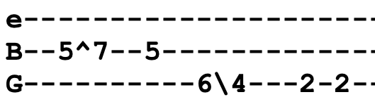
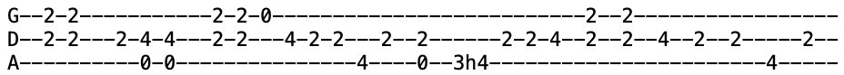
Anymore (x10ish) (* number varied between 5 and 14 times)
Big Railroad Blues (A) Riff
Intro

Verse 1 A (riff)
Well, my mama told me, my papa told me too
D A (riff)
Well, my mama told me, papa told me too
E D A
Well, I shouldn't be here trying to sing these railroad blues
Verse 2 Wish I had a-listened to oh what mama said (x2)
Well, I wouldn't be here trying to sleep in this cold iron bed
Lead=Verse (x2) (solo in A Major Pentatonic)
Verse 3 Well, I went to the depot, I never got there on time
Went down to the depot, never got there on time
Well, that train's rolling down, she's rolling down the line
Lead=Verse (x2)
Verse 4 Mister jailer, go away now, don't tell me no lies (x2)

going down, she's rolling down the line
Lead=Verse (x3)
Verse 1 ¢ Verse 2
A Major Pentatonic
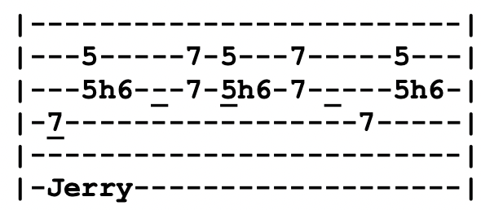
Big River (A)
Intro

Chorus A
Well, I taught that weeping willow how to cry, cry, cry
B E
Taught the clouds how to cover up a clear blue sky
A D
Tears I cried for that woman are gonna flood you, big river
A E A
I'm a-gonna sit right here until I die

Verse 1 I met her accidentally in St. Paul Minnesota
She tore me up everytime I heard her drawl, that southern drawl
Well, I heard my dream went back downstream cavorting in Davenport
And I follow you, big river, when you called
Chorus
Lead=Verse (x2) (Am Pentatonic with chromatic runs)
Verse 2 Well, I followed her down to St. Louis, later on down the river
A freighter said she's been here but she's gone, boy, she's gone
Well, I followed her down to Memphis but she just walked off the bluff
She raised a few eyebrows and she went on down alone
Chorus
Lead=Verse (x2)
Verse 3 Well, I'm batt'in on down to Baton Rouge, River Queen roll on
Take that woman down to New Orleans, New Orleans
I give up, I've had enough, followed my blues on down to the gulf
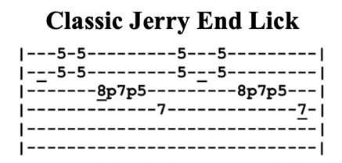
She loves you, big river, more than me
Chorus ¢ Lead=Verse
Chorus (repeat last line)
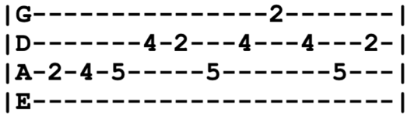
Bird Song (E) Riff
Initially in Key of D for first year until 7/18/72 when they shifted to Key of E
Intro Riff E⁷ E^{7sus2} D E⁷
Verse 1 E⁷⁼⁰²⁰¹⁰⁰ E^{7sus2=xx2432} (riff x2)
All I know is something like a bird within her sang
All I know she sang a little while and then flew on
C G D A E
Tell me all that you know, I'll show you snow and rain

Verse 2 If you hear that same sweet song again will you know why?
Anyone who sings a tune so sweet is passing by
Laugh in the sunshine, sing, cry in the dark, fly through the night
Chorus C^{#m} B A E B
Don't cry now, don't you cry
A E B A E
Don't you cry anymore, la da da da
C^{#m} B A E B
Sleep in the stars, don't you cry
A E B A E D E⁷
Dry your eyes on the wind, nah nah nah

Jam in E⁷ (solo in E Mixolydian)
Chorus

Verse 3 If you hear that same sweet song again will you know why?
Anyone who sings a tune so sweet is passing by
Tell me all that you know, I'll show you snow and rain
Snow and rain (x3)

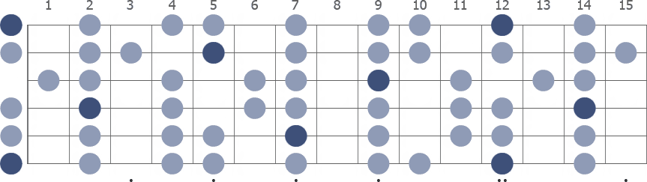
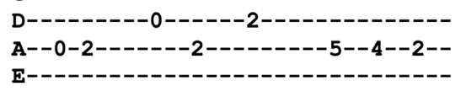
E Mixolydian Outro Lick

Black Muddy River (A)

Intro A D A F#m E D
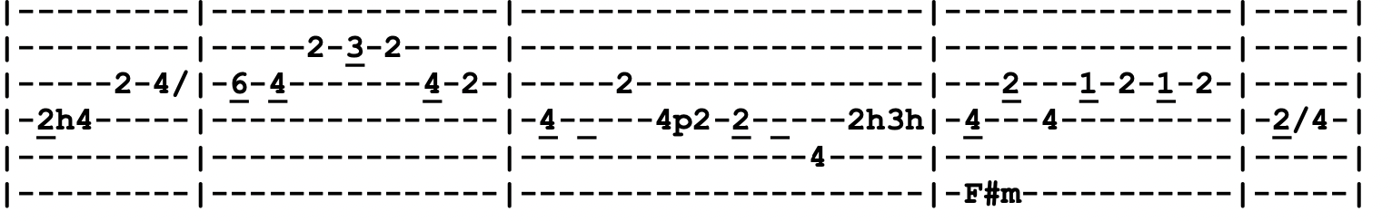
Verse 1 A A^{sus4} D A A^{sus4} D
When the last rose of summer pricks my finger and the hot sun chills me to the bone
A A^{sus4} D A F^{#m} E D
When I can't hear the song for the singer and I can't tell my pillow from a stone
Chorus E A D A E D
I will walk alone by the black muddy river, sing me a song of my own
E A D A F^{#m} E D
I will walk alone by the black muddy river, sing me a song of my own
Verse 2 When the last bolt of sunshine hits the mountain and the stars start to splatter in the sky
When the moon splits the southwest horizon with the scream of an eagle on the fly
Chorus I will walk alone by the black muddy river, listen to the ripples as they moan
I will walk alone by the black muddy river, sing me a song of my own
Bridge Bm E A A^{/G#} F^{#m}
Black muddy river, roll on forever
E A E A A^{/G#}
I don't care how deep or wide if you got another side
D A D A D E A
Roll muddy river, roll muddy river, black muddy river, roll
Instrumental=Verse
Bridge
Verse 3 When it seems like the night will last forever
And there's nothing left to do but count the years
When the strings of my heart start to sever, stones fall from my eyes instead of tears
Chorus I will walk alone by the black muddy river, dream me a dream of my own
I will walk alone by the black muddy river
F^{#m} E D
And sing me a song of my own (x2)
Outro=Intro
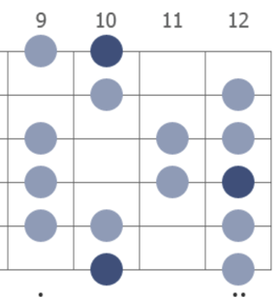
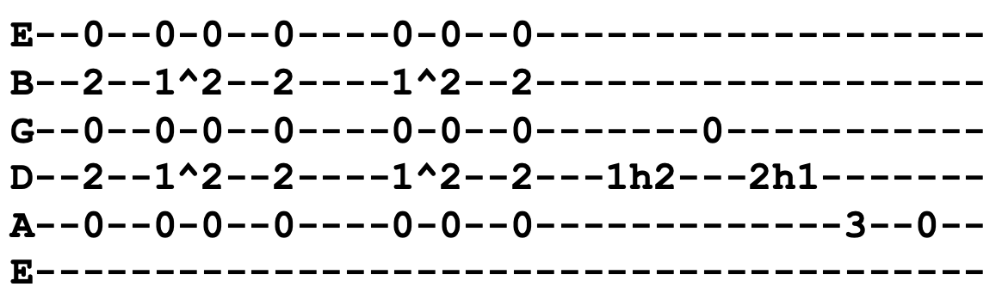
Black Peter (D) D Ionian
Intro
Verse 1 A⁷ D⁷
All of my friends come to see me last night
I was laying in my bed and dying
Em A G F^{#m}
Annie Bonneau from St. Angel
Em D⁷ D^{sus2=xx0230} D⁷
Say, “The weather down there so fine”

Verse 2 Just then the wind came squalling through the door
But who can the weather command?
Just wanna have a little peace to die and a friend or two I love at hand
Lead=Verse (solo in D Ionian)
Verse 3 Fever roll up to a hundred and five, roll on up, gonna roll back down
One more day I find myself alive, tomorrow maybe go beneath the ground
Bridge C Em
See here how everything lead up to this day
Dm Am Em
And it's just like any other day that's ever been
Dm G C Em Am
Sun going up and then the sun it going down
F^{maj7} C D⁷
Shine through my window and my friends they come around
Dm F^{maj7} A⁷
Come around, come around, around
Verse 4 The people might know but the people don't care
That a man can be as poor as me
Take a look at poor Peter, he's lying in pain, now, let's come run and see
Run and see (x5)
Jam in D⁷
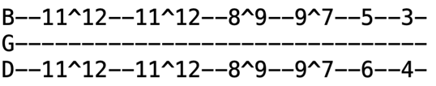
Black-Throated Wind (A) Intro Riff
Intro E E^{sus4} E E⁷ (x2) Intro Riff (x2)
Verse 1 E F^{#m} D A E E^{sus4}
Bringing me down, I'm running aground, blind in the light of the interstate cars
Passing me by, the busses and semis plunging like stones from a slingshot on Mars
A A⁷ D C^{#m} Bm A Bm E
But I'm here by the road bound to the load I picked up in ten thousand cafes and bars
Alone with the rush of the drivers that won't pick me up
The highway, the moon, the clouds and the stars
Chorus D C^{#m} A Em C A
Black-throated wind keeps on pouring in with its words of a life where nothing is new
D C^{#m} A Em A G D A
Ah, Mother American night, lo-ost from the light, whoa-oh, I'm drowning in you
Intro Riff (x2)
Verse 2 I left St. Louie, city of blues, in the midst of a storm I'd rather forget
I tried to pretend it came to an end 'cause you weren't the women I once thought I'd met
But I can't deny, oh times have gone by, never had doubts or thoughts of regret
And I was a man when all this began who wouldn't think twice about being there yet

Chorus Black-throated wind, whispering sin, speaking of life that passes like dew
Forced me to see, you've done better by me, better by me than I've done by you
Intro Riff (x2)
Verse 3 What's to be found racing around, you carry your pain wherever you go
Full of the blues, trying to lose, you ain't gonna learn what you don't wanna know
So I give you my eyes and all of their lies, please help them to learn as well as to see
Capture a glance, whoa, and make it dance of looking at you looking at me

Chorus Black-throated wind keeps on pouring in with its words of a life that could almost be true
Ah, Mother American Night, here comes the light, I'm turning around that's what I'm gonna do
Vocal Jam I'm going back home that's what I'm gonna do
I'm turning around that's what I'm gonna do, oh oh, I'm drowning in you
I'm going back home that's what I'm gonna do
Going back home that's what I'm gonna do
You've done better by me than I've done by you, oh oh, I'm drowning in you
Going, going, going back home, that's what I'm gonna do
You've done better by me than I've done by you
I'm going, going, going, back home, that's what I'm gonna do

Blow Away (B^{b})

Intro F F^{sus4} F F^{sus4} F | F F^{sus4} F E^{b} B^{b} (x4)
Verse 1 A^{b} E^{b} B^{b} B^{bsus4} B^{b} B^{bsus4} B^{b}
A man and a woman come together as strangers
When they part they're usually strangers still
It's like a practical joke played on us by our maker
Empty bottles that can't be filled
Chorus Cm Dm E^{b} F
Baby, who's to say it should have been different now that it's done?
Baby, who's to say it should have been anyway?
Baby, who's to say that it even matters in the long run?
Cm Dm E^{b} F Gm
Give it just a minute, it'll blow away, it'll blow away
Lead (Jerry) Gm F Gm F
Verse 2 You fancy me to be the master of your feelings
You barely bruise me with your looks to kill
Though I admit we were sometimes brutal in our dealings
I never held you against your will (Chorus)
Lead (Brent) A^{b} E^{b} B^{b} (x4) ¢ Lead (Jerry) Gm F (x2)

Verse 3 Your case against me is so very clearly stated
I plead no contest, I just turn and I shrug
I've come to figure all importance overestimated
You must mean water when you get on your knees
And you beg me for blood (Chorus)
Postchorus Cm Dm E^{b} F (riff on these two lines, and then "oh it will blow)
Like a feather in a whirlwind (blow away)
Just as sure as the world spins (blow away)
Oh, it will blow, oh it will blow
Vocal Jam F E^{b} B^{b}
Gimme just a little piece of your time
Gimme just a little second now
Box of Rain (G)
Intro A A^{sus4} (x4)
Verse 1 D Am Em C G
Look out of any window, any morning, any evening, any day
D Am Em G A
Maybe the sun is shining, birds are winging, no rain is falling from a heavy sky
D G Am Em D
What do you want me to do, to do for you to see you throu-ough?
C D Am G
For this is all a dream we dreamed one afternoon long ago
Verse 2 D Am Em C G
Walk out of any doorway, feel your way, feel your way like the day before
D Am Em G A
Maybe you'll find direction around some corner where it's been waiting to meet you
D G Am Em D
What do you want me to do, to watch for you while you're slee-e-e-e-ping
Am C G D
Then please don't be surprised when you find me dreaming too
Lead G Am Em C A D | G Am Em G D Em A A^{sus4} A A^{sus4}
Verse 3 D Am Em C G
Look into any eyes, you find by you, you can see clear to another day
D Am Em G A
Maybe been seen before through other eyes on other days while going home
D G Am Em D
What do you want me to do, to do for you, to see you through?
C Em D G
It's all a dream we dreamed one afternoon long ago
Verse 4 D Am Em C G
Walk into splintered sunlight, inch your way through dead dreams to another land
D Am Em G A
Maybe you're tired and broken, your tongue is twisted with words half spoken and thoughts unclear
D G Am Em D
What do you want me to do, to do for you, to see you through?
Am C G D
A box of rain will ease the pain and love will see you through

Chorus G Am Em C A D
Just a box of rain, wind and water, believe it if you need it, if you don't just pass it on
G Am Em G D Em A A^{sus4} A A^{sus4}
Sun and shower, wind and rain, in and out the window like a moth before a flame
D Em G D
And it's just a box of rain, I don't know who put it there
Bm G A
Believe it if you need it or leave it if you dare
D Em G D
And it's just a box of rain or a ribbon for your hair
Em G D C G D A^{sus4}
Such a long long time to be gone and a short time to be theeeeeeeeeeere

Bright Morning Stars (E)
Key of E (capo on 4th fret)

Chorus C
Bright morning stars are rising
G C
Bright morning stars are rising
C
Bright morning stars are rising
G C F C
Day is a-breaking in my soul

Verse 2 Oh, where are our dear fathers
Oh, where are our dear fathers
They are down in the valley a-praying
Day is a-breaking in my soul

Verse 3 Oh, where are our dear mothers?
Oh, where are our dear mothers?
They’re gone to heaven a-shouting
Day is a-breaking in my soul
Chorus
Brokedown Palace (F)
Played in the key of F for the first eight years. From 5/1/77 onwards it was played in Key of G
Intro G C (x4)
G Am B^{b} F C G
Fare you well, my honey, fare you well, my only true one
Dm B^{b} C F B^{b} F B^{b}
All the birds that were singing are flown except you alone
Verse 1 F B^{b}
Gonna leave this brokedown palace
F Dm B^{b} F B^{b}
On my hands and my knees, I will roll, roll, roll
F Am B^{b} F
Make myself a bed by the waterside
G B^{b} F B^{b}
In my time, in my time, I will roll, roll, roll
F A B^{b} F G
In a bed, in a bed, by the waterside I will lay my head
F G B^{b} F B^{b} F B^{b} F B^{b}
Listen to the river sing sweet songs to rock my soul

Verse 2 River gonna take me, sing me sweet and sleepy
Sing me sweet and sleepy all the way back home
It's a far gone lullaby sung many years ago
Mama, mama, many worlds I've come since I first left home
Going home, going home, by the waterside I will rest my bones
Listen to the river sing sweet songs to rock my soul

Verse 3 Gonna plant a weeping willow
On the bank's green edge, it will, grow, grow, grow
Sing a lullaby beside the water, lovers come and go, the river roll, roll, roll
Fare you well, fare you well, I love you more than words can tell
Listen to the river sing sweet songs to rock my soul
Lead=(first half of verse)
Outro F A B^{b} F G
Fare you well, fare you well, I love you more than words can tell
F G B^{b} F
Listen to the river sing sweet songs to rock my soul
I'm gonna listen to the river sing sweet songs to rock my soul
Broken Arrow (G)
Intro G Em F C G G^{sus4} G G^{sus4} G
Chorus G D Em C
Who else is gonna bring you a broken arrow?
Who else is gonna bring you a bottle of rain?
G Em F C G Em F C
There you go, moving across the water
G Em F C G G^{sus4} G G^{sus4} G
There you go, turning my whole world around

Verse 1 G D
Do you feel what I feel
C G Em C
Can we make that so it's part of the deal
D G Em
I gotta hold you in these arms of steel
D
Lay my heart on the line this time

Verse 2 I wanna breathe when you breathe
When you whisper like that hot summer breeze
Count the beads of sweat that cover me
Didn't you show me a sign this time? (Chorus)

Verse 3 Do you see what I see? Can you cut behind the mystery?
I will meet you at the witness tree, leave the whole world behind
Verse 4 I want to come when you call
I'll get to you if I have to crawl
They can't hold me with these iron walls
We got mountains to climb (Chorus)

Outro G Em F C G Em F C
There you go, moving across the water
There you go, turning my whole world around
Turning my whole world around

Brown-Eyed Women (E)

Intro C^{#m} E A E
Verse 1 C^{#m} E
Gone are the days when the ox fall down
B A
Take up the yoke and plow the fields around
C^{#m} E
Gone are the days when the ladies said, “Please
A E
Gently, Jack Jones, won't you come to me”

Chorus B A E B
Brown-eyed women and red grenadine, the bottle was dusty but the liquor was clean
A E C^{#m}
Sound of the thunder with the rain pouring down
F^{#m} A E
And it looks like the old man's getting on

Verse 2 1920 when he stepped to the bar, drank to the dregs of the whiskey jar
1930 when the wall caved in, made his way selling red-eyed gin (Chorus)
Lead=Verse (x3)

Verse 3 Delilah Jones was the mother of twins, two times over and the rest were sins
Raised eight boys, only I turned bad
Didn't get the lickins that the other ones had (Chorus)
Bridge Bm A E
Tumble down shack in Bigfoot County
Snowed so hard that the roof caved in
C^{#m} B A G^{#m} A E
Delilah Jones went to meet her God and the old man never was the same again
Verse 4 Daddy made whiskey and he made it well
Cost two dollars and it burned like hell
I cut hickory just to fire the still, drink down a bottle and be ready to kill (Chorus)
Verse 1
Chorus (repeat last line)
Built to Last (C)
Intro F C G C G F (x2)

Verse 1 G C F C
There are times when you can beckon, there are times when you must call
G Am Dm F
You can take a lot of reckoning but you can't take it all
G C F C
There are times when I can help you out and times when you must fall
G Am F G
There are times when you must live in doubt and I can't help at all
Chorus 1 F C G C G F F C G F^{maj7}
Three blue stars, rise on the hill, say no more now just be still
F C G C G F F C G Dm
All these trials, soon be past, look for something built to last

Verse 2 A wind held by the collar, yes, a cloud held by the breeze
You can walk on coals of fire but sometimes you must freeze
There are times when you offend me and I do the same to you
If we can't or won't forget it, I guess we could be through

Chorus 2 One blue star, sets on the hill, call it back you never will
One more star, sinks in the past, show me something built to last
Bridge F C G
Built to last till time itself falls tumbling from the wall
C G F
Built to last till sunshine fails and darkness moves on all
F C G Am
Built to last while years roll past like cloudscapes in the sky
F Dm B^{b}
Show me something built to last, something built to try
Lead=Verse
Verse 3 There are times when you get hit upon, try hard but you cannot give
Other times you'd gladly part with what you need to live
Don't waste your breath to save your face when you have done your best
Even more is asked of you, fate will decide the rest
Chorus 3 All the stars are gone but one, morning breaks here comes the sun
Cross the sky, now sinking fast, show me something built to last
Chorus 1 ¢ Chorus 2 ¢ Chorus 3

C.C. Rider (A)
Intro A⁷ D A⁷
Verse 1 A⁷
Well, now see C.C. Rider, well, now see see what you done done
D A⁷
Well, now see C.C. Rider, well, now see, see what you done done
E⁷ D A⁷ E⁷
Girl, now you made me love you, woman, now your man is gone

Verse 2 So I'm going away now, baby, and no I won't be back till fall
Say I'm going away now, baby, no I won't be back till fall
Just might find me that good girl, might not be coming back at all
Lead=Verse
Verse 3 Well, now see C.C. Rider, see now the moon is shining bright
Well, now see C.C. Rider, see now the moon is shining bright
Just might find me that good girl, everything will be alright
Verse 1

Lead=Verse

Verse 1

California Earthquake (G) 6/8 Time
Intro G ¢ C ¢ Em D^{sus} D G C G D
Verse 1 G C G
There was a California earthquake in the year of '83
Em A D
It shook the living daylights out of the Owens County seat
G Em C G
Not a building was left standing when the dust had cleared away
C Em D G ¢ D
Just a rumble in the distance all the way to San Andrea

Verse 2 Sherman Buck was driving his old mule into town
When a big one came and shook so hard that it knocked him to the ground
Lord, there opened up a hole so big he thought his time was up G C G ¢
Lord, it swallowed up that poor old mule and it just missed Sherman Buck

Chorus C G
California earthquake, you just don't know what you've done
Em D D^{sus4} D
We may fall off in the ocean but you'll never make us run
G C G
You're a partner to the Devil but we ain't afraid of him
C Em D G D
We'll build ourselves another town so you can tear it down again

Verse 4 Then came the quake of '99 that leveled Mission Creek
The earth was like an ocean churning with waves of twenty feet
Lord, it sounded like a thousand trains were screaming underground
All the way to San Joaquin, they heard that mournful sound (Chorus)

Verse 5 Then came one day the holocaust on the San Francisco Bay
Miles of walls came tumbling down like Jericho that day
Might near everything the earthquake missed, a holy fire consumed
Just left 'em smoke and ashes of the dreams that can't be ruined

Chorus (after singing chorus, repeat last line)
Outro G ¢ C ¢ Em D^{sus} D G
Candyman (C) 6/8 Time
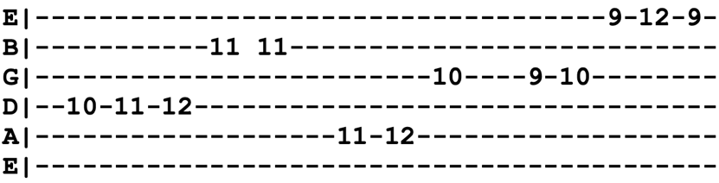
Intro Riff
Intro B^{b} F C (x4)
G G^{sus4} G G → C
Verse 1 C Gm F
Come on, you pretty women, with your hair a-hanging down
G
Open up your window 'cause the Candyman's in town
Dm G Dm
Come on boys and gamble, roll those laughing bones
F G
Seven come eleven, boys, I'll take your money home
Chorus B^{b} F C
Look out, look out, the Candyman
Here he comes and he's gone again
Am G F G
Pretty lady ain't got no friend till the Candyman comes around again

Verse 2 I come in from Memphis where I learned to talk the jive
When I get back to Memphis be one less man alive
Good morning, Mr. Benson, I see you're doing well
If I had me a shotgun you know I'd blow you straight to hell
Chorus

Lead=Verse
Chorus (sing "oooh, oooh, oooh" instead of words)

Verse 3 Come on boys and wager if you have got the mind
If you've got a dollar, boys, lay it on the line
Hand me my old guitar, pass the whiskey 'round
Won't you tell everybody you meet that the Candyman's in town
Chorus x2 (At end of 1st chorus, do quick turn around in 2/4 Time) F C
(At end of second chorus, end on "around")
Casey Jones (C)
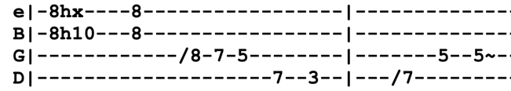
Intro Lick

Chorus 1 C F C
Driving that train, high on cocaine, Casey Jones you better watch your speed
Trouble ahead, trouble behind, and you know that notion just crossed my mind (lick)
Verse 1 C D F G
This old engine makes it on time, leaves central station at a quarter to nine
C D
Hits River Junction at seventeen to
F E⁷ Am G⁷
At a quarter to ten, you know it's traveling again (Chorus)
Bridge C C# D F G
Trouble ahead, THE lady in red, take my advice you’d be better off dead
C D
Switchman's sleeping, train Hundred-and-Two
F Em Dm G
Is on the wrong track and heading for you (Chorus)
Lead= Verse (arpeggiated) ¢ Chorus

Bridge Trouble with you is the trouble with me
Got two good eyes but we still don't see
Come round the bend, you know it's the end
The fireman screams and the engine just gleams
Chorus 1 C F C
(x2) Driving that train, high on cocaine, Casey Jones you better watch your speed
Trouble ahead, trouble behind, and you know that notion just crossed my mind
Chorus 2 C B^{b} F C
(x2) Driving that train, high on cocaine, Casey Jones, you better watch your speed
Trouble ahead, trouble behind, and you know that notion just crossed my mind
Outro Am D⁷ G C
And you know that notion just crossed my mind

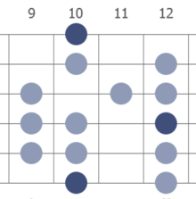
Cassidy (E) D Mixolydian
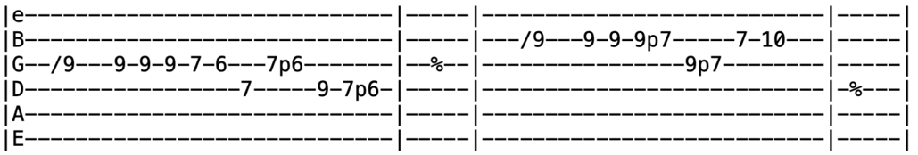
Intro Riff
Verse 1 E A
I have seen where the wolf has slept by the silver stream
I can tell by the mark he left you were in his dream
E^{m7=010000} Am E^{m7} Am
Ah, child of countless trees, ah, child of boundless seas
F^{#m} A
What you are and what you're meant to be?
F^{#m} A E (riff x2)
Speaks his name for you were born to me, born to me, Cassidy

Verse 2 Lost now on the country miles in his Cadillac
I can tell by the way you smile, he's rolling back
Come wash the nighttime clean, come grow the scorched ground green
Blow the horn, tap the tambourine
Close the gap on the dark years in between, you and me, Cassidy (no riff)
Bridge A E A E
Quick beats in an icy heart, catch colt draws a coffin cart
A E B
There he goes and now here she starts, hear her cry
F^{#m} E B F^{#m} E B F^{#m} E B A E
Flight of the seabirds, scattered like lost words, wheel to the storm and fly
Intro riff (x4)
Lead=Verse (solo in D Mixolydian)
Chorus E A
(x2) Faring thee well now, let your life proceed by its own design
Nothing to tell now, let the words be yours, I'm done with mine

Jam in E (optionally, drop down to A^{b}m to build tension before finale)
Bridge F^{#m} E B F^{#m} E B F^{#m} E B A E
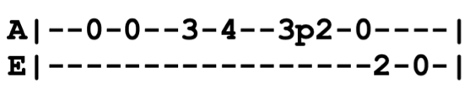
Flight of the seabirds, scattered like lost words, wheel to the storm and fly
Outro=Intro riff (x4)
Catfish John (A)
Intro Riff (x4)

Chorus A D
Mama said, “Don’t go near that river,
A E
Don’t be hanging around old Catfish John”
A D
Come the morning I’d always be there
A E A
Walking in his footsteps in the sweet delta dawn

Verse 1 D A
Take me back to another morning
To a time so long ago
Where the sweet magnolia blossom
E A
Cotton fields as white as snow
Verse 2 Catfish John was a river hobo
Lived and died by the river’s bend
Looking back, I still remember
I was proud to be his friend (Chorus)

Lead=Verse

Verse 3 Born a slave in the town of Vicksburg
Traded for a chestnut mare
Lord, he never spoke in anger
Though his load was hard to bear (Chorus)

Lead=Verse

Chorus (repeat last line)

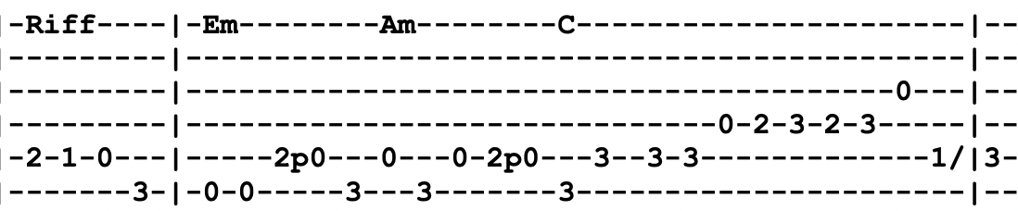
Cats Under the Stars (C)
Intro F Em Dm Am C G F
Em Am G F G
Chorus C7 F Am G Em Am G F G
Cats down under the stars
C7 F Am G
Cats down under the stars
Verse 1 C7
Cats on the blacktop, birdy in the treetop
F Em D
Someone plays guitar that sounds like cla-ri- net
Am D Am D
I ain't ready yet to go to bed
F Em Dm Am C G F
Think I'll take a walk downtown instead (Chorus)
Verse 2 Cats on the bandstand, give 'em each a big hand
Anyone who sweat like that must be alright
No one wants to fight, no black eyes
just another cat beneath the stars tonight (Chorus)

Verse 3 Cats in the limelight, feels like its alright
Everybody wants something they might not get
I ain't ready yet, it ain't complete
That's why I am heading down to Alley Cat Street
Chorus (after singing chorus, do chromatic ascent on G, and then to A)
Bridge Dm Dm^{/C} Dm Dm^{/C} B^{dim=xx343x} B^{b}
Sa- tin blouse un- but- toning (x2)
A F C G E^{b} B^{b} F
Time is a stripper, doing it just for you (x2) just for you!
Jam D (for three measures, and then quick turnaround) E^{b} B^{b} F (repeat many times)
D^{b} A^{b} E^{b} / | B^{b} F G (chromatic ascent back up to C7)

Verse 4 Nail in the brass tacks, cover up your tracks, Jack
You ain't nowhere till your pay own way back
What else do you like to make it right?
Cats down under the stars tonight?
Chorus (x4)
China Cat Sunflower (G)
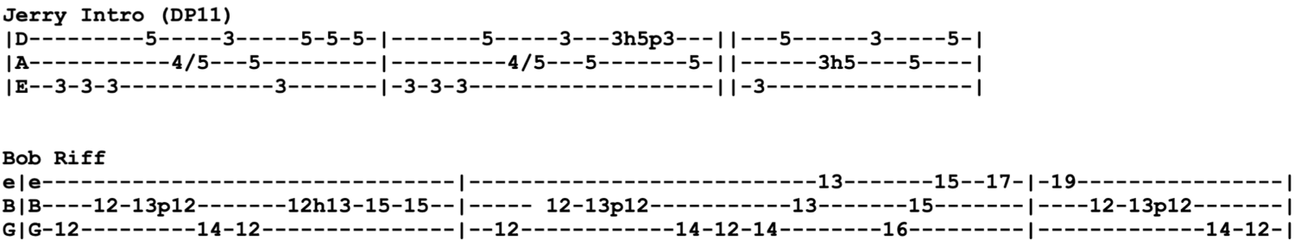
Intro Riff (x8)
Verse 1 G F
Look for a while at the China Cat Sunflower
G F G
Proud walking jingle in the midnight sun
Copper dome bodhi drip a silver kimono like a
Crazy quilt star gown through a dream night wind
Solo 1 G C G (x2) ¢ D C D

Verse 2 Krazy Kat peeking through a lace bandana
Like a one-eyed Cheshire, like a diamond-eye Jack
A leaf of all colors plays a golden string fiddle
To a double-E waterfall over my back
Solo 2 G C G (x2) ¢ D C D
E D E (x2) ¢ B A B

Verse 3 Comic book colors on a vi-olin river
Crying Leonardo words from out a silk trombone
I rang a silent bell beneath a shower of pearls
In the eagle wing palace of the Queen Chinee
Solo 1 (land on the D and transition into "I Know You Rider")
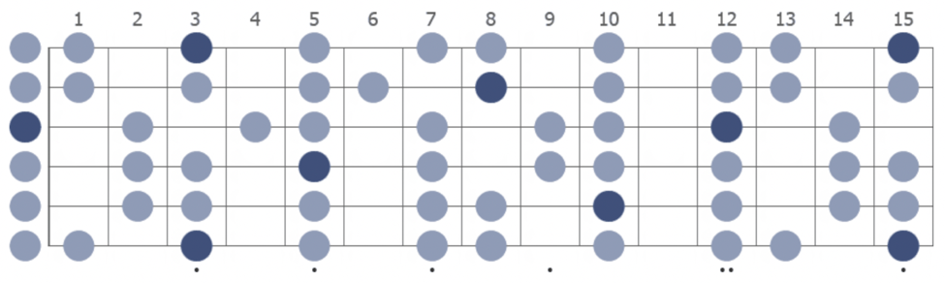
G Mixolydian

China Doll (Dm)
Intro Dm
Verse 1 Dm F^{maj7=xx3210} B^{dim7=x20101} B^{b} A⁷
A pistol shot at five o'clock, the bells of heaven ring
Dm F C A⁷
Tell me what you done it for, no I won't tell you a thing

Verse 2 Yesterday I begged you before I hit the ground
All I leave behind me is only what I found
Lead=Verse
Verse 3 If you can abide, let the hurdy-gurdy play
Stranger ones have come by here before they flew away
Verse 4 I will not condemn you nor yet would I deny
Dm F C A A7 D
I would ask the same of you but failing will not die
Chorus A
Take up your china doll (take up your china doll)
G D G¢D Riff
It's only fractured, just a little nervous from the fall
Outro G¢D Riff
La la la la la la la (x2)
Lead G¢D Riff (x4)
Cold Rain and Snow (A)
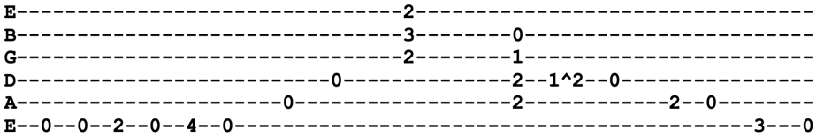
Intro Riff (x4) D E
Verse 1 D E
Well, I married me a wife, she's been trouble all my life
D E
Run me out in the cold rain and snow
E D E D E
Rain and snowwwww, run me out in the cold rain and snow

Instrumental=Intro (x4)

Verse 2 Well, she's coming down the stairs
Combing back her yellow hair
And I ain't gonna be treated this ol' way
This ol' wayyy, I ain't gonna be treated this ol' way

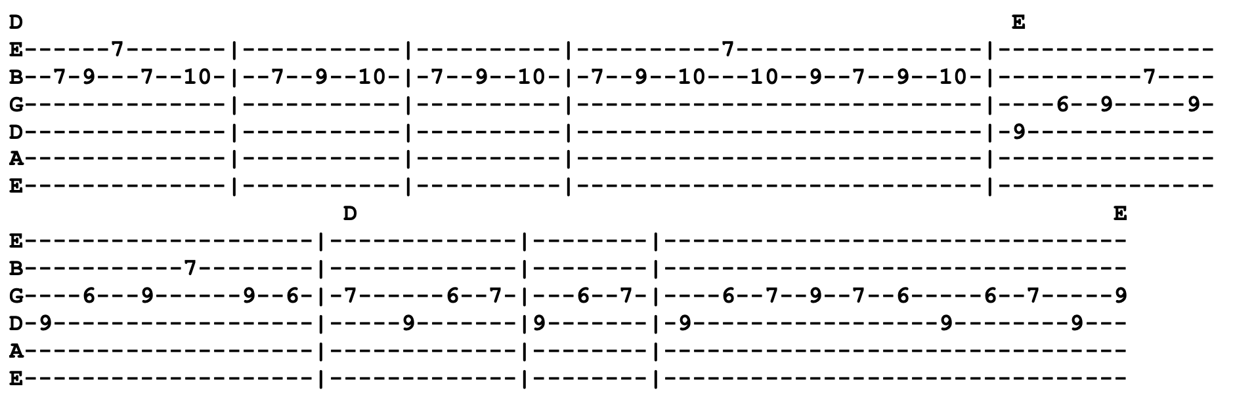
Lead=Riff (x2)
Verse 3 Well, she went up to her room and she sang her faithful tune
Well, I'm going where those chilly winds don’t blow
Winds don't blowww
And I'm going where those chilly winds don't blow

Instrumental=Intro
Verse 1 (after singing verse, repeat last line x8)
Run me out in the cold rain and snow (x8)
Comes A Time (A)

Intro Em Bm A | A D A D A
Chorus A Em D
Comes a time when the blind man takes your hand
A A^{/G#} A^{/F#}
Says, “Don't you see?”
A^{/E} B E Dm A
Gotta make it somehow on the dreams you still believe
E F^{#m} E^{m7=355430}
Don't give it up, you got an empty cup
F^{#m} E^{m7} F^{#m}
Only love can fill, only love can fill
Verse 1 A E Bm D
Been walking all morning, went walking all night
A E G D Dm
I can’t see much difference between the dark and light
A E Bm D
And I feel the wind and I taste the rain
A Em G^{maj7} D
Never in my mind to cause so much pain (Chorus)

Lead=Verse

Verse 2 From day to day, just letting it ride
You get so far away from how it feels inside
You can't let go 'cause you're afraid to fall
But the day may come when you can't feel at all
Chorus (sing "only love can fill" x4 total)

Lead F^{#m} E^{m7=355430}

Dropped Verse (from debut through first year, till 11/7/71, this was verse 2 and then it was dropped)
The words come out like an angry stream
You hear yourself say things you could never mean
When you cool down you find your mind
You got a lot of words you've gotta stand behind
Cosmic Charlie (A)

Intro A G A G D A

Verse 1 A G
Cosmic Charlie how do you do, truckin' in style along the avenue
A G D A
Dum de dum de dooodley do, go on home your mama's calling you
A G
Calico Kahlia, come tell me the news, calamity's waiting for a way to get to her
A G D A A G D A
Rosy red and electric blue, I bought you a paddle for your paper canoe
Break A⁷ D A D E⁷
Say you'll come back when you can, whenever your airplane happens to land
A⁷ D E A G A G A
Maybe I'll be back here too, it all depends on what's with you

Verse 2 Hung up waiting for a windy day
Kite on ice since the first of February
Mama Bee saying that the wind might blow
But standing here I say, “I just don't know”
New ones coming as the old ones go
Everything's moving here but much too slowly
Little bit quicker and we might have time
To say, “How do you do?” before we're left behind

Bridge C^{#m} F^{#m} E G D A D C^{#m} Bm A E^{/G#}
Callio- pe wail like a seaside zoo, the very last lately inquired about you
D A D E B D^{/F#} A
It's really very one or two, the first you wanted, the last I knew (Intro)
Lead=Verse (first two lines)

Verse 3 I just wonder if you shouldn't feel less concerned about the deep unreal
^{(half)} The very first word is “How do you do”
The last, “Go home, your mama's calling you”
Calling you (go on home your mama's calling you) (x4) (Intro)
Outro A G D A
Go on home your mama's calling you
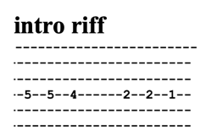
Crazy Fingers (G)

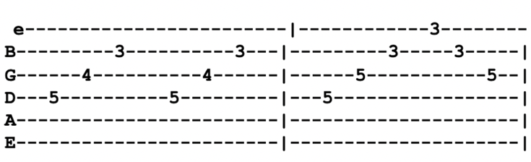
Intro 3/4 Time G G^{sus4} (x4)
G Gsus4
e|-----------------------------------------------------|
B|--------3------------3------------3----------3-------| or
G|------4------------4------------5-----------5--------|
D|-----------------------------------------------------| x3
A|-----------------------------------------------------|
E|--3-3----------3-3----------3-3---------3-3----------|

Verse 1 D C G B^{b} F Fm G^{sus4} G
Your rain falls like crazy fingers, peels of fragile thunder, keeping time
B^{b} B^{bm} E^{bmaj7=x68786} Cm G G^{sus4} G
Recall the days that still are to come, some sing blue

Verse 2 Hang your heart on laughing willow, stray down to the water, deep sea of love
Beneath the cool calm face of the sea, swift undertow
Chorus Fm E^{aug=xx2110} A^{b} E^{b}
Life may be sweeter for this, I don't know
Fm A^{b} E^{b} Cm^{/G=335543} G
See how it feels in the end
A^{b} A^{dim7=x01212} E^{bmaj7} D^{maj7}
While Lady Lullaby sings plainly for you
D^{bmaj7} D^{b7=x46464} D^{bmaj7} G^{sus4} G
Soft, strong, sweet and true

Verse 3 Cloud hands reaching from a rainbow, tapping at your window, touch your hair
So swift and bright, strange figures of light float in air

Verse 4 Who can stop what must arrive now, something new is waiting to be born
Dark as the night, you're still by my side, shine inside
Chorus Gone are the days we stopped to decide where we should go, we just ride
Gone are the broken eyes we saw through in dreams, gone, both dream and lie
Lead=Verse
Chorus Life may be sweeter for this, I don't know, feels like it might be alright
While Lady Lullaby sings plainly for you, love still rings true

Verse 5 Midnight on a carousel ride, reaching for the gold ring down inside
Never could reach it just slips away, but I try

Jam (in 3/4 Time) G C (x8) ¢ G G# (x8) ¢ G C (x8)
Cryptical Envelopment (E)

Intro=Verse
Verse 1 E E^{sus4=002200}
The other day they waited
A^{sus4=x00230} E
The sky was dark and faded
E D C# B A B D
So-lem-nly they stated
A G A G
He has to die, you know he had to die

Verse 2 All the children learning
From books that they were burning
Every leaf was turning
To watch him die, you know he had to die

Bridge (arpeggios)
Em G D
The summer sun looked down on him
C B Am Am^{/G}
His mother could but frown on him
Dm^{/F} D^{/F#} Em/^{G} G^{#dim=4564xx}
And all the others sound on him
Am F^{#7} B7
But it doesn't seem to matter

Verse 3 And when the day had ended
With rainbow colors blended
His mind remained unbended
He had to die, you know he had to die
Other One (segue into The Other One, and then segue back into Cryptical final verse)
Verse 3

Jam A G
Cumberland Blues (G) Intro Lick Late Period Intro Lick
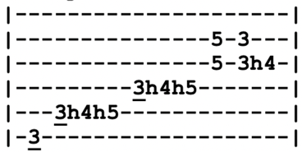
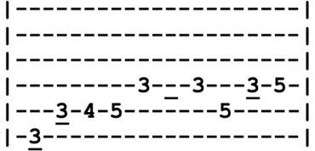

Intro G⁷
Verse 1 G
I can't stay much longer, Melinda, the sun is getting high
I can't help you with your troubles if you won't help with mine
G^{b} B^{b} B B^{b} A A^{b} G
I gotta get down, I gotta get down, I gotta get down to, to the mine
Lead G⁷ (solo in G Blues scale)
Verse 2 You keep me up just one more night, I can't sleep here no more
Little Ben clock says quarter to eight, you kept me up till four
I gotta get down, I gotta get down or I can't work there no more
Lead G⁷
Verse 3 A lotta poor man make a five dollar bill, keep him happy all the time
Some other fellow makin nothing at all and you can hear him cry-y
C D
Can I go, buddy, can I go down, take your shift at the mine?
C F C
Gotta get down to the Cumberland mine (gotta get down to the Cumberland mine)
F
That's where I mainly spend my time
C
Make good money, five dollars a day
F C A^{m7=x02010} Em G
Made anymore, I might move away-ay
Lead G⁷
Verse 4 G C G C
Lotta poor man got the Cumberland blues, he can't win for losing
G A D
Lotta poor man got to walk the line just to pay his union dues
C D C G
I don't know now, I just don't know, if I'm going back again (x3)
Dancing in the Street (A)
Note: it's never "streets" plural.
Intro A⁷⁼⁰⁰⁷⁹⁸⁹
Verse 1 A⁷
Coming out around the world, are you ready for a brand new beat?
Summer's here and the time is right for dancing in the street
Dancing in Chicago, down in New Orleans, New York City
Chorus D
All we need is music, sweet music, there'll be music everywhere
A
They'll be laughing and singing, music swinging, dancing in the street
C^{#7} F^{#m}
Doesn't matter what you wear just as long as you are there
Bm E
Come on every guy, grab a girl, everywhere around the world
A
Dancing, dancing in the street (x2)
Verse 2 This is an invitation across the nation, a chance for folks to meet
There'll be swinging and swaying, music playing, dancing in the street
Philadelphia PA, Baltimore and DC now, can't forget that Motor City
Chorus (after singing chorus, repeat last line 4-8 times)
Vocal Jam Dancing, dancing in the street (x4)
Jam in A (solo in A Mixolydian)
Chorus
A Mixolydian
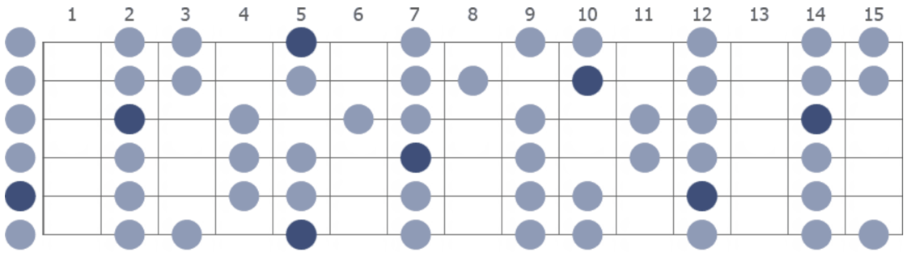

Dark Hollow (A)
Bob used capo 2nd fret. Jerry played in open position.
Intro =Verse
Verse 1 A E A D A
I’d rather be in some dark hollow where the sun don't ever shine
A⁷ D A E A
Then to be in some big city in a small room with a girl on my mind

Chorus So blow your whistle freight train
Take me far on down the track
I'm going away, I'm leaving today
I'm going but I ain't coming back

Lead=Verse

Verse 2 I’d rather be in some dark hollow where the sun don't ever shine
Then to see you as another man's darling
And to know you will never be mine (Chorus)

Lead=Verse

Verse 3 I’d rather be in some dark hollow where the sun don't ever shine
Then to be home alone knowing that you're gone
Would cause me to lose my mind

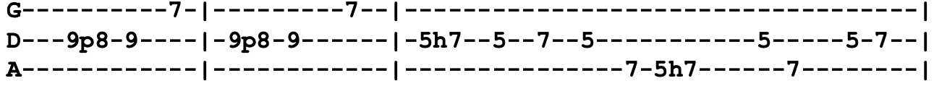
Chorus (repeat last two lines "I'm going away...")
Dark Star (D)
Intro Riff
Intro A E^{m7=x22030}
A^{=x07650} E^{m7=075400} G^{sus4=xx578x} D^{=x047xx} (These are Bob's chords over A E^{m7} groove)
Verse 1 A E^{m7=x22030}A E^{m7} A E^{m7} A E^{m7}
Dark star crashes, pouring its light into ashes
E^{m7} A E^{m7} A E^{m7} A E^{m7}
Reason tatters, the forces tear loose from the axis
A E^{m7} A E^{m7} A E^{m7} A
Searchlight casting for faults in the clouds of delusion
Chorus A A^{sus4} A Em
` Shall we go, you and I while we can
A A^{sus4} A Em (Intro Riff)
Through the-e transitive nightfall of diamonds
Verse 2 Mirror shatters in formless reflections of matter
^{(rarely played)} Glass hand dissolving in ice petal flowers revolving
Lady in velvet recedes in the nights of goodbye (Chorus)

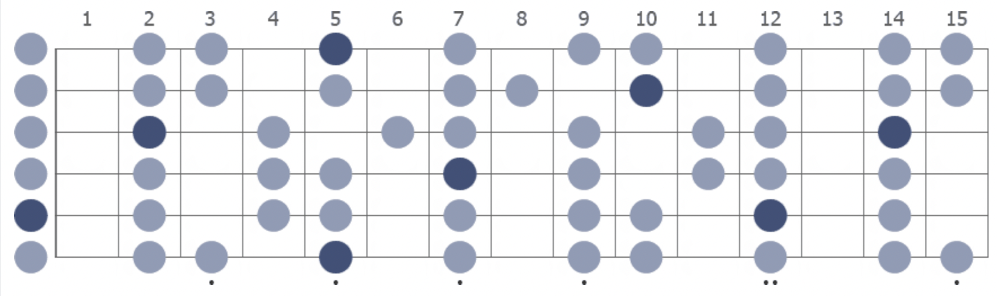
A Mixolydian
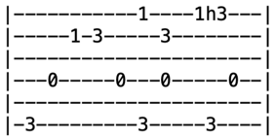
Days Between (G)
Intro Riff
(x4)
Verse 1 G^{sus4=330013} G C G Gm E^{b=x6534x}
There were days and there were days, and there were days between
Dm E^{b} B^{b} F
Summer flies and August dies, the world grows dark and mean
Dm E^{b} Dm E^{b}
Comes the shimmer of the moon on black infested trees
F Gm F Gm
The singing man is at his song, the holy on their knees
C Gm C Gm
The reckless are out wrecking, the timid plead their pleas
Dm E^{b} B^{b} F E^{b} (Intro Riff x4)
No one knows much more of this than anyone can see, one can see
Verse 2 There were days and there were days, and there were days besides
When phantom ships with phantom sails set to sea on phantom tides
Comes the lightning of the sun on bright unfocused eyes
The blue of yet another day, a springtime wet with sighs
A hopeful candle lingers in the land of lullabies
Where headless horsemen vanish with wild and lonely cries, lonely cries

Verse 3 There were days and there were days, and there were days I know
When all we ever wanted was to learn and love and grow
Once we grew into our shoes we told them where to go
Walked halfway around the world on promise of the glow
Stood upon a mountain top, walked barefoot in the snow
Gave the best we had to give, how much we'll never know, never know
Lead=Verse
Verse 4 There were days, there were days, there were days between
Polished like a golden bowl, the finest ever seen
Hearts of summer held in trust, still tender, young and green
Left on shelves collecting dust not knowing what they mean
Valentines of flesh and blood, soft as velveteen
Hoping love would not forsake the days that lie between, lie between
Outro Jam in G^{sus4}
Deal (D)

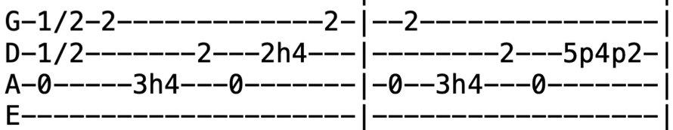
Intro Riff
(x8)
Verse 1 A C^{#7} F^{#m} A^{/E} D⁷ D^{#dim7=xx1212}
Since it costs alot to win and even more to lose
A F# B D
You and me bound to spend some time, wondering what to choose
A C^{#7}
Goes to show, you don't ever know
F^{#m} A^{/E} D⁷ D^{#dim7}
Watch each card you play and play it slow
Chorus A G D
Wait until that deal come 'round
Don't you let that deal go down, oh no

Verse 2 I been gambling hereabouts for ten good solid years
If I told you 'bout all that went down
It would burn off both of your ears
Goes to show, you don't ever know
Watch each card you play and play it slow (Chorus)
Lead=Verse

Verse 3 Since you poured the wine for me and tightened up my shoes
I hate to leave you sitting there composing lonesome blues
Goes to show, you don't ever know
Watch each card you play and play it slow (Chorus)
Verse 1
Chorus (x3)
Outro Don't you let that deal go down (x8)

Jam A G D
Dear Mr. Fantasy (C) riff
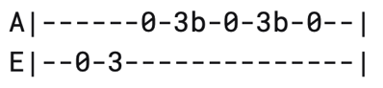
Intro=Verse
Verse 1 G F
Dear Mr. Fantasy, play us a tune
C G (riff)
Something to make us all happy
Do anything, take us out of this gloom
Sing a song, play guitar, make it snappy

Verse 2 You are the one who can make us all glad
But doing that, you break out in tears
Please don't be sad if it was a straight life you had
We wouldn't have known you all these years

Jam Em G (x3)
F D7

Lead=Verse
Verse 1

Verse 2

Lead=Verse

Occassionally (e.g. 9/7/85, 4/14/88) they would sing the Hey Jude outro
Outro G F C G
Na na na, na na na na, na na na na, Hey Jude
Dear Prudence (C)
Intro C C^{7=x3231x} C^{6=x3221x} C^{aug=x3211x}
Verse 1 C C⁷ C⁶ C^{aug} C C⁷ C⁶ C^{aug}
Dear Prudence, won't you come out to play
Dear Prudence, greet the brand new day-ay-ay
C C^{/Bb=x855xx} C^{/A=x755xx} C^{aug/G#= x655xx}
The sky is blue, the birds will sing, that you are part of everything
C B^{b} F C C⁷ C⁶ C^{aug} C C⁷ C⁶ C^{aug}
Dear Prudence, won't you come out to play

Verse 2 Dear Prudence, open up your eyes
Dear Prudence, see the sunny skies
The wind is low, the birds will sing
That you are part of everything
C B^{b} F C
Dear Prudence, won't you open up your eyes?

Bridge C F G F
Look around 'round 'round, look around 'round 'round
Look around 'round 'round
Look around 'round 'round, look around 'round 'round
C F G F G^{#7} G⁷ F^{#7}
Look around 'round 'round
Verse 3 Dear Prudence, let me see you smile
Dear Prudence, like a little child
The clouds will be a daisy chain
So let me see you smile again
Dear Prudence, won't you let me see you smile?
Bridge
Lead=Intro

Death Don't Have No Mercy (Em)
The lyrics for this song varied regularly.
Intro Em
Verse 1 Em G B⁷ Em
^{(Jerry)} Death don't have no mercy in this land
G Am D⁷ G B⁷
Death don't have no mercy in this land, in this land
Em
Come to your house, you know it don't take long
Am C
Look in the bed, find your mother gone
Em G B⁷ Em
Death don't have no mercy in this land
Verse 2 Death don't take no vacation in this land
^{(Bobby)} Death don't take no vacation in this land, in this land
Come to your house, you know he don't take long
Look around the room, find your brothers and sisters will be gone
Death don't have no mercy, no mercy, in this land

Lead=Verse

Verse 3 Death will leave you standing and crying in this land
^{(Brent)} Death will leave you standing and crying in this land, in this land
Come to your house, you know it don't take long
You look in bed, find your mother gone
Death don't, death don't have no mercy in this in this land
Verse 4 Death don't have no mercy in this land
^{(everyone)} Death don't have no mercy in this land, in this land
Come to your house and it don't take long
You wake up one morning, everybody be gone
Death don't have no mercy in this land
Deep Elem Blues (E)
Initially in Key of A (1970 acoustic sets) followed by 7 year hiatus, and then reemerged in 1978 in Key of E. The verses of this song are fluid and every version has a different order, some verses omitted.
Verse 1 E
When you go down to Deep Elem, have a little fun
Have your ten dollars ready when that police man comes
Chorus A E
Oh, sweet mama, daddy's got them Deep Elem Blues
B A
Oh, sweet mama, your daddy's got them Deep Elem Blues

Verse 2 When you go down to Deep Elem, put your money in your shoes
The women in Deep Elem got them Deep Elem Blues (Chorus)
Lead=Verse ¢ Chorus
Verse 3 Once I knew a preacher, preached the bible through and through
Went down to Deep Elem, now his preaching days are through (Chorus)
Verse 4 Once I had a girlfriend, she meant the world to me
Went down to Deep Elem, now she ain't what she used to be (Chorus)
Lead=Verse ¢ Chorus
Verse 1

Chorus
Verse 5 When you go down to Deep Elem, put your money in your pants
The women in Deep Elem, they don't give a man a chance (Chorus)
Verse 6 When you go down to Deep Elem, put your money in your socks
The women in Deep Elem, they'll put you on the rocks (Chorus)
Desolation Row (E)
Intro E E^{sus4} E (x8)
Verse 1 E A E
They're selling postcards of the hanging, they're painting the passports brown B A E E^{sus4} E
The beauty parlor is filled with sailors, the circus is in town
In walks the blind commissioner, they've got him in a trance
One hand is tied to the tight-rope walker, the other is in his pants
A E A
And the riot squad they're restless, they need somewhere to go
E B A E E^{sus4} E E^{sus4} E
As Lady and I look out tonight on Desolation Row
Verse 2 Cinderella, she seems so easy. “It takes one to know one,” she smiles
And puts her hands in her back pockets Bette Davis style
In walks Romeo, he's moaning, “You belong to me I believe”
And someone says, “You're in the wrong place, my friend, you better leave” And the only sound that's left after the ambulances go
Is Cinderella sweeping up on Desolation Row
Verse 3 Now, the moon is almost hidden, the stars are beginning to hide
The fortune telling lady has already taken all her things inside
All except for Cain and Abel and the hunchback of Notre Dame
Everybody is making love or else expecting rain
And the good Samaritan he's dressing, he's getting ready for the show
He's going down to the carnival tonight on Desolation Row
Verse 4 Now, Ophelia, she's 'neath the window, for her I feel so afraid
On her twenty-second birthday she already is an old maid
To her, death is quite romantic, she wears an iron vest
Her profession's her religion, her sin is her lifelessness
And though her eyes are fixed upon Noah's great rainbow
She spends her time peeking into Desolation Row
Verse 5 Einstein disguised as Robin Hood with his memories in a trunk
Passed this way an hour ago with his friend, a jealous monk
He looked so immaculately frightful as he bummed a cigarette
As he went off sniffing drainpipes and reciting the alphabet
You would not think to look at him, he was famous long ago
For playing the electric violin on Desolation Row (Lead=Verse)
Desolation Row (page 2)
Verse 6 Dr. Filth, he keeps his world inside of a leather cup
But all his sexless patients they're all trying to blow it up
Now, his nurse, some local loser, she's in charge of the cyanide hole
She also keeps the cards that read, “Have mercy on his soul”
They all play on the penny whistles, you can hear then blow
If you lean your head out far enough from Desolation Row
Verse 7 Across the street they've nailed the curtains, they're getting ready for the feast
Phantom of the Opera, the perfect image of a priest
They're spoonfeeding Casanova to get him to feel more assured
Then they'll kill him with self-confidence after poisoning him with words
And the Phantom's shouting to skinny girls,“Get out of here if you don't know”
Casanova is just being punished for going to Desolation Row
Verse 8 Now, at midnight all the agents and the superhuman crew
They go and round up everyone who knows more than they do
They take them to the facory where the heart attack machine
Is strapped across their shoulders, and then the kerosene
Is brought down from the castles by insurance men who go
Make sure that nobody is escaping to Desolation Row (Lead=Verse)
Verse 9 Praise be to Nero's Neptune, the Titanic sails at dawn
Everybody's shouting, “Which side are you on?”
Ezra Pound and T.S.Eliot, they're fighting in the captain's tower While calypso singers laugh at them and fishermen throw flowers
Between the windows of the sea where lovely mermaids flow
No one has to think too much about Desolation Row
Verse 10 Yes, I received your letter yesterday about the time the doorknob broke
When you asked how I was doing, was that some kind of joke?
All these people that you mentioned, yes I know them, they're quite lame
I had to rearrange their faces and give them all another name
Right now I can't read so good, don't send me no more letters, no
Not unless you mail them from Desolation Row
Dire Wolf (C)
Played in Key of E (Workingman's Dead) for first seven years. On 11/5/77, moved to Key of C where it remained

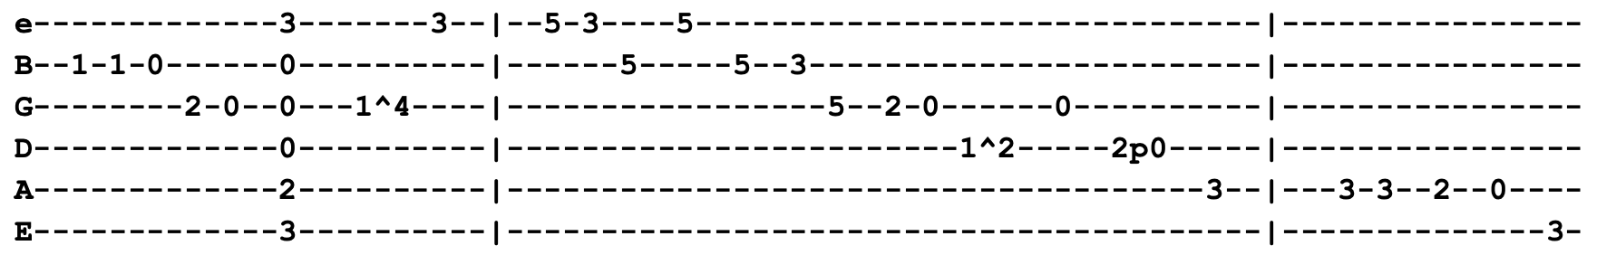
Intro C G F C

Verse 1 G B^{b} F
In the timbers of Fennario, the wolves are running 'round
G
The winter was so hard and cold, froze ten feet 'neath the ground
Chorus 1 F G C ¢ F G F C
Don't murder me, I beg of you don't murder me, please don't murder me

Verse 2 G B^{b} F
I sat down to my supper, 'twas a bottle of red whisky
C ¢ Am
I said my prayers and went to bed, that's the last they saw of me
Chorus 2 G F C E7 Am G F C
Don't murder me, I beg of you don't murder me, please don't murder me

Bridge 1 Am G C B^{b} F
When I awoke the Dire Wolf, six hundred pounds of sin
G
Was grinning at my window, all I said was, “Come on in” (Chorus 2)
Bridge 2 Am G C B^{b} F
The wolf came in, I got my cards, we sat down for a game
G
I cut my deck to the Queen of Spades but the cards were all the same
Chorus 2
Lead=Verse ¢ Chorus 1

Verse 3 In the backwash of Fennario, the black and bloody mire
The Dire Wolf collects his dues while the boys sing 'round the fire
Chorus 1 ¢ Chorus 2 (repeat last line "please don't murder me")
Don't Ease Me In (E)

Intro E A E A E A E
Chorus E B
Don't ease, don't ease, don't ease me in
A G^{#m} F^{#m} B E A E
I've been all night long coming home, don't ease me in

Verse 1 E B
I was standing on the corner talking to Miss Brown
E
When I turned around, sweet mama, she was way across town
So I'm walking down the street with a dollar in my hand
I've been looking for a woman, sweet mama, ain't got no man (Chorus)

Lead=Verse

Verse 2 The girl I love, she's sweet and true
The dress she wears, sweet mama, it's pink and blue
She brings me coffee, she brings me tea
She brings me 'bout every damn thing but the jailhouse key (Chorus)

Lead=Verse

Chorus
Don’t Let Go (A)

Intro A D A
Verse 1 A D A
Hear that whistle, it's six o'clock (don’t let go, don’t let go)
Come on, baby, it's time to rock (don’t let go, don’t let go)
I'm so happy to have you here (don’t let go, don’t let go)
Keeps me grinning from ear to ear (don’t let go, don’t let go)
Chorus D A
Oooo we, this feeling's killing me
Aww shucks, I wouldn't stop for a million bucks
I love you so, just hold me tight and don't let go (don’t let go, don’t let go)
Hold me tight and don't let go (don’t let go, don’t let go)
Verse 2 Thunder, lightning, wind, and rain (don’t let go, don’t let go)
Love is pounding inside my brain (don’t let go, don’t let go)
I'm so eager, I'm nearly dying (don’t let go, don’t let go)
You been keeping your lips from mine (don’t let go, don’t let go) (Chorus)
Vocal Jam Hold me tight and don't let go (x8) (don’t let go, don’t let go)
Jam in A
Verse 3 Hound dog barking upside the hill (don’t let go, don’t let go)
Love is dragging him through the mill (don’t let go, don’t let go)
If it wasn't for having you (don’t let go, don’t let go)
I'd be barking and crying too (don’t let go, don’t let go) (Chorus)
Verse 4 Someday, baby, I'll get you yet (don’t let go, don’t let go)
I'd be crying and soaking wet (don’t let go, don’t let go)
One thing, baby, I'll never stand (don’t let go, don’t let go)
Your lips kissing some other man (don’t let go, don’t let go) (Chorus)
Vocal Jam Hold me tight and don't let go (x8) (don’t let go, don’t let go)
Don't Need Love (D)
Intro D D^{sus2} D G D
D D^{sus2} D Bm
Verse 1 D D^{sus2} D Bm D D^{sus2} D G D
I don't need love anymore
I don't need love anymore
G A F^{#m} G
I don't need anyone to tell me that I do
A D D^{sus2} D G D
I don't need love and I don't need you
Verse 2 I try and I try to make it work
I try and I try to make it work
I try and I try again, I won't forget, I know
Love gets you nowhere slow

Chorus 1 E^{m7} A
I want no more heartaches, I want no more goodbyes (* frequent variations this line)
Ain't no more real good love, only new love, but old love dies

Lead=Verse (solo in D Major)
Verse 3 Ain't worth the time, the time that it takes
Ain't worth the time, the time that it takes
Ain't worth the endless hours, of changes I go through
I don't need love and I don't need you

Chorus 2 Ain't no more heartaches, no more goodbyes
Ain't no more real good love, only new love but old love dies

Verse 2

Verse 1
Dreadful Wind and Rain (E)
Intro E
Verse 1 E A D A E
There were two sisters came walking down the stream, oh, the wind and rain
A Bm C^{#m} D E
The one behind pushed the other one in, crying, oh the dreadful wind and rain

Verse 2 Johnny gave the youngest a gay gold ring (oh, the wind and rain)
Didn't give the oldest one anything (crying, oh the dreadful wind and rain)

Verse 3 Pushed her into the river to drown
And watched her as she floated down (Lead=Verse)

Verse 4 Floated till she came to a miller's pond
Mama oh father there swims a swan

Verse 5 Miller pushed her out with a fishing hook
Drew that fair maiden from the brook

Verse 6 He left her on the bank to dry
And a fingering fool come passing by

Verse 7 Out of the woods came a fiddler fair
Took thirty strands of her long yellow hair

Verse 8 And he made a fiddle bow of her long yellow hair
And he made a fiddle bow of her long yellow hair

Verse 9 He made fiddle pegs of her long finger bones
He made fiddle pegs of her long finger bones

Verse 10 Then he made a little fiddle out of her brass bow
Whose sound could melt a heart of stone

Verse 11 And the only tune that fiddle would play
The only tune that fiddle would play was oh the... (Lead=Verse)

Drifting Too Far From the Shore (G) 3/4 Time
Jerry 10-31-87 played it in G | Old and In the Way played it in Bb
Verse 1 G D G (riff)
Out on the perilous deep
D G
Where danger silently sleeps
C
And storms so violently sweep
G D G (riff)
You're drifting too far from the shore
Chorus C G
Drifting too far from the shore
D G
You're drifting too far from the shore
C
Come to Jesus today, let him show you the way
G D G (riff)
You're drifting too far from the shore

Verse 2 Today the tempest rose high
And clouds overshadow the sky
Sure death is hovering nigh
You're drifting too far from the shore (Chorus)

Verse 3 Why meet a terrible fate?
Mercies abundantly wait
Turn back before it's too late
You're drifting too far from the shore (Chorus)

Drink Up and Go Home (A) 3/4 Time
Intro A D E A
Verse 1 A
You sit there a-crying, crying in your beer
D E
You say you got troubles, my friend listen here
Chorus D A
Don't tell me your troubles, I got enough of my own
D E A
Be thankful you're living, drink up and go home

Verse 2 I'm fresh out of prison
Six years in the pen
Lost my wife and family
No one to call friend (Chorus)

Lead=Verse ¢ Chorus
Verse 3 Now, there stands a blind man
So blind he can't see
Do you think he's complaining?
Why should you or me? (Chorus)

Dupree's Diamond Blues (E)
Intro=Verse (begin with G → E)
Verse 1 E Am D G G ¢
When I was just a little young boy, Papa said son, you'll never get far
E Am D C Cm D G
I'll tell you the reason if you want to know, 'cause child of mine, there isn't really very far to go
Verse 2 Baby, baby wants a gold diamond ring, wants it more than most any old thing
Well, when I get those jellyroll blues
Why I'd go and get anything in this world for you
Verse 3 Down to the jewelry store packing a gun, wrap it up, I think I'll take this one
“A thousand dollars, please”, the jewelry man said
Dupree, he said, “I'll pay this one off to you in lead”
Chorus G D C G
Well you know son, you just can't figure
Am D^{7sus4} D⁷ D^{7sus2} G
First thing you know you're gonna pull that trig- ger
G→ E Am D G ¢
And it's no wonder your reason goes bad, Jellyroll will drive you stone-mad
Lead=Verse
Verse 4 Judge said, “Son, this gonna cost you your time”
Dupree said, “Judge, you know that crossed my mind”
Judge said, “Fact, it's gonna cost you your life”
Dupree, he said, “Judge, you know that seems to me to be about right”
Verse 5 Baby, baby's gonna lose her sweet man, Dupree comes out with a losing hand
Baby's gonna weep it up for a while, then go out
Find another sweet man's gonna treat her with style
Verse 6 Judge said, “Son, I know your baby well, but that's a secret I can never tell”

Dupree said, “Judge, well, it's well understood
And you got to admit that sweet, sweet, jelly's so good” (Chorus)
Lead=Verse
Verse 7 Same old story, I know it's been told, some like jelly jelly, some like gold
Many a-man's done a terrible thing just to get baby a shiny diamond ring
Lead=Verse (repeat last melodic figure 4x)
Outro C Cm D G
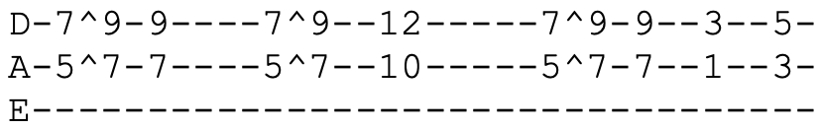
Easy to Love You (G) Intro Riff
Note: for the first year the lyrics were signficantly different then remainder of life
Intro D⁵ E⁵ D⁵ E⁵ G⁵ | D⁵ E⁵ B^{bmaj7=x13231} F^{maj9=xx3553}
(note: D and Em are one bar of 3/4 time)
Verse 1 C G D Em C G D G
Good, good morning, so good to see you, weren't just a dream of mine
C G D Em C G D
Real as a raven, real as thunder, real as the sun shining
Chorus C G C G
But still so very undefined
C D Bm C D G
I can't imagine, what's behind those sleepy eyes
D D7 B^{bmaj7=x13231} F^{maj9=xx3553}
Oooo, ooo, ooo, ooo, ooo, ooo, ooo

Verse 2 Little stranger, don't try to hide now, you look so young when you're afraid
There is no danger, but from the Devil, he may want you but I'm in his way
Chorus 2 C G C G
You don't know how, easy it is
C D Bm C D B^{bmaj7=x13231} F^{maj9=xx3553}
You don't know how, easy it is to love you
Interlude D⁵ E⁵ D⁵ E⁵ G⁵ | D⁵ E⁵ G^{/A=5x543x} A^{/B=7x765x}
D⁵ E⁵ D⁵ E⁵ G⁵ | B^{bmaj7=x13231} F^{maj9=xx3553} G^{/A}
Piano Lead=Verse ¢ Chorus 3
D D7 B^{bmaj7=x13231} F^{maj9=xx3553}
Oooo, ooo, ooo, ooo, ooo, ooo, ooo
Verse 3 And come the moonrise when the dew falls, don't be the sun that fades away
Don't leave me darkness, she is no lover, she hides the day
Chorus 3 C G C G C D Bm C D G
You don't know how, easy it is, you don't know how easy it is to love you
Vocal Jam=Chorus 3 (Brent sings "ooo" over the chords of chorus)
Chorus 3
El Paso (D) 3/4 Time
Verse 1 D G A D
Out in the West Texas town of El Paso, I fell in love with a Mexican girl
Nighttime would fine me in Rose's Cantina, music would play and Felina would whirl
Black as the night were the eyes of Felina, wicked and evil while casting a spell
D G A D D7
My love was strong for this Mexican maiden, I was in love but in vain I could tell
G D D7
One night a wild young cowboy came in, wild as the West Texas wind
D
Dashing and daring, a drink he was sharing with wicked Felina
G A
The girl that I love, so in anger
Verse 2 I challenged his right for the love of this maiden
Down went his hand for the gun that he wore
My challenge was answered in less than a heartbeat
The handsome young stranger lay dead on the floor
Just for a moment I stood there in silence, shocked by the foul evil deed I had done
Many thoughts ran through my mind as I stood there
I had but one chance and that was to run
Out through the back door of Rose's I ran, out where the horses were tied
I picked a good one, he looked like he could run, up on his back and away I did ride
Just as fast as

Verse 3 I could from the West Texas town of El Paso, out thru the badlands of New Mexico
Back in El Paso my life would be worthless, everything's gone in life nothing is left
But it's been so long since I've seen the young maiden
My love is stronger that my fear of death
I saddled up and away I did go, riding alone in the dark
Maybe tomorrow a bullet may find me
Tonight nothing's worse than this pain in my heart, and as last here
Verse 4 I am on the hill overlooking El Paso I can see Rose's Cantina below
My love is strong and it pushes me onward, down off the hill to Felina I go
Off to my right I see five mounted cowboys, off to my left ride a dozen or more
Shouting and shooting, I can't let them catch me, I've got to make it to Rose's back door
Something is dreadfully wrong for I feel, a deep burning pain in my side
It's getting harder to stay in the saddle, I'm getting weary, unable to ride

Verse 5 But my love for Felina is strong and I rise where I've fallen
Though I am weary, I can't stop to rest
I see the white puff of smoke from the rifle, I feel the bullet go deep in my chest
From out of nowhere, Felina has found me, kissing my cheek as she kneels by my side
D G A D G A D
Cradled by two loving arms that I'll die for, one little kiss and Felina goodbye
Estimated Prophet (Bm) 7/4 Time

Verse 1 F^{#m} Bm^{6=x20102}
^{(7/4 Time)} My time coming any day, don't worry about me, no
Been so long I felt this way, I'm in no hurry, no
Rainbows end down that highway where ocean breezes blow
My time coming, voices saying, they tell me where to go
Don't worry about me, nah nah nah, don't worry about me, no
And I'm in no hurry, nah nah nah, I know where to go
Chorus 1 G C G F C
^{(4/4 Time)} (California) Preaching on the burning shore
(California) I'll be knocking on the golden door
(Like an angel) Standing in a shaft of light
(Rising up to paradise) I know I'm gonna shine
Verse 2 My time coming any day, don't worry about me, no
^{(7/4 Time)} It's gonna be just like they say, them voices tell me so
Seems so long I felt this way and time sure passing slow
Still I know I lead the way, they tell me where I go
Don't worry about me, no no no, don't worry about me, no
And I'm in no hurry, no no no, I know where to go
Chorus 2 (California) Prophet on the burning shore (remainder of chorus is same Chorus 1)
Bridge G C G F C
^{(4/4 Time)} You've all been asleep, you would not believe me (oooooh)
Them voices telling me you will soon receive me (ooooooh)
Standing on the beach, the sea will part before me (fire wheel burning in the air)
You will follow me and we will ride to glory (way up, the middle of the air)
Dm E⁷ Dm E⁷
And I'll call down thunder and speak the same, my work fills the sky with flame
Might and glory gonna be my name, men gonna light my way
Interlude Dm F A Bm Dm Am Cm Gm B^{bm} Fm F# B^{dim7} (4/4 Time)
Lead=Chorus
Vocal Jam F^{#m} Bm^{6=x20102}
My time coming any day, don't worry about me, no
Been so long I felt this way, time sure passing slow
Seems so long I felt this way, I ain't in no hurry no
My time coming any day, don't worry about me, no
Don't worry about me no, no no no (x4)
Jam in F^{#m}

Eyes of the World (A)
Intro E^{maj7=079890} E^{6=x76650} E^{maj7=x764xx}
Verse 1 E^{maj7} A E^{maj7} Bm A
Right outside this lazy summer home
You ain't got time to call your soul a critic no
C^{#m} B A
Right outside the lazy gate of winter's summer home
C^{#m} B D A
Wondering where the nuthatch winters, wings a mile long
E A E A C
Just carried the bird away
Chorus G C G C
Wake up to find out that you are the eyes of the world
G C G C C#
Heart has its beaches, its homeland, and thoughts of its own
D C G C
Wake now, discover that you are the song that the morning brings
G C D Bm A
Heart has its seasons, its evenings and songs of its own

Lead E^{maj7} (solo in E Major Pentatonic) Bm (solo in A Major, E Mixolydian or B Dorian) (x16ish)
Verse 2 There comes a redeemer, he slowly too fades away
Follows a wagon behind him that's loaded with clay
Seeds that were silent all burst into bloom and deca-ay
Night comes so quiet, it's close on the heels of the day (Chorus)

Lead E^{maj7} Bm A (x16ish)
Verse 3 Sometimes we live no particular way but our own
Sometimes we visit your country and live in your home
Sometimes we ride on your horses, sometimes we walk alone
Sometimes the songs that we hear are just songs of our own (Chorus)
Far From Me (D)
Intro D⁷ G A D D^{sus4} D
Verse 1 D A
You say you want to try again
D A
Wear it down between the lines, well I have a better end in mind
G A
It doesn't seem you really have to
D D^{maj7=xx0222} C^{/D=xx0020} G
Close your eyes to see
F^{#sus4} F# Bm A G G⁶⁼³²²⁰⁰⁰ G Em A
Though I know you don't mean to be, you are so far from me
Intro
Verse 2 There was something I had caught inside
Screaming hard to make it known, well in time it died alone
G A D D^{maj7} C^{/D} G
It doesn't seem you really have to close your eyes to see
F^{#sus4} F# Bm A G
You have been, all you'll be to me
Bm Bm^{/Bb} Bm^{/A} Bm A
It's just too late and we can't relate at all
Lead=Verse (first half of verse, D and A)
Verse 1 It doesn't seem you really have to close your eyes to see
^{(2nd half)} Though I know you don't mean to be, you are so far from me
Bridge G A D G
This time's the last time I want to say so long (so long oooo)
This song's my last song for you
There's just nothing here to hold on to, baby (hold on to)
Nothing to hold on to

Lead=Bridge (Bobby and Brent sing the ooooo's during the lead, the final turn around lands on the Intro Riff. Or, Brent would sing Bridge once more after end of Intro Riff)

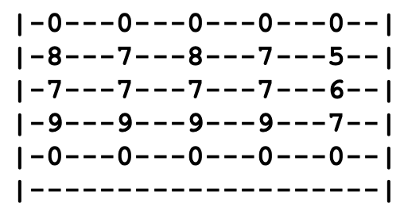
Feel Like A Stranger (Bm)
Intro G^{/A=x09780} A^{=x07650}
(x4)

Verse 1 A G A A G A
Inside you're burning, I can see clear through

Your eyes tell more than you mean them to

Lit up and flashing like the reds and blues

Out there on the neon avenue, but I
Chorus C#m B C#m C#m B C#m C#m B D
Feel like a stranger, feel like a stranger

Jam A7^{sus4} A (x2) (solo in A Mixolydian)
Verse 2 Well, the music's thundering, we're restless and hot
You keep firing glances across the room
I can't stop wondering just what you got
Get the feeling I'm going to find out real soon, but still I (Chorus)
Instrumental A7^{sus4} A
Bridge D D# E7^{#9=076780} D^{sus4=xx0233}
You know it's gonna get stranger, so let's get on with the show
Instrumental A7^{sus4} G^{maj7} F^{#m7} Em⁷ (x4)
Verse 3 Yes and the wheel get smoking round midnight
You show me a look that says, “Let's go”
Yes and it feels about like running a red light
Now there ain't no point in looking behind us, no
Chorus 2 Still I (feel like a stranger) I feel like a, feel like a stranger, like a stranger
Instrumental A7^{sus4} A D D#
Bridge 2 E7^{#9=076780} D^{sus4=xx0233}
You know it's gonna get stranger, if it's love then how would I know?

Feel Like A Stranger (page 2)
Vocal Jam C^{#m} B C^{#m}
How would I know? How would I know?
This be love now, how would I know?
(Feel like a stranger) stranger / like a stranger / how would I know
(Feel like a stranger) Gonna be a long, long, crazy night (x8)
Silky silky crazy crazy night
Jam in C#m (at conclusion of jam, play riff x number of times)
Outro C^{#m} Bm C^{#m} C^{#m} Bm A (x4)
A F^{#m} C^{#m} Bm C^{#m}
Fire On the Mountain (E) B Mixolydian A Lydian
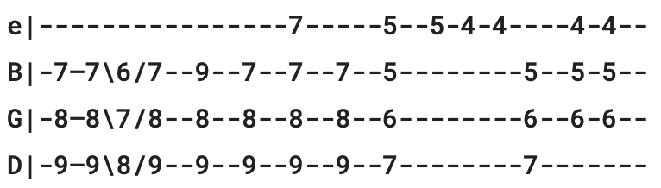
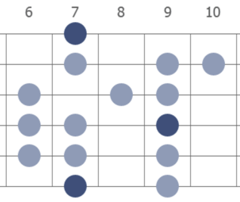
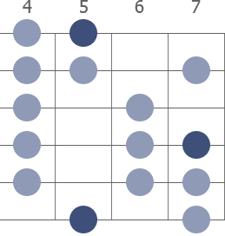
Jerry regularly mixed words from verses
Intro

Verse 1 B A
Long distance runner, what you standing there for?
Caught in slow motion in a fall to the door
You're playing cold music on the barroom floor
Drowned in your laughter and dead to the core
There's a dragon with matches that's loose on the town
Take a whole pail of water just to cool him down
Chorus Fire, fire on the mountain (x4)
Lead (B Mixolydian over B, A Lydian over A)

Verse 2 Almost ablaze, still you don't feel the heat
Takes all you got just to stay on the beat
You say it's a living, we all gotta eat
But you're here alone, there's no one to compete
If mercy's in business, I wish it for you
More than just ashes when your dreams come true, well (Chorus ¢ Lead)
Verse 3 Long distance runner, what you holding out for?
Caught in slow motion in a dash for the door
The flame from your stage has now spread to the floor
You gave all you had why you wanna give more?
The more that you give, the more it will take
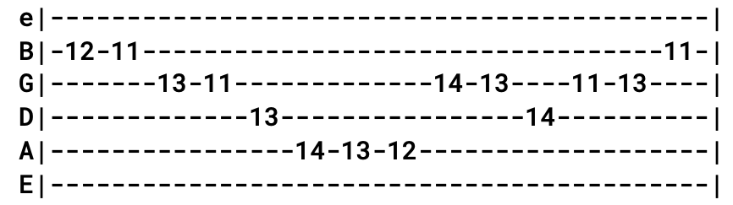
To the thin line beyond which you really can't fake (Chorus x2 ¢ Lead)
Outro Riff (x4)

Foolish Heart (A)
Intro Riff A A^{sus4} (x8)
Verse 1 Bm D F^{#m}
Carve your name, carve your name in ice and wind
Bm D A E D
Search for where, search for where the river ends or where the river starts
E F^{#m}
Do everything that's in you, you feel to be your part
Bm Bm^{7/A=x00432} G^{maj7=xx5432} D A D (Intro riff x4)
Never give your love my friend, unto a foolish heart, unto a foolish heart
Verse 2 Dare to leap, leap from ledges high and wide
Learn to speak, speak with wisdom like a child directly to the heart
Crown yourself the "King of Clowns" or stand way back apart
Never give your love my friend unto a foolish heart, unto a foolish heart
Verse 3 Shun a friend, shun a brother and a friend
Never look, never look around the bend or check the weather charts
Sign the Mona Lisa with a spraycan, call it art A A#
But never give your love my friend unto a foolish heart, unto a foolish heart
Break B^{sus4} B B^{sus4} B
A foolish heart will call on you, toss your dreams away
Then turn around and blame you for the way you went astray
G^{#m} C^{#m7-5=x42100}
A foolish heart will cost you sleep and often make you curse
F^{#7sus4=xx4420} F^{#7} F^{#7sus4} F^{#7-9=212020}
A selfish heart is trouble but a foolish heart is worse
Lead D E (x8)
Verse 4 Bite the hand, bite the hand that bakes your bread
Dare to leap where the angels fear to tread till you are torn apart
Stoke the fires of paradise with coals from hell to start
But never give your love my friend unto a foolish heart, unto a foolish heart
Outro (Intro riff and chords, sing "unto a foolish heart" and then jam)
Unto a foolish heart (x4)

Forever Young (D)
Key of D | Dylan=D | Jerry=E
Intro D D^{sus4=xx0233}

Verse 1 D
May God bless and keep you always
F^{#m}
May your wishes all come true
Em G D
May you always do for others and let others do for you
D
May you build a ladder to the stars
F^{#m}
And climb on every rung
Em A D D^{sus4} D
May you stay forever young

Chorus A A⁷ Bm
Forever young, forever young
D A⁷ D
May you stay forever young

Verse 2 May you grow up to be righteous, may you grow up to be true
May you always know the truth and see the lights surrounding you
May you always be courageous, stand upright and be strong
May you stay forever young

Chorus

Verse 3 May your hands always be steady, may your feet always be swift
May you have a strong foundation when the winds of changes shift
May your heart always be joyful, may your song always be sung May you stay forever young

Chorus (x2)
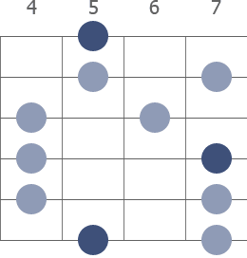
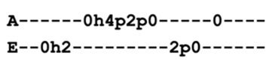
Franklin's Tower (D) Riff at end of line
Verse 1 A G D G
In another time's forgotten space
Your eyes looked from your mother's face A Maj Pentatonic
Wildflower seed on the sand and stone
May the four winds blow you safely home
Chorus Roll away, roll away the dew (x4)
Lead (solo in A Major Pentatonic)
Verse 2 I'll tell you where the four winds dwell
In Franklin's Tower there hangs a bell
It can ring turn night to day
Ring like fire when you loose your way (Chorus ¢ Lead)
Verse 3 God save the child that rings that bell
It may have one good ring, baby, you can't tell
One watch by night, one watch by day
If you get confused listen to the music play (Chorus ¢ Lead)
Verse 4 Some come to laugh their past away
Some come to make it just one more day
Whichever way your pleasure tends
If you plant ice you're gonna harvest wind (Chorus ¢ Lead)
Verse 5 I'll tell you where the four winds sleep
Like four lean hounds the lighthouse keep
Wildflower seed on the sand and wind
May the four winds blow you home again (Chorus x2 ¢ Lead)


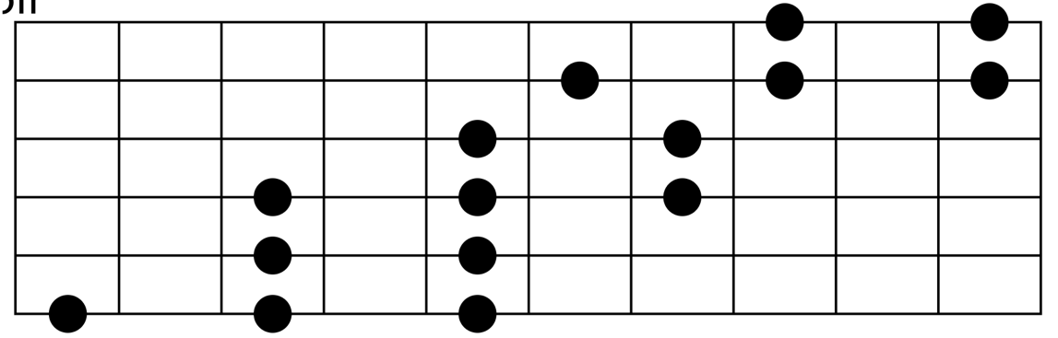
A Major Pentatonic (sliding shape)
5th Fret
Freight Train (C)

Verse 1 C G G⁷
Freight train, freight train, run so fast
G C
Freight train, freight train, run so fast
E F
Please don't tell what train I'm on
C F G C
They won't know what route I'm gone

Verse 2 When I'm dead and in my grave
No more good times here I crave
Place the stones at my head and feet
Tell them all I've gone to sleep

Verse 3 When I die, oh, bury me deep
Down at the end of old Chestnut Street
So I can hear old '99 as she comes rolling by

Verse 4 When I die, oh, bury me deep
Down at the end of old Chestnut Street
Place the stones at my head and feet
Tell them all I've gone to sleep

Verse 1
Friend of the Devil (G)
Intro =Verse
Verse 1 G G^{/F#} G^{/E} G^{/D} C C^{/B} C^{/A} C^{/G}
I lit out from Reno, I was trailed by twenty hounds
Didn't get to sleep that night till the morning came around
Chorus D Am
Set out running but I take my time, a friend of the Devil is a friend of mine
D Am D
If I get home before daylight, I just might get some sleep tonight

Verse 2 Ran into the Devil, babe, he loaned me twenty bills
I spent the night in Utah in a cave up in the hills (Chorus)
Verse 3 I ran down to the levee but the Devil caught me there
Took my twenty dollar bill and vanished in the air (Chorus)
Bridge D
Got two reasons why I cry away each lonely night
C C C#
First one's named sweet Anne Marie, she's my hearts delight
D
Second one is prison, babe, sheriff's on my trail
Am C D
And if he catches up with me I'll spend my life in jail

Verse 4 Got a wife in Chino, babe, one in Cherokee
First one says she's got my child but it don't look like me (Chorus)
Lead=Verse ¢ Chorus
Bridge
Verse 4 ¢ Chorus

Frozen Logger (C) 3/4 Time
Played on 9-7-85 Red Rocks, Bob forgets most of the lyrics
Verse 1 As I sat strolled out one evening within a small cafe
A forty-year old waitress, to me these words did say

Verse 2 I see that you are a logger, and not just a common bum
'Cause nobody but a logger stirs his coffee with is thumb

Verse 3 My lover was a logger, there's none like him today
If you'd pour whiskey on it he could eat a bale of hay

Verse 4 My lover came to see me upon one freezing day
He held me in his fond embrace which broke three vertebrae

Verse 5 He kissed me when we parted, so hard that he broke my jaw
I could not speak to tell him he'd forgot his mackinaw

Verse 6 I saw my lover leaving sauntering through the snow
Going gaily homeward at forty-eight below

Verse 7 The weather it tried to freeze him, it tried its very best
At a hundred degrees below zero, he buttoned up his vest

Verse 8 It froze clear down to China, it froze to the stars above
At a thousand degrees below zero, it froze my logger love

Verse 9 They tried in vain to thaw him, and would you believe me, sir
They made him into axeblades, to chop the Douglas fir

Verse 10 And so I lost my lover, and to this cafe I come
And here I wait till someone stirs his coffee with his thumb

Get Out of My Life (C)
Intro=Verse

Verse 1 C⁷
Get out of my life, woman, I don't love you no more
F C⁷
Get out of my life, woman, I don't love you no more
B^{b} F C⁷
Get out of my life, woman, nothing but heartaches by the score

Verse 2 Get out of my eyes, teardrops, I've got to see my way around (x2)
Get out of my eyes, teardrops, nothing but heartaches by the pound

Verse 1

Lead=Verse (solo in C Major Pentatonic)

Verse 1 ¢ Verse 2

Verse 1 (repeat last line three times and tag it)
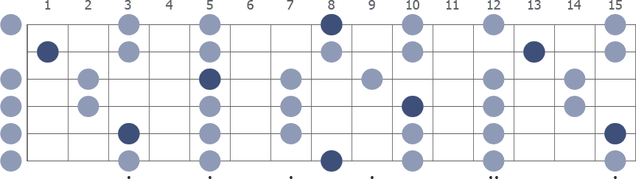

C Major Pentatonic
Gimme Some Lovin' (C)
Intro B^{b} C (x4)
Verse 1 C
Well, my temperature is rising, got my feet on the floor
Many people rocking 'cause they want to go more
Let me in, baby, I don't know what you got
But you better take it easy 'cause this place is hot
Chorus C E^{b} F A^{b} C
And I'm so glad you made it, so glad you made it, you gotta
F C
Gimme some lovin' (gimme, gimme some lovin') (x2)
Gimme some lovin' every day (Intro)
Lead=Verse ¢ Chorus
Verse 2 Well, I feel so good, everybody's getting high
You better take it easy 'cause the place is on fire
Been a hard day and I don't know what to do
Wait a minute, baby, this could happen to you
Chorus
Outro Gimme some lovin' (gimme, gimme some lovin') (x6)

Going Down the Road Feeling Bad (E)
Folk song of unknown origin first appeared in 1923 and had several verses. GD played just two verses.
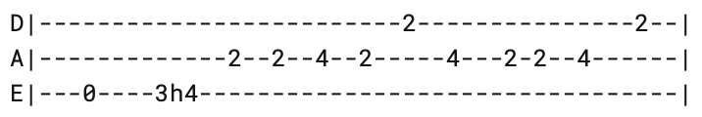
Intro Riff

Chorus E D
Going down the road feeling bad
A E D
Going down the road feeling bad
A E C^{#m}
Going down the road feeling bad, bad, bad
E B E
Don't want to be treated this a-way
Verse 1 Going where the water tastes like wine (x3)
Don't want to be treated this a-way (Chorus)
Lead=Verse (solo in E Major)
Verse 2 Going where the climate suits my clothes (x3)
Don't want to be treated this a-way (Chorus)
Lead=Verse
Chorus (x4)
Outro ("And We Bid You Goodnight" melody)
E B E | A E A B E
D E (x4) | C

Verse 3 (for the first year, up until August 1971, a third verse was sung)
Going where the chilly winds don't blow (x3)
Don't wanna be treated this a way

Golden Road (To Unlimited Devotion) (D)
Intro D
Verse 1 D C
See that girl barefootin' along
G D
Whistling and singing, she's a-carrying on
C
There's laughing in her eyes, dancing in her feet
F C G D
She's a neon bright diamond, she can live on the street
Chorus D C G D
Hey, hey, come right away, join the coming every day (x2)
Verse 2 Well, everybody’s dancing in a ring around the sun
Nobody's finished, we ain’t even begun
So take off your shoes, child, take off your hat
Try on your wings and find out where it's at
Chorus
Lead=Chorus
Verse 3 Take a vacation, fall out for a while
Summers coming in and it's goin out of style
Well, lie down smoking, honey have yourself a ball
'Cause your mothers down in Memphis won't be back till the fall
Chorus (x2)

Gomorrah (G)
Intro B^{b} F F C G (x4)r1
Verse 1 G C^{/G=332010} G7⁼³⁰⁰⁰³¹ G A^{m7=x02010} G^{7/B=x20001} C
Just a song of Gomorrah, I wonder what they did there
G F C B^{b} F F C G
Must've been a bad thing to get shot down for
Verse 2 I wonder how they blew it up or if they burned it down
Get out, get out, Mr. Lott, don't you turn around
Verse 3 Who gave you your orders, someone from the sky?
I heard a voice inside my head in the desert wind so dry
Bridge Bm Em G D
I heard a voice telling me to flee the very same voice I always believe
Bm Am D D^{sus4} D
Say a lot of trouble coming but it don't have to come to you
C G F C B^{b} F F C G
I'm telling you so you can tell the rest what you've been through
Verse 4 But don't you turn around, no, don't look after you
It's not your business how it's done, you're lucky to get through
Lead=Verse
Verse 5 You're a good upstanding man, a credit to the flock
But if you don't face straight ahead, you could not take the shock
Verse 6 Blew the city off the map, left nothing there but fire
The wife of Lott got turned to salt because she looked behind her
Outro G F C B^{b} F F C G
Because she looked behind her (x2)
Gone Home (G) 3/4 Time
Intro G
Verse 1 G G⁷ C G
All of my friends that I loved yesterday
D
Gone home (they have gone home)
G C G
Gone home (they have gone home)
The songbird that sings in the dell seems to say
Gone home (they have gone home) (x2)

Chorus C G
They've joined the heavenly folk
A D
They're walking the streets of pure gold
G C (stop!)
They left one by one as their work here was done
D
Gone home (they have gone home)
G C G
Gone home (they have gone home)
Lead=Verse

Verse 2 Life here is lonely since they've gone before
Gone home (they have gone home) (x2)
The old weeping willow that stands by the door
Gone home (they have gone home) (x2) (Chorus)
Lead=Verse
Verse 1

Chorus
Good Lovin' (C)

Intro C F G F (arpeggiated) (x2)
C F G F G F C F G
Verse 1 C F G F C F G F
Well, I was feeling oh so bad
C F G F C F G F
So I asked my family doctor 'bout what I had
C F G F C F G F
I said now, “Doctor (doctor), Mister MD (doctor)
C F G F C F G F
Oh, can you tell me (doctor), what's ailing me?” (doctor)
C F C F C C F C F C
He said, yeah, yeah, yeah, yeah, yeah (yeah, yeah, yeah, yeah, yeah)
D G (stop!)
All you need, all you, really need

Chorus C F G F
Good love (you gotta have lovin') (x2)
C F G F C F G F G F C F G
Good love (a little good lovin' now baby), good love

Verse 2 So come on baby, oh squeeze me tight
Don't you want your daddy to be alright?
I said now baby (baby), now it's for sure (baby)
I've got the fever (baby), you got the cure (baby)
She said, yeah, yeah, yeah, yeah, yeah (yeah, yeah, yeah, yeah, yeah)
All you need, all you, really need
Chorus
Lead=Verse ¢ Chorus (x2)
Verse 1 ¢ Chorus
Verse 2 ¢ Chorus (x3)
Outro=Intro
Goodnight Irene (C)
Leadbelly’s original was in 3/4 time, but Jerry played it with an upbeat, swinging 4/4 groove
Verse 1 C D⁷ G D⁷ G C
Saturday night I got married, me and my wife settled down
C⁷ F D
Now me and my wife have parted
C G Am G F
Gonna take another walk downtown

Chorus C D⁷ G
Goodnight Irene, goodnight
D⁷ G C
Goodnight Irene, goodnight
C⁷ F D
Goodnight Irene, goodnight Irene
C G Am G F
I'll see you in my dreams
Verse 2 Sometimes I live in the country
Sometimes I live in town
Sometimes I take a fool notion
I'm gonna jump in the river and drown (Chorus)
Lead=Verse
Verse 3 Stop rambling, stop your gambling
Stop staying out late every night
Stay home with your wife and your children
Stay by the fireside bright (Chorus x2)

The Great Pretender (G) 3/4 Time

Intro G D⁷ B⁷ C G D⁷ G

Verse 1 G D G G⁷
Oh, yes I'm the great pretender
C G G⁷
Pretending that I'm doing well
C D G C
My need is such I pretend too much
G D⁷ G
I'm lonely but no one can tell

Verse 2 Oh, yes I'm the great pretender
Adrift in a world of my own
I've played the game but to my real shame
You've left me to grieve all alone

Chorus C G G⁷
Too real is this feeling of make-believe
C G D⁷
Too real when I feel what my heart can't conceal

Verse 3 Oh yes, I'm the great pretender
Just laughin' and gay like a clown
I seem to be what I'm not, you see
I'm wearing my heart like a crown
Pretending that you're still around

Chorus

Greatest Story Ever Told (C)
Intro C F C F C G
Verse 1 C F C F C
Moses come riding up on a quasar
His spurs were jingling, the door was ajar
His buckle was silver, his manner was bold
I asked to come in out of the cold
Am Em C F C
His brain was boiling, his reason was spent
Nothing is borrowed, nothing is lent
C F C F C
I asked him for mercy, he gave me a gun
Now and again, these things just got to be done
Bridge G
Abraham and Isaac sitting on a fence
Am D
You'd get right to work if you had any sense
C F C F C
You know the one thing we need is a left-handed monkey wrench
Break F G C G Dm G C C7 (x2)
Verse 3 Gideon come up with his eyes on the floor
Said, “You ain't got a hinge, you can't close the door”
Moses stood up a full six foot ten
Said, “You can't close the door when the wall's caved in”
Ask him for water, he poured me some wine
We finished the bottle and broke into mine
You get what you come for, ya ready to go
And it's one in ten thousand that come for the show

Bridge 2 Abraham and Isaac digging on a well
Mama come quick with the water witch spell
Cool clear water, well, you can't ever tell
Lead=Break ¢ Verse
Bridge 2
Hard To Handle (B)

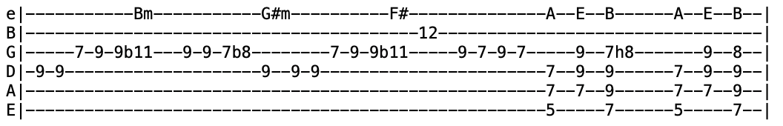
Intro
Verse 1 B⁷
Baby, here I am and I'm a man upon the scene
I can give you what you want but you got to come home with me
I got a whole lot of good ol' loving and I got some in store
When I get through throwing it on, you gotta come back for more

Chorus F#
Boys and things will come by the dozen
Ain't nothing but drug store loving
B
Pretty little thing let me light your candle
A E B (x4)
'Cause mama I'm sure hard to handle now, yes I am
Verse 2 Action speaks louder than words and I'm a man with great experience
I know you got another man but I can love you better than him
Take my hand, don't be afraid, I'm gonna prove every word I say
I'm advertising love for free so won't you place your ad with me?
Chorus
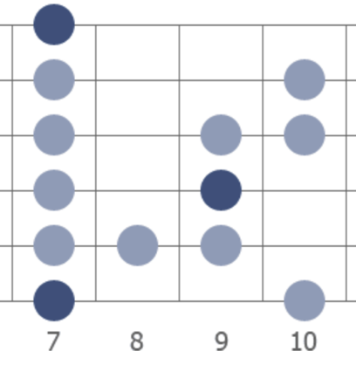
Vocal Jam B⁷
Give it to me... I got to have it... some of your love... it's all I need
Early in the morning... late in the evening (continue with adlib)
Lead B7 (solo in B Blues scale) B Blues Scale
Verse 1 ¢ Chorus
Harder They Come (C)
Intro C G F G | C G F (x2)

Verse 1 G F
They tell me of a pie up in the sky waiting for me when I die
The minute you're born till when you die
They never seem to hear you even your cry

Chorus Em Am
As sure as the sun will shine, I'm gonna get my share of what's mine
G F C
The harder they come, harder they fall, one and all (x2)

Verse 2 The oppressors are trying to keep me down
Trying to drive me underground
Though they think they've got the battle won
I say, “Forgive them, Lord, they know not what they've done” (Chorus)
Intro
Verse 3 And I'll keep on fighting for the things I want
Though I know that when you're dead you can't
I'd rather be a free man in my grave
Than living as a puppet or a slave (Chorus)
Lead=Verse ¢ Chorus
Verse 1 ¢ Chorus
Verse 2 ¢ Chorus
Verse 3 ¢ Chorus (repeat last line)
Outro=Intro
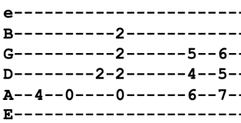
He Ain't Give You None (A) Intro Riff
Intro A A^{b}7 A7 (x4)
Verse 1 D A D A
Little girl, little girl, Lord, you know it's true (x2)
E D
I'd give my life for you, baby A D A
If I thought you could love me the way that I love you
Chorus I've done more for you, than your daddy's ever done (x2)
I give my heart and soul to you, baby
He ain't give you none
Verse 2 And I wonder, are you gonna, are you gonna, let me stand alone?
Are you gonna, are you gonna, let me stand alone?
I caught you early this morning, baby
Before your daddy came home
Chorus

Verse 3 Don't you ever go down, down, down, down, down, on Broadway Street (x2)
Ain't nothing but heartaches there, baby
With the kinda guy you plan to meet
Chorus
Lead (solo in A Major)
Verse 3
Chorus (x2) (after second chorus repeat last line twice)
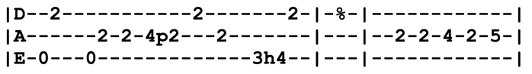
He's Gone (E)
Intro Riff

Verse 1 E A B E
Rat in a drain ditch, caught on a limb, you know better but I know him
Like I told you, what I said, steal your face right off your head
Chorus A E A E E7 A B
Now he's gone, now he's gone. Lord, he's gone, he's gone
A B
Like a steam locomotive rolling down the track
A E E7 A E
He's gone, gone, nothing's gonna bring him back, he's gone

Verse 2 Nine mile skid on a ten mile ride, hot as a pistol but cool inside
Cat on a tin roof, dogs in a pile, nothing left to do but smile, smile, smile
Chorus
Interlude F#m E F#m E E7 A E
Lead=Verse
Break B D A
Going where the wind don't blow so strange
Maybe off on some high cold mountain chain
D A G D Dm
Lost one round but the price wasn't anything, a knife in the back
A B
And more of the same

Verse 1 (Same old...)
Chorus (after singing chorus, repeat last line "like a steam locomotive...")

Vocal Jam (everyone contributes improv vocalizations and words)
Oo-oo, nothing's gonna bring him back (x8)
Jam in E/E⁷
Help on the Way (Fm)
Intro Fm^{=X 8 10 10 9 8} Fm⁼¹³³¹¹¹ (x4)
Verse 1 Fm^{=X 8 10 10 9 8} Cm^{=865xxx}
Paradise waits
Cm^{=xx554x} Cm^{=xx534x} Fm^{=xx331x} Fm^{=xx311x}
On the crest of a wave, her an gels in flames
Fm^{=X 8 10 10 9 8} Cm^{=865xxx} Cm^{=xx554x} Cm^{=xx534x} Fm^{=xx331x} Fm^{=xx311x}
She has no pain, like a child she is pure, she is not to blame
Bb^{9=xx656x} Bb^{9=xx654x} Bb^{9=xx653x} Bb^{9=xx656x} Bb^{9=xx654x} Bb^{9=xx653x}
Poised for flight, wings spread bright
Bb^{9=xx654x} Bb^{9=xx653x} Fm^{=xx311x} Bb^{9=xx878x} Bb^{9= xx876x} Bb^{9= xx654x} B^{bmaj7=xx6543}
Spring from night into the sun
Fm^{=X 8 10 10 9 8} Cm^{=865xxx} Cm^{=xx554x} Cm^{=xx534x} Fm^{=xx331x} Fm^{=xx311x}
Don't stop to run, she can fly like a lie, she can't be outdone

Verse 2 Tell me the cost, I can pay, let me go, tell me love is not lost
Sell everything, without love day to day insanity's king
I will pay day by day, anyway lock, bolt, and key
Crippled but free, I was blind all the time I was learning to see
Lead=Verse (solo in F Dorian)

Verse 3 Help on the way, well, I know only this, I've got you today
Don't fly away 'cause I love what I love and I want it that way
I will stay one more day, like I say, honey it's you
Making it too, without love in a dream it will never come true
F Dorian
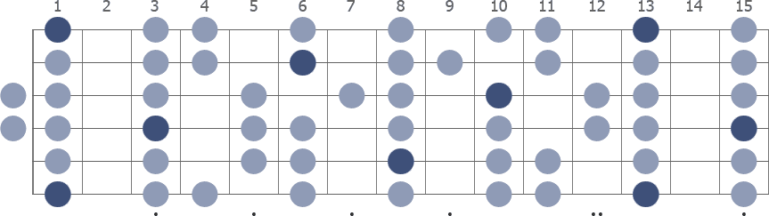
Here Comes Sunshine (C) Intro Lick
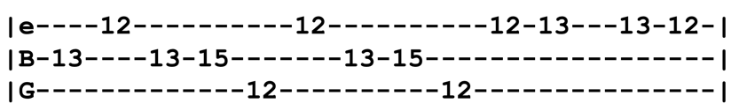
Intro Lick in C (x4)
Verse 1 C B^{b} Dm C G A^{m7=x02010} G^{7=323xxx}
Wake of the flood, laughing water, forty-nine
Get out the pans, don't just stand there dreaming
Get out the way, get out the way
Chorus Am B^{b} C G B^{b} Dm F G G F Em Dm (x4)
Here comes sunshine, here comes sunshine
Intro Lick (x4)

Verse 2 Line up a long shot, maybe try it two times, maybe more
Good to know you got shoes to wear when you find the floor
Why hold out for more? (Chorus)
Lead = Jam in C Mixolydian (70's version)
Verse ¢ Chorus (modern version)

Verse 3 Asking you nice now
Keep the mother rolling one more time
Been down before
You just don't have to go no more, go no more (Chorus)
Jam G F Em Dm
Chorus Am B^{b} C G B^{b} Dm F G ^{(stop!)}
Here comes sunshine, here comes sunshine (x2)
Hey Pocky Way (D)

Intro D C G (x4) (quick turnarounds)
D C G (x4) (verse groove)

Verse 1 D C G
Little bitty boy with a heart of steel
I know you can't boogie now but your sister sure will
Feel good music in your soul
Makes your body wanna rock, wanna rock and roll
Chorus D
Say hey hey hey, hey pocky way
Hey hey, hey pocky way (Intro)

Verse 2 Laugh back grooving in your car
Makes no difference who or where you are
Feel good music in your soul
Makes your body wanna rock, wanna rock and roll (Chorus)
Lead=Verse

Verse 2

Chorus (x2)

Outro D C G (x4) (quick turnarounds)
High Time (E) 3/4 Time
Intro=Verse
Verse 1 D C^{#m} G# F# A
You told me goodbye, how was I to know?
E D A A^{sus4} A You didn't mean goodbye, you meant pleee-ease, don't let me go?
B E B A
I was having a high time
E D A E G A A^{sus4=x00230} A
Living the good life Iiiii, well, I know

Verse 2 The wheels are muddy, got a ton of hay
Now, listen here, baby 'cause I mean what I say
I'm having a hard time
E D A E G
Living the good life Iiiii, well, I know

Bridge F E B C^{#m} E
I was losing time, I had nothing to do, no one to fight, I came to you
F E
Wheels broke down, the leader won't draw
B C^{#m} E D A
The line is busted, the last one I saw
Verse 3 Tomorrow come trouble, tomorrow come pain
Now, don't think too hard, babe, 'cause you know what I'm saying
I could show you a high time
Living the good life, Iiiii, don't be that way

Verse 4 Nothing's for certain, it could always go wrong
Come in when it's raining, go on out when it's gone
We could have us a high time
Living the good life Iiiiii, well, I know
E D A A ¢ E
Living the good life Iiiii, well, I know

How Sweet It Is (C)
Intro C Am G F | C G F C G
C Am G F | C G F C7

Chorus F G C C⁷
How sweet it is to be loved by you
F G C G
How sweet it is to be loved by you

Verse 1 C Am G F
I needed the shelter of someone's arms and there you were
I needed someone to understand my ups and downs, there you were
C F C F
Sweet love and devotion, deeply touching my emotion
C F
I want to stop and thank you, baby
C ^{(stop!)} C⁷
I want to stop and thank you baaa-by (Chorus)
Lead C Am G F | C G F C G

Verse 2 Open my eyes at night
I wonder where I'd be without you in my life
Everything was such a bore
All the things I've done, you know I've done 'em before
You brightened up all of my days
With love so sweet in so may ways
I want to stop and thank you, baby
I want to stop ^{(stop!)} and thank you, baaa-by (Chorus)

Lead C Am G F | C G F C G
Verse 2 ¢ Chorus
Chorus (x2) (with adlibs between lines)
Sweeter than a honey from a bee, baby...
Yes it is, you know it is darling...
Hurts Me Too (A) 6/8 Time
Intro=Verse (Jerry plays melody using slide)3

Verse 1 A
You said you was hurting, almost lost your mind
D
'Cause the man you love hurts you all the time
A E
But when things go wrong, wrong with you
D A D A E
It hurts me too
Verse 2 You love him a little more when you should love him less
Why pick up behind him and take his mess?
'Cause when things go wrong, wrong with you
It hurts me too
Verse 3 You love another man, little girl, you know I love you
But you love him darling, stick to him like glue
But when things go wrong, wrong with you
It hurts me too
Lead=Verse (solo in A Blues Scale)
Verse 4 Well, he'd better leave you, or you best put him down
'Cause you know I just can't stand to see, see you pushed around
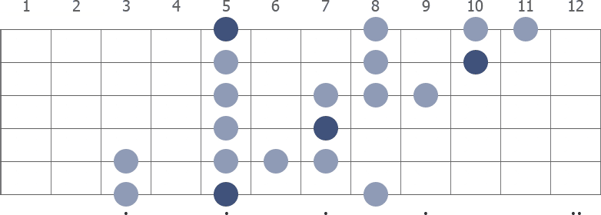
But when things go wrong, wrong with you
It hurts me too
A Blues Scale
I Ain't Never (E)
Intro E
Verse 1 A E
Well, I ain't never, I ain't never, seen nobody like you
Oh, no never, have I ever, seen nobody like you
A
Well, you call me up, say you'll meet me at nine
E
I have to hurry hurry but I'm there on time
A
I walk right up, knock on your door
F# B
The landlord says, “She ain't here no more”

Chorus A E
I ain't never, oh darlin', seen nobody like you
We-e-ell, but I love you, yes I love you, I love you just the same
Instrumental=Verse (first two lines only)
Verse 2 Well, I ain't never, I ain't never, seen nobody like you
Oh, no never, have I ever, seen nobody like you
Well, you tell me sweet things that you don't mean
You got me living in a walking dream
You told me things that you don't do
My friends say “Man, what's wrong with you?” (Chorus)
Instrumental=Verse (first two lines only)
Verse 2 (second half only, beginning with "well, you tell me things")
Chorus
I Know You Rider (G)

Chorus D C G D
I know you rider, gonna miss me when I'm gone (x2)
F C F C D
Gonna miss your baby from rolling in your arms

Verse 1 Laid down last night, Lord, I could not take my rest (x2)
My mind was wandering like the wild geese in the west
Lead=Verse (solo in D Mixolydian)

Verse 2 The sun will shine in my back door someday (x2)
^{(Bob)} March winds will blow all my troubles away

Verse 3 I wish I was a headlight on a northbound train (x2)
^{(Jerry)} I'd shine my light through the cool Colorado rain (Chorus)
Lead=Verse
Chorus (acapella)

D Mixolydian
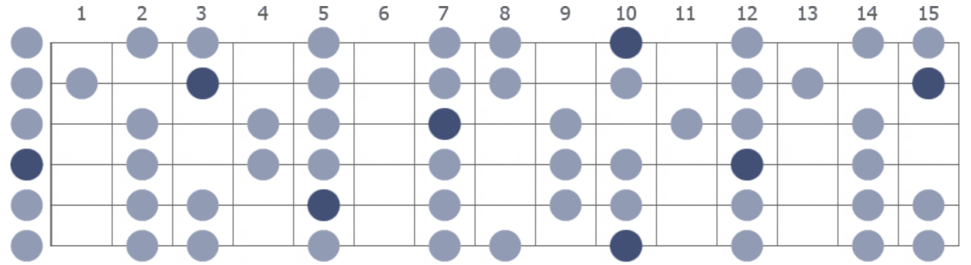
I Need A Miracle (E) Riff
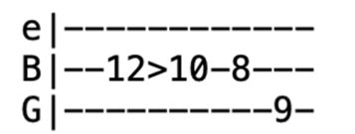
Intro Riff (x4)
Verse 1 E (riff)
I need a woman 'bout twice my age
A lady of nobility, gentility, and rage
Splendor in the dark, lightning on the draw
Who'll go right through the book and break each and every law
A E
I got a feeling and it won't go away, oh no
B E ^{(stop!)}
Just one thing and I'll be ok, I need a miracle every day

Verse 2 I need a woman 'bout twice my height
Statuesque, raven-dressed, goddess of the night
Secret incantations, candle burning blue
We'll consult the spirits, maybe they'll know what to do
And it's real, it won't go away, oh no
Can't get around it and I can't run away, I need a miracle every day

Lead=Verse

Verse 3 I need a woman 'bout twice my weight
A ton of fun who packs a gun with all her other freight
Find her in a sideshow, leave her in L.A.
Ride her like a surfer running on a tidal wave
And it's real, believe what I say, yeah
Just one thing I got to say, I need a miracle every day
Bridge B E
It takes dynamite to get me up, too much of everything is just enough
B E ^{(stop!)} E¢G
One more thing I just got to say, I need a miracle every day
Vocal Jam G
I need a miracle every day (x3) I need a miracle (x2) (repeat)
Jam in G
I Second That Emotion (A)

Intro E D A (x4)

Verse 1 A
Maybe you like to give me kisses sweet
Only for one night with no repeat
Maybe you'll go away and never call
D E A
But the taste of honey is worse than none at all (oh little girl)
Chorus D A D A
In that case I don't want no part, that would only break my heart
E D
Well, if you feel like loving me and if you got the notion
A
I second that emotion
E D
Well, if you feel like giving me a lifetime of devotion
A E D A (x4)
I second that emotion

Verse 2 Maybe you think that love will tie you down
You ain't got the time to hang around
Maybe you think that love will make us fools
So it makes you wise to break the rules (oh little girl) (Chorus)
Lead=Verse ¢ Chorus
Verse 1
Chorus
Outro=Intro

I Shall Be Released (G)
Jerry regularly sang lyrics mixed up from all of the verses. Lyrics below are as Bob Dylan wrote them.
Intro G C G (x4)
Verse 1 G Am Bm
They say everything can be replaced
C G G^{sus4} G
Yet every distance is not near
So I remember every face
Of every man who put me here
Chorus I see my light come shining
From the west down to the east
Any day now, any day now
I shall be released
Lead=Verse
Verse 2 They say every man needs protection
They say every man must fall
Yet I swear I see my reflection
Some place so high above this wall (Chorus)
Verse 3 Standing next to me in this lonely crowd
Is a man who swears he's not to blame
All day long I hear him shout so loud
Crying out that he was framed

Chorus (repeat the last line "any day now")

I Will Take You Home (B)
Intro B B^{sus4} B (x8)
Verse 1 B
Little girl lost in a forest of dreams, it's dark old wood
F#
And it's damp with dew, hoot owl hoots for a moment it seems
E F^{#sus4} F#
Something big and cold has got a hold of you
G^{#m} F# E F^{#sus4} F#
Just when everything gets scary, Daddy's come 'round for his darling again
G^{#m} F# E F^{#sus4} F#
Hold my hand with your little fingers, Daddy's loving arms are gonna gather you in
B F#
Ain't no way the Boogeyman can get you
B
You can close your eyes, the world is gonna let you
E
Your daddy's here and he never will forget you
F^{#sus4} F# B
I will take you home (x2)
G^{#m} E B G^{#m} E B
Gonna carry you back home in my arms, I will take you home (Intro)
Verse 2 Long is the road we must travel on down
Short are the legs that we struggle behind
I wish I knew for sure just where we were bound
What we will be doing, what we're gonna find
Wherever we go there will be birds to cheer you
Flowers to color in the fields around
Wherever we go I'll be right here near you
You can't get lost when you're always found
Ain't no fog thick enough to hide you
Your daddy's gonna be right here, right here beside you
If your fears should start to get inside you
I will take you home (x2) (hold for 3 measures)
Gonna carry you back home in my arms, I willll, take you home
Outro=Intro

I'll Be With Thee (E)
Intro C^{#7} F^{#7} B⁷ E A E B⁷
Verse 1 E
Just like the prodigal son when he was far from home
B⁷
He wanted to go back and tell his father he had done wrong
E E⁷ A
He fell on his knees, the Lord answered his pleas
E C^{#7} B⁷ E
Said “If you go back home I'll go with thee”
Verse 2 Just like the Israelites who were Pharaoh's slaves
They suffered in bondage and they prayed for days
The Lord said, “Moses, go set them free, I am the Lord thy God and I'll go with thee”
Verse 3 Just like old Joshua at Jericho, the Jericho walls he wanted to ovеrthrow
The Lord said, “Fight and I'll give you victory,
I am the Lord thy God and I'll go with thee”
Chorus 1 E
I'll be with thee (I can hear God saying)
A E
I'll be with thee (whenever you're in trouble)
A E
I'll be with thee (the power is in my hands), I'll be with thee
B E E⁷ A
Through the water, through the flood, through the fire, through the blood
E C^{#7} F^{#7} B⁷ E A E B⁷
I am the Lord, thy God, and I'll go with thee, I'll be with thee
Chorus 2 I'll be with thee (you don't have to worry)
I'll be with thee (you don't have to feel afraid)
I'll be with thee (the power is in my hands), I'll be with thee
Through failure, success, I'll understand when you done your best
I am the Lord, thy God, and I'll be with thee, I'll be with thee
Lead=Verse
Verse 2 ¢ Verse 3 ¢ Chorus 1 ¢ Chorus 2
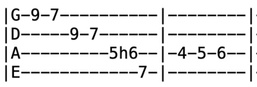
I'll Take a Melody (A) Turnaround Riff

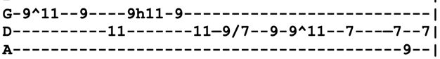
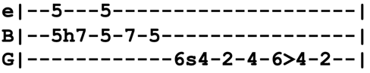
Intro Riff (x2)
or
Verse 1 A D E A A^{sus4} A
I've seen the rain pouring down, the sky was grey with a speck of blue
Peek through a hole in the clouds, sun was screaming, “Hey you”
As you ramble through your sorrow, seems like everything come out wrong
I'm living in yesterday's tomorrow, I know something's helping me along (riff)
Chorus A D E (turnaround riff)
I'll take a melody and see what I can do about it
A D E (turnaround riff) c# e f
I'll take a simple C to G and feel brand new about it
F^{#m} C^{#m} F^{#m} C^{#m} D C^{#m} F^{#m} C^{#m} F^{#m}
I understand why the old fisherman sail alone, sail along, sail alone
A^{sus4=x00230} E⁷ A (intro riff x2)
Someday he'll be gone
Verse 2 I hear you talking 'bout your troubles, everybody's got their troubles too
You can make them burst like bubbles if you know just what to do
You know I've been called a dreamer, dreams that never will come true
But I've been called so many things before, tell you what I'm gonna do
Chorus
Break | C / / / | D / / / | C A / / | C B A# A / / |
| C / / / | D / / / | E / / / | (turnaround riff)
Chorus I'll take a melody and see what I can do about it
^{(first half)} I'll take a simple C to G and feel brand new about it
Vocal Jam Shine on, keep on shining (x3) (turnaround riff) (repeat this line x3)
Lead A D E (chorus melody)
Chorus I understand why the old fisherman sail alone, sail along, sail alone
^{(second half)} Someday he'll be gone
Outro=Intro
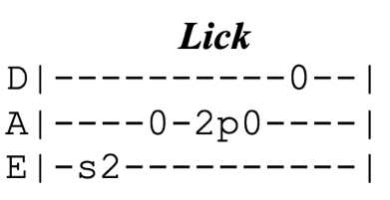
I'm Troubled (D)
Jerry played this in open position. Song is in 4/4.
Intro=Chorus (x2)
Chorus D G D
I'm troubled, I'm troubled, I'm troubled in mind
A D (lick)
If trouble don't kill me, Lord, I'll live a long time

Verse 1 Courting is pleasure and parting is grief
But a false-hearted lover is worse than a thief (lick)
A thief will just rob you and take what you save
But a false-hearted lover will lead you to the grave (lick) (Chorus)

Lead=Verse

Verse 2 Now the grave will decay you and turn you to dust
Not one girl in a hundred that a poor boy can trust
They'll hug you and kiss you and tell you more lies
Than cross ties on a railroad or stars in the sky (Chorus)

Lead=Verse

Verse 3 Gonna build me a cabin in the mountain so high
^{(half verse)} Where the wild birds and the turtle dove will hear my sad cry

Chorus (repeat last line)

If I Had the World To Give (C)
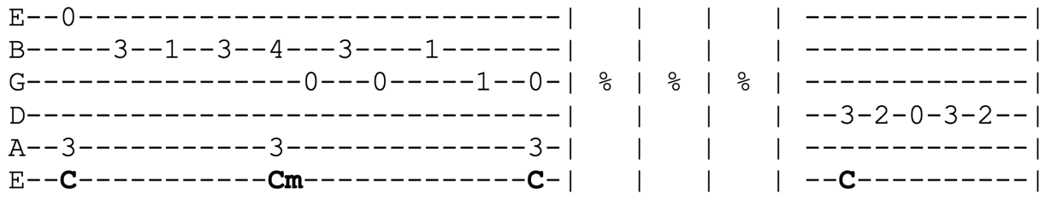
Intro

Verse 1 C F C^{/E=xx201x} Dm G C E
If I had the world to give, I'd give it to you long as you live
Am G F C
Would you let it fall or hold it all in your arms?

Verse 2 F C^{/E} Dm G C E Am
If I had a song to sing, I'd sing it to you as long as you live, lullaby
G F G F
Or maybe a plain serenade, wouldn't you laugh, dance, and cry
C C⁷
Or feel afraid at the change you made

Bridge F^{maj7} B^{bmaj7=x13231}
I may not have the world to give to you
But maybe I have a tune or two
Only if you let me be your world
Cm C
Could I ever give this world to you (x2) (Intro Riff x1)
Chorus G C B^{b} F G
But I will give what love I have to give
I will give what love I have to give
C B^{b} F C
I will give what love I have to give, long as I live

Lead=Verse

Verse 3 If I had a star to give, I'd give it to you long as you live
Would you have the time to watch it shine, watch it shine
Or ask for the moon and heaven too? I'd give it to you
Bridge Well, maybe I've got no star to spare
Or anything fine or even rare
Only if you let me be your world
Could I ever give this world to you (x2)
Outro Jam=Intro Riff
If I Lose (A)
Jerry played this in open position
Intro=Verse
Verse 1 A D
I never thought I'd need you but now I found I'm wrong
E A
Come on back, sweet mama, back where you belong
E¢ A D
I've gambled over town to find that I can't win
E A
Come on back and pick me up again
Chorus A¢E A
If I lose (if I lose), let me lose (let me lose)
E A
I don't care, (I don't care) how much I lose
E ¢ A D B
If I lose a hundred dollars while trying to win a dime
E A A ¢ E E ¢ A
My baby, she's got money all the time

Lead=Verse ¢ Chorus

Verse 2 Of all the other girls I've known none could take your place
When I get into a jam they just ain't in the race
Come on back, sweet mama, let's take another round
With you right by my side, babe, the deal just can't go down

Chorus (x2)

Iko Iko (D)
Debuted in Key of E (5-15-77), second time played was in Key of C (10-7-77), and from third performance (10-12-77) onwards it was played in Key of D. The verses/lyrics of this song varied considerably each performance.

Intro =Verse
Chorus D A
Hey now (hey now), hey now (hey now), iko iko ah nay
D
Jockomo feeno ah na nay, jockomo feena nay (talkin' bout)
Hey now (hey now), hey now (hey now), iko iko ah nay
Jockomo feeno ah na nay, jockomo feena nay
Verse 1 My spy dog say your spy dog sitting by the fi-yo
My spy dog say your spy dog gonna set your tail on fi-yo (Chorus)
Chorus (sing chorus just one round and then begin lead)
Lead=Verse
Verse 2 My grandma say your grandpa sitting by the fi-yo

My grandma say your grandpa gonna fix your chicken wi-yo (Chorus)
Lead=Verse
Verse 3 Indian boy gotta go downtown, iko iko ah nay

If he don't like what the big chief say, jockomo feena nay
Chorus (x3) (w/ adlibs between lines)
Talkin' 'bout...well...everybody say....
Outro=Chorus (big chords punctuated)

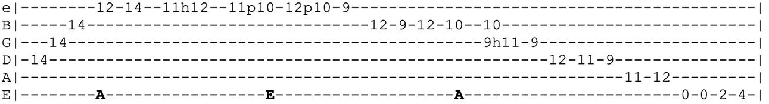
It Must Have Been The Roses (A)
Intro Riff
Verse 1 A D A
^{(half)} Annie laid her head down in the roses
A⁷ D
She had ribbons, ribbons, ribbons in her long brown hair
Chorus E A F^{#m} A E A
^{(2nd half)} I don't know, maybe it was the roses, all I know I could not leave her there
Chorus D E A
I don't know, it must have been the roses
D E A G D
The roses or the ribbons in her long brown hair
E A F^{#m}
I don't know, maybe it was the roses
A E A A^{sus4} A
All I know I could not leave her there
Verse 2 A⁷ D A
Ten years the waves roll the ships home from the sea
A⁷ D
Thinking well how it may blow in all good company
A E D
If I tell another what your own lips told to me
A E D
Let me lay 'neath the roses, let my eyes no longer see (Chorus)
Lead=Intro (brief solo)
Verse 3 One pane of glass in the window
No one is complaining, no, come in and shut the door
Faded is the crimson from the ribbons that she wore
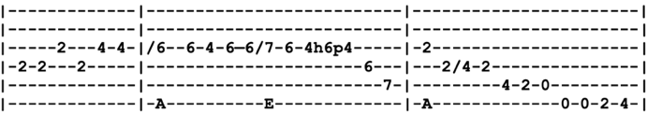
And it's strange how no one comes 'round anymore (Chorus)
Lead=Verse Original intro for the first 10 years
Chorus
Outro=Intro Riff
It Takes a Train to Cry (A) riff
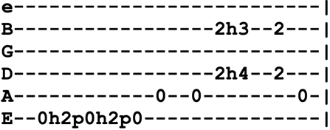
Intro Riff (x4)
Verse 1 A D A E A (riff x2)
I drive a mail train, mama, can't buy a thrill
I've been up all night, mama, leaning on a windowsill
A G D E E⁷
If I die on top of the hill
A E^{7 (blues walkdown)} A (riff x2)
If I don't make it you know my baby will
Lead=Verse

Verse 2 Don't the moon look good, mama, shining through the trees?
Don't the brakeman look good, mama, flagging down the Double E?
Don't the sun look good going down over the sea?
Don't my gal look fine when she's coming after me?
Lead=Verse

Verse 3 Winter time is coming, the windows are filled with frost
I went to tell everybody but I could not get across
I want to be your lover, baby, I don't wanna be your boss
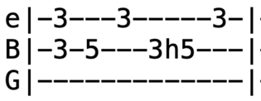
Don't say I didn't warn you when your train gets lost (x3)
It's All Over Now (G) riff #1
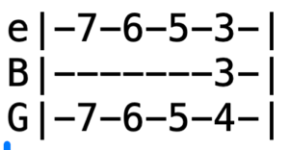
Intro C C# D C# C G ¢ Riff #1 (x2)
Verse 1 G (riff #1 throughout verse) riff #2
Well, now baby used to stay out all night long
Made me cry, Lord, she done me wrong (riff #2)
Hurt my eyes open, baby, that's no lie
Tables turning, now it's her turn to cry (riff #2)

Chorus C C# D C# C G (riff #1)
Because I used to love her, but it's all over now
Yes and I used to love her, but it's all over now

Verse 2 Well, I used to wake in morning, get my breakfast in bed
When I got worried, Lord, she'd ease my aching head
But now she's here and there with every man in town
Still trying to take me for that same old clown (Chorus)
Lead=Verse
Verse 3 Well, she used to run around with every man in town
Spend all my money, Lord, now playing her high fast games
Put me out, it was a pity how I cried
Table's turning, now it's her turn to cry (Chorus)
Lead=Verse
Verse 1
Chorus (repeat last line x4)
Outro=Intro
It's All Over Now, Baby Blue (D)
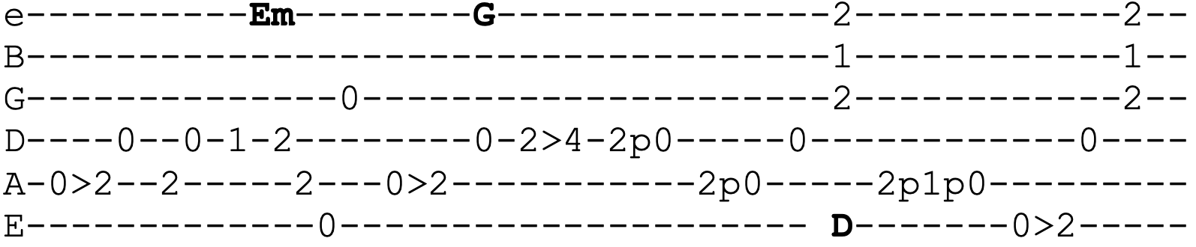
Intro Riff
(x4)
Verse 1 A G D
You must leave, now take what you need, you think will last
Whatever you wish to keep, you better grab it fast
Em G D
Yonder stands your orphan with his gun
He's crying like a fire in the sun
F# A A^{sus4} A
Look out all those saints are coming through
Refrain Em G D
And it's all over now, Baby Blue (Intro riff x2)

Verse 2 The highway is for gamblers, you better use your sense
Take what you have gathered from coincidence
The empty-handed painter from your streets
Is drawing crazy patterns on your sheets
The sky, too, is folding over you (Refrain)
Lead=Verse ¢ Refrain
Verse 3 All your seasick sailors, they are rowing home
Your empty-handed armies are all going home
The lover who just walked out your door
Has taken all his blankets from the floor
The carpet, too, is moving under you (Refrain)
Verse 4 Leave your stepping stones behind, something calls for you
Forget about the dead you left, they will not follow you
The vagabond who's rapping at your door
Is standing in the clothes that you once wore
Strike another match, go start anew (Refrain x4)
Outro=Intro
Jack Straw (E)
Intro E E^{sus4} (x4)
Verse 1 E F^{#m} C^{#m} A
We can share the women, we can share the wine
E Bm D A E G^{#m} D A
We can share what we got of yours 'cause we done shared all of mine
E F^{#m} C^{#m} A
Keep on rolling, just a mile to go
E Bm D A E B A E
Keep on rolling my old buddy, you're moving much too slowww
E7^{sus4=020200} E E7^{sus4} E
I just jumped the watchman right outside the fence
Took his rings, four bucks in change, ain't that heaven sent?
F^{#7sus4=242422} F^{#7} F^{#7sus4} F^{#7}
Hurts my ears to listen, Shannon, burns my eyes to see
F^{#7sus4} F^{#7} F^{#7sus4} D Bm A E
Cut down a man in cold blood, Shannon, might as well been me

Lead D Bm A E (x3)
Bridge D Bm A E
We used to play for silver, now we play for life
One's for sport and one's for blood at the point of a knife
And now the die is shaken, now the die must fall
D Bm A E A D G D G ¢ E E^{sus4} E E^{sus4}
There ain't a winner in the game, he don't go home with all, not with all
Verse 2 Leaving Texas, fourth day of July
Sun so hot, the clouds so low, the eagles filled the sky
Catch the Detroit Lightning out of Sante Fe
Great Northern out of Cheyenne from sea to shining sea
Gotta go to Tulsa, first train we can ride
Gotta settle one old score, one small point of pride
There ain't a place a man can hide, Shannon, will keep him from the sun
Ain't a bed can give us rest now, you keep us on the run
Instrumental D Bm A E (x3)
Bridge D Bm A E
Jack Straw from Wichita cut his buddy down
Dug for him a shallow grave and laid his body down
Half a mile from Tucson by the morning light
D Bm A E A D G D G ¢ E E^{sus4} E E^{sus4}
One man gone and another to go, my old buddy you're moving much too slow
Outro E F^{#m} C^{#m} A
We can share the women, we can share the wine
Jack-A-Roe (Am)
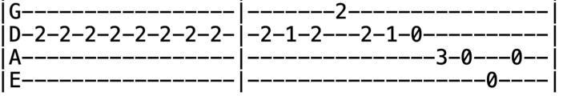
Intro
Verse 1 Am C E
There was a wealthy merchant in London he did dwell
Am C F C Am E Am (riff)
He had a beautiful daughter, the truth to you I'll tell, oh, the truth to you I'll tell
Verse 2 She had sweethearts-a-plenty and men of high degree
But none but Jack the sailor her true love ever could be
Oh, her true love ever be
Verse 3 Now, Jackie's gone a-sailing with trouble on his mind
He's left his native country and his darling girl behind
Oh, his darling girl behind (Lead=Verse)
Verse 4 She went down to a tailor shop and dressed in man's array
She climbed on board a vessel to convey herself away
Oh, convey herself away
Verse 5 Before you get on board, sir, your name we'd like to know
She smiled all in her countenance, “They call me Jack-A-Roe”
Oh, they call me Jack-A-Roe
Verse 6 I see your waist is slender, your fingers they are small
Your cheeks too red and rosy to face the cannonball
Oh, to face the cannonball
Verse 7 I know my waist is slender, my fingers they are small
But it would not make me tremble to see ten thousand fall
Oh, to see ten thousand fall (Lead=Verse)
Verse 8 The war soon being over, she went and looked around
Among the dead and wounded, her darling boy she found
Oh, her darling boy she found
Verse 9 She picked him up on in her arms and carried him to the town
She sent for a physician to quickly heal his wounds
Oh, to quickly heal his wounds
Verse 10 This couple they got married so well they did agree
This couple they got married, so why not you and me?
Oh, why not you and me? (x2) (tag it!)
Jams
This page is devoted to progressions the Dead played
Mind Left Body Jam (A)
Nickname based on resemblence to Jefferson Airplane's "My Mind Has Left My Body" even though the jam was being played before that song was recorded in Nov 1972, with Jerry on pedal steel. The jam most commonly occurred in A, but also in E (5/19/74)
Version 1 A^{=x05650} A7^{=x04540} Dm^{=x03230} A^{=x02220} (x8)
E (for 8 measures) (E Major Pentatonic Jam)
Version 2 (12-30-83 SF)
A7^{=x07989} A^{dim7=x07878} A^{susb6/9=xx7767} A^{=x07650}
or A7^{=x07989} A^{dim7=x07878} Dm A^{=x07650}
Version 3 (3-24-90 Knickerbocker)
D7 G Gm D
Version 4 A7^{=x05650} D^{add9=x04230} Dm^{add9= x03230} A^{=x02220}
Version 5 (5-19-74 Portland)
E (walk the five down from B Bb A Ab)

Feelin' Groovy Jam (D)
Initially appearing in Dark Star, it later appeared in the transition from China Cat to I Know You Rider. Hear 3/19/73. 1974-06-26, 1973-11-11, 1970-09-19, 1969-09-26, 1972-11-26, 1973-02-24
Jam D C#m Bm A (x16)
G (for 4 measures)

Spanish Jam (E)
As played on 6-26-74
Jam E F
Jenny Jenkins (D)
Verse 1 D A
Will you wear white, oh my dear, oh my dear
D A
Will you wear white, Jenny Jenkins?
D G
No, I won't wear white for the color's too bright
Refrain D
I'll buy me a foldy-roldy tildy-toldy, seek-a-double, use-a-cozza roll to find me
A¢ D A D
Roll, Jenny Jenkins, roll
Verse 2 Will you wear green
No, I won't wear green, it's a shame to be seen (Refrain)
Verse 3 Will you wear blue
No, I won't wear blue for the color's too true (Refrain)
Verse 4 Will you wear yellow
No, I won't wear yellow for I'd never get a fellow (Refrain)
Verse 5 Will you wear brown
No, I won't wear brown for I'd never get around (Refrain)
Verse 6 Will you wear beige
No, I won't wear beige for it shows my age (Refrain)
Verse 7 Will you wear orange
No, orange I won't wear and it rhymes so there (Refrain)
Verse 8 What will you wear
Oh, what do you care if I just go bare (Refrain)
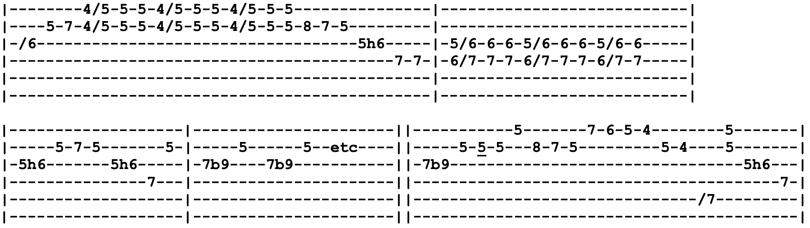
Johnny B. Goode (A)
Intro Riff
Verse 1 A
Deep down in Louisiana close to New Orleans
Way back in the woods among the evergreens
D

There in an old cabin made of earth and wood
A
Where lived a country boy named Johnny B. Goode
E
He never learned to read or write so well
A (E⁷) A
But he could play the guitar like ringing a bell

Chorus Go go! Go Johnny, go go! (x4) Johnny B. Goode
Verse 2 He used to carry his guitar in a gunny sack

Sit up in the tree by the railroad track

The engineers would see him sitting in the shade

Strumming to the rhythm that the drivers made

People passing by would stop and say

“Oh my, that little country boy can play” (Chorus)
Lead A D⁷ A D A E A E⁷ (x2)
Verse 3 Papa told him someday you will be a man
You will be the leader of a big old band
Many people coming from miles around
To hear you play your music when the sun go down
Maybe someday your name will be in lights
Saying, “Johnny B. Goode Tonight” (Chorus)
Lead A D⁷ A D A E A E⁷ (x2)
Chorus
Just a Little Light (Am)
Brent regularly sang slightly modified lyrics, mixing verse 1 and 2 words
Intro Am
Verse 1 Am
Well, there ain't nobody safer than someone who doesn't care
Em Am
And it isn't even lonely when no one's ever there
Dm
I had a lot of dreams once, some of them came true
Em Am
The honey's sometimes bitter when fortune falls on you
Dm Em Am
And you know I've been a soldier in the armies of the night
And I'll find the fatal error in what's otherwise all right
But now you're trembling like a sparrow, I will try with all my might
Dm Em F^{maj7} ^{(hold for 4 bars)} Am
To give you just a little sweetness, just a little light
Verse 2 I have always heard that virtue oughta be its own reward
But it never comes so easy when you're living by the sword
It's even harder to be heartless when you look at me that way
You're as mighty as the flower that will grow the stones away
Even though I been a stranger full of irony and spite
Holding little but contempt for all things beautiful and bright
Something shines around you and it seems to my delight
To give me just a little sweetness, just a little light
Bridge C G
This could be just another highway coiled up in the night
Dm Am
You could be just another white-tail, baby, stranded on my brights
G D
There's a tingling recognition like the sound of distant thunder
C Am E F
And I begin to wonder if the love I've driven under won't ignite
Lead F Am (x4) (Jerry tripplets lead w Mutron)
Verse 2 Even though I been a stranger full of irony and spite
^{(second half)} Holding little but contempt for all things beautiful and bright
Something shines around you and it seems to my delight
Dm Em F^{maj7} ^{(hold 8 bars)} Am
To give me just a little sweetness, just a little light
Dm Em F^{maj7 (just one bar)} Am
To give me just a little sweetness, just a little light
To give me, to give me, to give me just a little sweetness, just a little light
Just Like Tom Thumb's Blues (E)
Phil sang wildly modified lyrics regularly. Lyrics below are as Dylan wrote it.
Intro A B A (x3) | E E^{sus4}
Verse 1 E A E
When you're lost in the rain in Juarez and it's Eastertime too
And your gravity fails and negativity don't pull you through
A E
Don't put on any airs when you're down on Rue Morgue Avenue
B A E
They got some hungry women there and they really make a mess outta you

Verse 2 Now, if you see St. Annie, please tell her thanks a lot
I cannot move, my fingers are all in a knot
I don't even have the strength to get up and take another shot
Now my best friend, my doctor
Won't even tell me what it was that I've got (Intro)
Verse 3 Sweet Melinda, the peasants call her the goddess of gloom
She speaks good English and she invites you up into her room
And you're so kind and careful not to go to her too soon
And she steals your voice and leaves you howling at the moon

Verse 4 Up on Housing Project Hill, it's either fortune or fame
You must choose one or the other though neither are to be what they claim
If you're looking to get silly, you better go back to from where you came
Because the cops don't need you and man they expect the same
Lead=Verse
Verse 5 Now, all the authorities, they just lay around and boast
How they blackmailed the seargent-at-arms into leaving his post
And picking up Angel who just arrived here from the coast
Who looked so fine at first but left looking just like a ghost

Verse 6 I started out on Burgandy but soon hit the harder stuff
Everybody said they'd stand behind me when the game got rough
But the joke was on me, there was nobody even there to call my bluff
I'm going back to New York City, I do believe I've had enough
Outro=Intro
Keep Your Day Job (A)
Intro Riff A B D E A D D# E
Verse 1 A (riff) D A
Maybe you collect or maybe you pay
You gotta work that eight-hour day
D A E
Whether you like that job or not
Keep it on ice while you're lining up your long shot
B D
Which is to say, hey hey
Chorus A A⁷ D D⁷
Keep your day job, don't give it away
Keep your day job, whatever they say
A F^{#7} B D E A D D# E
Keep your day job till your night job pays
Verse 2 Steady boys study that eight day hour
Never underrate that paycheck power
By now you know the face on your dollar
Got a thumb on its nose and a hand on your collar
Which is to say, hey hey (Chorus)
Lead=Verse ¢ Chorus

Verse 3 Sunday comes, gonna forget about work
Ring that bell for whatever it's worth
If you ask me, which I know you don't
I'll tell you what to do, but I know that you won't
Which is to say, hey hey
Chorus (x3)
______________________________________________________________
(After playing this song for 3 years, from 4/3/85 onwards, verse 3 was replaced with below)
Verse 3 Daddy may drive a stingray 'vette
Mama may bathe in champagne yet
God bless the child that's got his own stash
Nine to five and a place to crash, which is to say, hey hey
Knockin' On Heaven's Door (G)
Dylan resolves to C at the end of every other line, GD never resolved, always ends on Am. Jerry regularly varied lyrics of the verses.
Intro G D Am (x4)
Verse 1 G D Am
Come take this badge off of me
I won't wear it anymore
It's getting dark, too dark to see
I feel like I'm knockin' on heaven's door
Chorus Knock, knock, knockin' on heaven's door (x4)

Lead=Verse

Verse 2 Come take these guns off of me
I won't shoot them anymore
The sun is sinking over me
I believe I must be knockin' on heaven's door (Chorus ¢ Lead)

Verse 3 Come dry these tears from my eyes
I can't shed them anymore
Sun is setting in western skies
People I believe I must be knockin' on heaven's door
Chorus 2 Knock, knock, knockin' on heaven's door (x4)
Just like so many times before
Lead=Verse
Chorus 2
The Last Time (E) Intro Riff
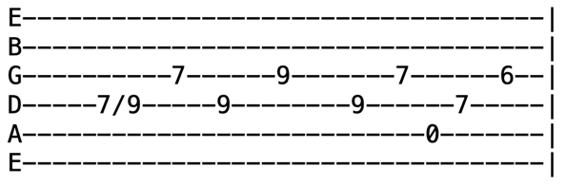
Intro Riff E D A (x8)
Verse 1 E D A E D A (riff)
I told you once and I told you twice
Never listen to my advice
Don't try very hard to please me
What you know it should be easy
Chorus A
Well, this could be the last time, this could be the last time
D A E D A (Intro riff x4)
Maybe the last time, I don't know, oh no
Verse 2 I'm sorry girl but I can't stay
Feeling like I do today
Too much pain and too much sorrow
Guess I'll feel the same tomorrow (Chorus)
Lead=Verse ¢ Chorus
Verse 3 I told you once and I told you twice
Someone have to pay the price
Here's a chance to change your mind
I'll be gone a long, long time (Chorus)
Vocal Jam Could be the last time, baby, I don't know (x4)
(This could be the last time) no, and I don't know (x8)
Lazy River Road (G)

Intro G D G C G^{/B=x20030} G^{/Bb=x10030} Am^{11=x00010} G
Verse 1 G D G C G

Way down upon Sycamore Slough, a white man sings the blues
D G C D

Selling roses of paper maché, specks of starlight dew
Em D C Bm
I swiped a bunch and threw it your way where hazy moonlight glowed

C G^{/B=x20030} G^{/Bb=x10030} Am^{11=x00010} G

Way down, down along Lazy River Road

Verse 2 Way down upon Shadowfall Ward, end of the avenue
Run hide seek in your own backyard, mama's backyard won't do
All night long I sing love's sweet song down where the water flowed
Way down, down along Lazy River Road

Bridge Am D Em B⁷ Em E
Moonlight wanes as hound dogs bay, never quite catch the tune
Am D Em B⁷ Em E
Stars fall down in buckets like rain till there ain't no standing room
Am B⁷ Am B⁷
Bright blue boxcars, train by train, clatter while dreams unfold

Em G⁷ C Am^{11=x00010} G

Way down, down along Lazy River Road
Verse 3 Way down upon Seminole Square, belly of the river tide
Call for me and I will be there for the price of a taxi ride
Nighttime double-clutches into the day
Like a truck down-shifting its load
Way down, down along Lazy River Road (Lead=Verse)
Bridge
Verse 4 Thread the needle right through the eye, thread that runs so true
All the others I let pass by, I only wanted you
Never cared much for careless love, oh how your bright eyes glowed
Way down, down along Lazy River Road (x3)
Outro (one instrumental walkdown)
Let It Grow (Am7)
Intro Am7^{=xx3141} E7^{b9=xx4210}
Verse 1 Am7= ^{x x x9 10 8} E7^{b9= x x x 12 11 12}
Jerry's chords
Am7^{=x x x 9 10 8}
E^{dim=x x x 12 11 12}
G#^{dim=x x 6 7 6 x}
B^{dim=x x x 9 10 9 x}
D^{dim=x x x 7 6 6}
F^{dim=x x x 10 9 10}
Morning comes, she follows the path to the river shore
Am E7^{b9}
Lightly sung, her song is the latch on the morning's door
Am C^{sus2=x13311} Am C^{sus2} Bm D
See the sun sparkling in the reeds, silver beads pass into the sea
Chorus D A7
She comes from a town where they call her the woodcutter's daughter
D
She's brown as the bank where she kneels down to gather her water
Bm Am C^{sus2} E^{sus2}
She bears it away with a love that the river has taught her, let it flow, let it flow, wide and clear
Verse 2 Round and round, the cut of the plow in the furrowed fields
Seasons round, the bushels of corn and the barley meal
Broken ground, open and beckoning, to the spring, black dirt live again
Chorus The plowman is broad as the back of the land he is sowing
As he dances the circular track of the plow ever knowing
That the work of his days measures more than the planting and growing
Let it grow, let it grow, greatly yield
Bridge E^{sus2=x79977} B^{=x9987x} G^{=x 10 9 7 8 x} E^{sus2=x79977} C^{=x3555} G^{=x5543x} Bm^{=x2443x}
What shall we say, shall we call it by name, as well to count the angels dancing on a pin
E^{sus2} B G E^{sus2} D^{=x9777x} A^{=x 12 11 9 10 x}
Water bright as the sky from which it came and the name is on the earth that takes it in
G^{=x 10 9 7 8} D^{=x9777x} Em^{=x79987}
We will not speak but stand inside the rain
C^{=x 10 10 9 8 x} G^{=x 10 9 7 8 x} D Em^{=x79987} Am C^{sus2} E^{sus2}
And listen to the thunder shout, “I am, I am, I am, I am”
Jam=Verse (solo in D Mixolydian/ A Dorian)
Verse 3 So it goes, we make what we made since the world began
Nothing more, the love of the women, work of man
Seasons round, creatures great and small, up and down, as we rise and fall
Jam D C C^{/B} D (do this quick turnaround groove x8-ish)
Am7 E7^{b9} (jam over intro chords for a while)
Em7 (jam hard and wild over this chord, then get quiet with pretty outro lick x4)
Bridge
Jam on Em7 (jam hard and wild over this chord, then get quiet with pretty outro lick x4)
Let It Rock (A)

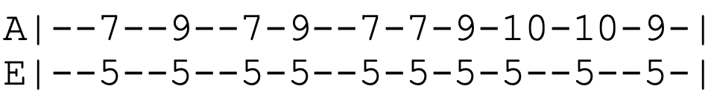
Intro
(x4)
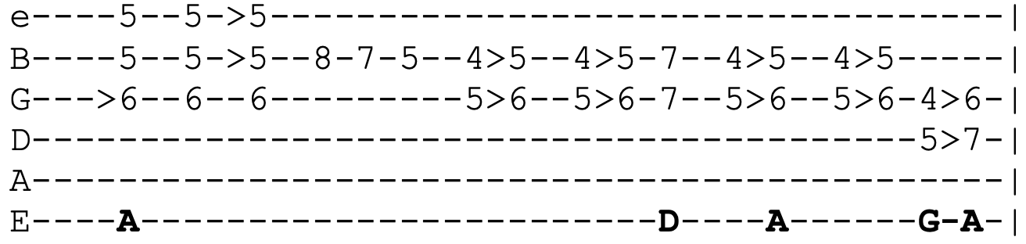
Riff
(x4)

Verse 1 A
Well, up in the evening down in Mobile, Alabama
Working on a railroad with a steel driving hammer
D
Gotta make some money, buy some brand new shoes
A
Try to find somebody take away these blues
E
She don't love me and I'm singing in the sun
A
Payday's coming and my work is all done (Lead=Verse)
Verse 2 Early in the evening when the sun is sinking low
All day I been waiting for the whistle to blow
Sitting in a teepee built right on the tracks
Rolling them bones until the foreman comes back
Pick up your belongings, boys, and scatter about
We've got an off-schedule train coming two miles out (Lead=Verse)
Verse 3 Everybody's scrambling and running around
Picking up their money, tear the teepee down
Foreman wants to panic, 'bout to go insane
Trying to get the workers out the way of the train
Engineer blows the whistle loud and long
Can't stop the train, gotta let it roll on (Lead=Verse)
Let the Good Times Roll (A)

Intro A F^{#m} (x4)

Chorus A D
Get in the groove and let the good times roll
A E F^{#m} A E
We're gonna stay here till we soothe our soul if it takes all night long Come on and let the good times roll
We're gonna stay here till we soothe our soul if it takes all night long

Verse 1 A D
^{(Brent)} The evening sun is sinking low
A E
The clock on the wall says it’s time to go
A D
I got my plans and I got plans for you
E A
I tell you exactly what we're all gonna do (Chorus)
Lead=Verse (half)
Verse 2 It might be twelve o’clock and it it might be three
^{(Bob)} Time doesn’t mean that much to me
Ain't felt this way since I don’t know when
Don't know when I'm gonna feel this way again (Chorus)
Verse 3 It might be six o’clock, it might be eight
^{(Jerry)} It don't matter that it's getting late
We’re gonna make the band play one more song
Get in the groove if it takes all night long (Chorus)
Vocal Jam A F^{#m}
All night (all night), all night (all night) (x8)
(everyone improvises here, saying things in between lines)
Chorus Come on and let the good times roll
^{(acapella)} We’re gonna stay here till we soothe our soul if it takes all night long
Liberty (E)
Intro E B E (x8)
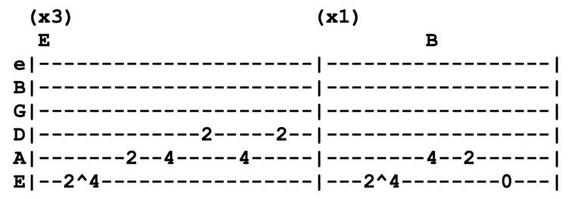

Verse 1 E C^{#m} B A E B E
Saw a bird with a tear in his eye, walk to New Orleans, my oh my
Say, “Hey bird, would you rather die, walk this world when you're born to fly”
A B E C^{#m} B A
If I was the sun, would look for the shade. If I was a bed I would stay unmade C^{#m} B A E A B E A
If I was a river I’d run uphill. If you call me you know I will
C^{#m} B E
And if you call me, you know I will
Chorus E B E D A E
Ooooo freedom, ooooo liberty
E B E C^{#m} B A B E A C^{#m} B A B E(riff x8)
Oh, leave me alone, find my own way home, I'm gonna find my own way home

Verse 2 Say what I mean and I don’t give a damn, I do believe I am who I am
Hey now, mama, come and take my hand, whole lotta shaking all over this land
If I was an eagle, I’d dress like a duck, crawl like a lizard and honk like a truck
If I take a notion I’ll climb this tree, or chop it down, you can’t stop me
Oh, chop it down, you can’t stop me
Chorus
Verse 3 Went to the well but the water was dry, dipped my bucket in the clear blue sky
Looked in the bottom and what did I see, whole damn world looking back at me
If I was a bottle, I'd spill for love, sake of mercy, I would kill for love
If I was liar, I'd lie for love, sake of my baby, I'd die for love
Sake of my baby, I'd die for love
Chorus (x2)
Like A Road (G)

Intro G Bm C | G F C G
Verse 1 G Bm C
When the road gets too long
And you run all out of song
G B⁷ E A D^{sus4} D
And the pain gets too much for you to bare
Chorus C G B⁷ C
Turn around, turn around, turn around and I'll be there
G D G F C G
Like a road, like a road leading home

Verse 2 When the dark clouds start to blow
And you need somewhere to go
And you want some company that really cares (Chorus)
Lead=Verse ¢ Chorus

Verse 3 When the rain is past and gone
And the road you're traveling on
Doesn't seem to be going anywhere (Chorus)
Lead=Verse ¢Chorus

Verse 1

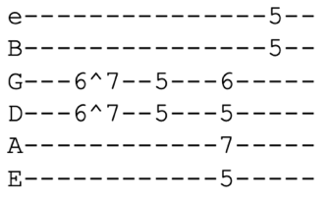
Chorus
Little Red Rooster (A) 6/8 Time
Intro Riff D C A (x8)
Verse 1 D A⁷ D C A
I got a little red rooster, too lazy to crow for days
Got a little red rooster, too lazy to crow for days
E⁷ D A⁷
Keep everything in the barnyard, people, upset in every way

Verse 2 Dogs begin to bark now, hounds begin to howl (x2)
Watch out stray cat people, the little red rooster's on the prowl

Lead=Verse (solo in A Minor Pentatonic)

Verse 3 If you see my little red rooster, won't you please drive him home (x2) Been no peace in the barnyard, people
Since my little red rooster's been gone

Lead=Verse

Verse 4 Hey there, little red rooster, well, you ain't shit to me
^{(Brent)} Think you're a stud boy, well I doubt, I doubt you'll ever be
While you're away I'm gonna fuck with your henhouse
I'm just being neighborly
A Minor Pentatonic
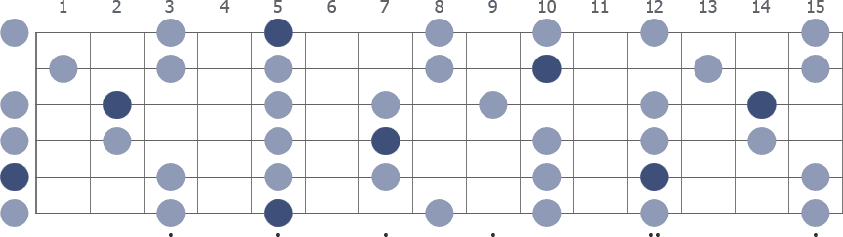

Lonesome and a Long Way From Home (C)
Intro C F C (x4)
Verse 1 C F
Out on the open highway, such a lovely day but something's wrong
C
Something, something surely’s wrong
Just left home this morning, this old road keeps rolling, rolling on
Rolling, rolling on and on ^{(stop!)}
Chorus C
Somebody help me (somebody help me) (x4)
B^{b} C
I have never been so lonesome and a long way from home
B^{b} C
Never been lonesome and a long way from home
B^{b} C
Lonesome and a long way from home
Intro ¢ Verse 1 ¢ Chorus
Bridge C C# D / |F / / / |G# / / /|G / / /|G / / /
Lead=Verse ¢ Chorus (solo in C Major)
Jam B^{b} C (x24-ish) ¢ (long spacey jam in C Mixolydian)
Intro ¢ Verse 1 ¢ Chorus
Vocal Jam Never been lonesome and a long way from home (x4)
Outro C C# D / |F / / / |G# / / /|G / / /| G / / /| C
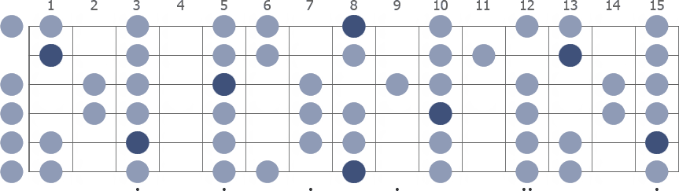
C Mixolydian
Long Black Veil (D)

Intro A G D
Verse 1 D
Ten years ago on a cold dark night
A G D
There was someone killed 'neath the townhall light
There were few at the scene but they all agreed
That the slayer who ran looked a lot like me
Verse 2 The judge said, “Son, what is your alibi?
If you were somewhere else then you won't have to die”
I spoke not a word though it meant my life
For I had been in the arms of my best friend's wife

Chorus G D G D
She walks these hills in a long black veil
She visits my grave when the night winds wail
D G D G A D
Nobody knows, nobody sees, nobody knows but me
Lead=Verse
Verse 3 The scaffold was high and eternity near
She stood in the crowd and shed not a tear
But sometimes at night when the cold winds blow
In a long black veil, she cries over my bones

Chorus (repeat last line)
Looks Like Rain (E)
Intro E^{=x76450} E^{sus4} E (x4)
Verse 1 E E^{sus4} E A^{=54222x} C^{#7} F^{#m}
I woke today, felt your side of bed
E B^{=76444x} C^{#m} F^{#m=x 9 11 11 10 x} E
The covers were still warm where you’d been layin'
C^{#m} Bm7 A^{=54222x} C^{#7} F^{#m}
You were go- ne, my heart was filled with dread
E B C^{#m} A E
You might not be sleeping here again
A^{sus4} A A^{sus4} A F^{#m} D A E
It's alright 'cause I love you that's not gonna change
F^{#m} B B^{=76445x} E G^{#sus4} G#
Run me 'round, make me hurt again and again
C^{#m} C^{#m7=x46454} A A^{add9=x04242x}
But I'll still sing you love songs
E B^{bdim=6xx65x} B B^{=7xx87x} C^{#m} F^{#m7=xx4655} E
Written in the letters of your name
A^{sus4} A F^{#m} E A^{sus4} A F^{#m}
Brave the storm to come for it surely looks like rain

Verse 2 Did you ever waken to the sound of street cats making love?
^{(1st half)} You guess from their cries you were listening to a fight
Well you kno-ow hate's just the last thing they're thinking of
They're only trying to make it through the night
Lead=Verse (second half of verse beginning with A^{sus4})
Verse 3 I only wanna hold you, I don't wanna tie you down
Or fence you in the lines I might've drawn
It's just that I-I-I gotten used to having you around
My landscape would be empty if you were gone
But it's alright 'cause I love you and that's not gonna change
Run me around, make me hurt again and again
But I'll still sing you love songs written in the letters of your name
Brave the storm to come for it surely looks like rain (x2)
Vocal Jam Looks like rain, here comes the rain
Looks like rain and it feels like rain, here comes the rain
Turning grey and it looks like rain, feels like rain
Loose Lucy (E)
Intro Riff
Verse 1 E (riff) (riff)
Loose Lucy is my delight, she comes running and we ball all night
A A⁷
Round and round and round and round
E (riff)
Don't take much to get me on the ground
B A
She's my yo-yo, I'm her string, listen to the birds on the hot wire sing
Chorus E^{7/E=0xx434} E^{b7/E=0xx323} D^{7/E=0xx212} E
Singing yeah ^{(yeah)}, yeah ^{(yeah)}, yeah ^{(yeah)}, yeah
F# B E (riff x2)
Singing, “Thank you for a real good time”

Verse 2 I got jumped coming home last night
Shadow in the alley turned out all my lights
Round and round and round and round, don't take much to get me on the ground
Loose Lucy, she was sore
Says, “I know you don't want my love no more” (Chorus)
Lead=Verse ¢ Chorus
Verse 3 Beebop baby, how can this be?
I know you been out a-cheating on me
Round and round and round and round, don't take much to get the word around
Cross my heart and hope to die
I was just hanging out with the other guys (Chorus)
Verse 4 Went back home with two black eyes
You know I'll love you till the day I die
Round and round and round and round, don't take much to get the word around
I like your smile but I ain't your type
Don't shake the tree when the fruit ain't ripe
Chorus (repeat first line three times before tagging final line)
Loser (Am)
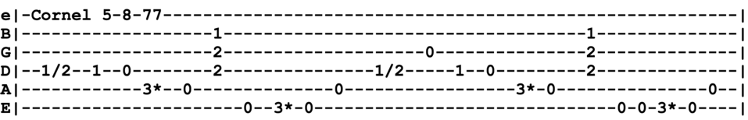
Intro
Verse 1 Am G C D C Em Am
If I had a gun for every ace I've drawn, I could arm a town the size of Abilene
C G Em D
Don't you push me ba-by 'cause I'm moaning low
C C^{/B=x22010} Am G Am
And you know I'm only in it for the gold

Verse 2 All that I am asking for is ten gold dollars
I could pay you back with one good hand
You can look around about the wide world over
You'll never find another honest man
Chorus G D A G D A
Last fair deal in the country, last fair deal in the town
Put your gold money where your love is, baby
C C^{/B} Am G D Am
Before you let my deal go down, go down

Verse 3 Don't you push me, baby, 'cause I'm moaning low
I know a little something you won't never know
Don't you touch hard liquor, just a cup of cold cof-fee
Gonna get up in the morning and go
Verse 4 Everybody's bragging and drinking that wine
I can tell the Queen of Diamonds by the way she shines
Come to daddy on the inside straight and I got no chance of losing this time
Well, I got no chance of losing this time (x2) (Lead=Verse)
Chorus
Verse 4 Everybody bragging and drinking that wine
I can tell the Queen of Diamonds by the way she shines
Come to daddy on the inside straight
Well, I got no chance of losing this time (x2)
C C^{/B} Am G D Am
Well, I got no chance of losing this time
Louis Collins (C)
Intro=Verse
Verse 1 G C
Ms. Collins weep, Ms. Collins moan
F
What made her son, Louis, leave his home?
C F G C
Angels laid him away
Chorus Angels laid him away
Laid him six feet under the clay
Angels laid him away
Lead=Verse
Verse 2 Oh, kind friends, now ain't it hard
To see poor Louis in a new grave yard
Angels laid him away (Chorus)
Lead=Verse
Verse 3 When they heard that Louis was dead
All the women folk they dressed in red
Angels laid him away (Chorus)
Lead=Verse
Verse 4 Bob shot one and Louis shot two
Shot poor Collins, shot him through and through
Angels laid him away (Chorus)
Lead=Verse
Verse 1 ¢ Chorus
Love in the Afternoon (C)
Intro F E^{b} C | B^{b} F A^{bAug7=} ^{4x455x}
Verse 1 C E^{bDim7=} ^{xx1212}
Love in the afternoon
Dm F G C
Outside the window an organ grinder's tune

Verse 2 Rhythm, wine, touch of Jamaica
Twilight time with a Kingston lady
All the time in the world for me and that girl

Verse 3 Sweet, she sang sweetly, come back soon
Come back for more of that love in the afternoon

Verse 4 Breezes blow by me in the afternoon
She sings sweetly an organ grinder's tune
Chorus Em F C
Finally recovered from last year's round of bye, bye baby blues
Em F E D C A^{bAug7}
All I crave today love in the afternoon

Verse 1
Intro

Lead =Verse
Chorus Gone with the moon and any old trouble, it can't leave too soon
Trouble's no part of what I want, 'specially in the afternoon

Verse 5 Singing, sleeping till noon

Waking to make more love in the afternoon (x3)
Outro=Intro
Maggies Farm (G)
Intro G
Verse 1 G
I ain't gonna work on Maggie's farm no more
No, I ain't gonna work on Maggie's farm no more
Well, I wake up in the morning, hold my hands and pray for rain
I got a head full of ideas that are driving me insane
Em D
It's a shame the way she makes me scrub the floor
G
I ain't gonna work on Maggie's farm no more

Verse 2 I ain't gonna work for Maggie's brother no more
No, I ain't gonna work for Maggie's brother no more
Well, he hands you a nickel, he hands you a dime
He asks you with a grin if you're having a good time
Then he fines you every time you slam the door
I ain't gonna work for Maggie's brother no more (Lead=Intro)

Verse 3 I ain't gonna work for Maggie's pa no more (x2)
Well, he puts his cigar out in your face just for kicks
His bedroom window, it is made out of bricks
The National Guard stands around his door
I ain't gonna work for Maggie's pa no more (Lead=Intro)

Verse 4 I ain't gonna work for Maggie's ma no more (x2)
Well, she talks to all the servants about Man and God and Law
Everybody says she's the brains behind Pa

She's sixty-eight, but she says she's fifty-four
I ain't gonna work for Maggie's ma no more

Verse 5 I ain't gonna work on Maggie's farm no more (x2)
Well, I try my best to be just like I am
But everybody wants you to be just like them
They say, “Sing while you slave”, but I just get bored

I ain't gonna work on Maggie's farm no more (Lead=Intro)

The Maker (E)
Intro E
Verse 1 C^{#m} B E C^{#m} B E
Oh, oh oh deep water, black and cold like the night
A B E A
I stand with arms wide open, I've run a twisted line
F^{#m} B E
I'm a stranger in the eyes of the maker

Verse 2 I could not see for the fog in my eyes
I could not feel for the pain in my life
From across the great divide, in the distance I saw the light
John Baptise walking to me with the maker

Bridge C^{#m} B E C^{#m} B E
My body is bent and broken by long and dangerous sleep
A B E A
I can't work the fields of Abraham and turn my head away
F^{#m} B E
I'm not a stranger in the eyes of the maker

Lead=Verse

Verse 4 Brother John, have you seen the homeless daughter
Standing there with broken wings
I have seen the flaming swords there over east of Eden
Burning in the eyes of the maker (x4)

Jam in E
Mama Tried (D)

Intro D A D A D
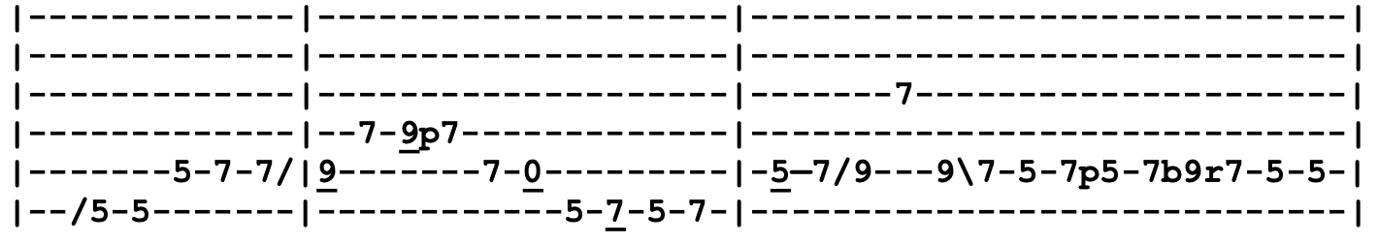

Verse 1 D G D G
First thing I remember knowing was a lonesome whistle blowing
D G A
And a youngin's dream of growing up to ride
D G D G
On a freight train leaving town not knowing where I's bound
D A D
No one could steer me right but mama tried
Verse 2 One and only rebel child from a family meek and mild
Mama seemed to know what lay in store
In spite of all my Sunday learning, for the bad I kept on turning
Mama couldn't hold me anymore

Chorus D C D
I turned 21 in prison doing life without parole
Bm A
No one could steer me right but mama tried, mama tried D G D
Mama tried to raise me better but her pleading I denied
A D (Intro Riff)
That leaves no one but me to blame 'cause mama tried
Verse 3 Dear old daddy rest his soul, left my mom a heavy load
She tried so very hard to fill his shoes
Working hours without rest, wanted me to have the best
She tried to raise me right but I refused (Chorus)
Lead=Verse
Chorus (repeat the last line and tag it)

Man of Constant Sorrow (D)
Intro d d f# g A D

Verse 1 D D⁷ G A D
I am a man of constant sorrow, I have seen trouble all my day
I bid farewell to old Kentucky, a state where I was born and raised

Lead=Verse

Verse 2 For six long years I’ve been in trouble
No pleasure here on earth I found
For in this world I’m bound to travel
I have no friends to help me now (Lead=Verse)

Verse 3 You may bury me in some deep valley
For many years where I may lay
There you may learn to love one another
While I am sleeping in my grave (Lead=Verse)

Verse 4 Maybe your friends think I’m just a stranger
My face you’ll never see no more
But there is one promise that is given
I’ll meet you on God’s golden shore
Outro d d f# g A D

Me and Bobby McGee (D)
Verse 1 D A
Busted flat in Baton Rouge waiting for a train, feeling nearly faded as my jeans
A⁷ D
Bobby flagged a diesel down just before it rained, took us all the way to New Orleans
D
I took my harpoon out of my dirty red bandana
G
I was blowing sad while Bobby sang the blues
D
With them windshield wipers slapping time, Bobby clapping hands
A D D⁷
We finally sang near every song that driver knew
Chorus 1 G D
Freedom's just another word for nothing left to do
A D
Nothing ain't worth nothing but it's free
Feeling good was easy, Lord, when Bobby sang the blues
Feeling good was good enough for me, good enough for me and Bobby McGee
Lead=Verse
Verse 2 From the coal mines of Kentucky to the California sun
Bobby shared the secrets of my soul
Standing right beside me, Lord, in everything I done
Bobby's body kept me from the cold
Then somewhere near Salinas, Lord, I let her slip away
Looking for that home, I hope she finds it
And I'd trade all my tomorrows for one single yesterday
Holding Bobby's body close to mine
Chorus 2 Freedom's just another word for nothing left to lose
Nothing was all she left for me
Feeling good was easy, Lord, when Bobby sang the blues
Feeling good was good enough for me, good enough for me and Bobby McGee
Vocal Jam La-de-da, la-de-lay-hah, la-de-da, la-de-lay-hay
Chorus 1
Outro D D# E A D A D
Me and My Uncle (G)
Intro Em B⁷ Em
Verse 1 G Em
Me and my uncle went riding down
South Colorado, West Texas bound
We stopped over in Santa Fe
G A
That being the point, just about half way
Em B⁷ Em
And you know it was the hottest part of the day
Verse 2 I took the horses up to the stall, went to the barroom, ordered drinks for all
Three days in the saddle, you know my body hurt
It being summer, I took off my shirt
And I tried to wash off some of that dusty dirt
Verse 3 West Texas cowboys, they's all around
With liquor and money, they's loaded down
So soon after payday, know it seemed a shame
You know my uncle, he starts a friendly game
It's high-low jack and the winner take the hand (Intro ¢ Lead=Verse)
Verse 4 My uncle starts winning, cowboys got sore
One of them called him and then two more
Accused him of cheating, oh no, it couldn't be
I know my uncle, he's as honest as me, ayyy
And I'm as honest as a Denver man can be
Verse 5 One of them cowboys, he starts to draw, I shot him down, Lord, he never saw
Shot me another, oh damn, he won't grow old
In the confusion my uncle grabbed the gold
And we high-tailed it down to Mexico (Intro)
Verse 6 I love those cowboys, I love their gold, I loved my uncle, God rest his soul
He taught me good, Lord, he taught me all I know
Taught me so well I grabbed that gold
And I left his dead ass there by the side of the road (tag it!)
Mexicali Blues (D)
Intro D A D
Verse 1 A C B Em
Laid back in an old saloon with a peso in my hand
A D
Watching flies and children on the street
I catch a glimpse of black-eyed girls who giggle when I smile
There's a little boy who wants to shine my feet
G B Em
And it's three days ride from Bakersfield and I don't know why I came
A D
I guess I came to keep from paying dues
G B Em
So instead I've got a bottle and a girl who's just fourteen
A
And a damn good case of the Mexicali blues, yeah
Chorus D A ^{(hold for remainder of chorus)}
Is there anything a man don't stand to lose when the Devil wants to take it all away?
Cherish well your thoughts and keep a tight grip on your booze
'Cause thinking and drinking are all I have today-ay (Lead=Intro)
Verse 2 She said her name was Billy Jean and she was fresh in town
I didn't know a stage line ran from hell
She had raven hair, a ruffled dress, a necklace made of gold
All the french perfume you'd care to smell
She took me up into her room and whispered in my ear
“Go on, my friend, do anything you choose”
Now I'm paying for those happy hours I spent there in her arms
With a lifetime's worth of the Mexicali blues, yeah (Chorus)
Verse 3 And then a man rode into town, some thought he was the law
Billy Jean was waiting when he came
She told me he would take her if I didn't use my gun
I'd have no one but myself to blame
I went down to those dusty streets, blood was on my mind
I guess that stranger hadn't heard the news
'Cause I shot first and killed him, Lord, he didn't even draw
Now I spend my lifetime running with the Mexicali blues
Chorus Is there anything a man don't stand to lose
When he lets a woman hold him in her hands?
He just might find himself out there on horseback in the dark
Just riding and running across those desert sands
Midnight Hour (D)

Intro C A G F
D G (x4)
Verse 1 D G D G
Gonna wait till the midnight hour
Till my love come tumbling down
Gonna wait till the midnight hour
Till there’s no one else around
Chorus A G
Gonna take you girl and hold you
A G D G D G C A
Do all the things I told you in the midnight hour oh yes I am

Verse 2 Gonna wait till the stars come out
The twinkling in your eyes
Gonna wait till the midnight hour
That's when my love begins to shine
Chorus A G
You're the only girl I know
A G D G D G C A
Really love to show you in the midnight hour oh yes I am

Lead D G D G D G A
D G D C A
Verse 1

Vocal Jam G D G D
Just you and I, just you and I
Oh, midnight hour
Gonna wait, wait, wait, till the midnight hour
Oh you and I
Outro C A G F D
Midnight Moonlight (A)
Intro Riff in A (x8)

Verse 1 A E Bm
If you ever feel lonesome and you're down in San Antone
E D G A
Beg, steal, or borrow two nickels or a dime to call me on the phone
E Bm
And I'll meet you at Alamo Mission, we can say our prayers
E F^{#m} E D
The Holy Ghost and the Virgin Mother will heal us as we kneel there
Chorus G D G D G D A
In the moonlight, in the midnight in the moonlight, Midnight Moonlight (x2)

Verse 2 If you ever feel sorrow for the things you might have done
With no hope for tomorrow in the setting of the sun
And the ocean is howling for the things that might have been
That last good morning sunrise will be the brightest you've ever seen
Chorus
Lead=Verse ¢Chorus
Verse 1 ¢ Chorus
Verse 2 ¢ Chorus (x2)
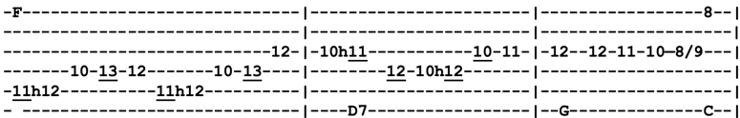
Might As Well (C)
Intro=Chorus
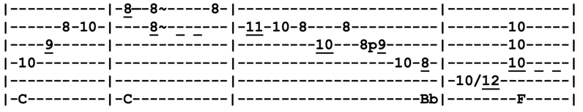
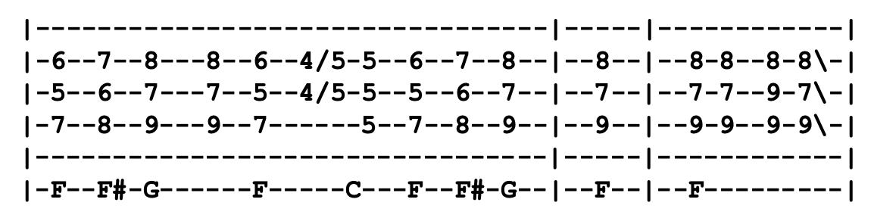

Verse 1 C B^{b} F E^{b}
Great North Special, were you on board? You can't find a ride like that no more
D G
The night the chariot swung down low, ninety-nine children had a chance to go
One long party from front to end, tune to the whistle going 'round the bend
No big hurry, what do you say? Might as well travel the elegant way
Chorus C B^{b}
You might as well, might as well (might as well, might as well)
F E^{b}
Might as well, might as well (might as well, might as well)
D G F
Might as well, might as well (might as well) might as well
C F F# G F C F F# G F
Might as well (might as well) might as well, might as well (might as well)
Verse 2 Ragtime slowly for 25 miles, then switch over to the cajun style
Bar car loaded with rhythm and blues, rock and roll wailing in the old caboose
Long train running from coast to coast
Bringing 'long the party where they need it the most
Work on the box car, beat on the bell
Nothing else shaking so you might just as well (Chorus)
Break C G B^{b} F F# G B^{b}
Never had such a good time in my life before, I'd like to have it one time more
F D G E⁷ Am B^{b} F F# G
One good ride from start to end, I'd like to take that ride again, again
Lead=Verse ¢ Chorus
Verse 5 Ran out of track and I caught the plane, back in the county with the blues again
Great North Special been on my mind, I might like to ride it just one more time
Chorus (x2) (repeat last line x8)
Jam C F F# G (x16)
Mighty Quinn (C)
Titled as "Quinn the Eskimo" by Bob Dylan, first released by Manfred Mann as "Mighty Quinn"
Intro Riff ¢ C F (x4)
Verse 1 C F C F
Everybody's building ships and the boats
Some are making monuments, some are jotting down notes
Everybody's in despair, every girl and boy
C G F C
When Quinn the Eskimo gets here everybody's gonna jump for joy
Chorus C G C
Come all without, come all within
C⁷ F C
You'll not see nothing like the Mighty Quinn
C G C
Come all without, come all within
C⁷ F C F C F C
You'll not see nothing like the Mighty Quinn
Verse 2 Like my coffee, like the rest, I like my sugar sweet
Dropping cues and making haste just ain't my cup of meat
Everybody's 'neath the trees feeding pigeons on a limb
When Quinn the Eskimo gets here
All the pigeons gonna run to him (Chorus)

Lead=Verse

Verse 3 Ever do what I want you to, I can't decide in my heart
Tell me where you put it and I'll tell you who to call
Nobody can get no sleep, there's someone on everyone's toes
When Quinn the Eskimo gets here
Everybody's gonna wanna dose (Chorus)

Lead=Verse
Chorus (acapella) ¢ Chorus (with band)
Outro=Intro Riff
Mission in the Rain (A) Intro
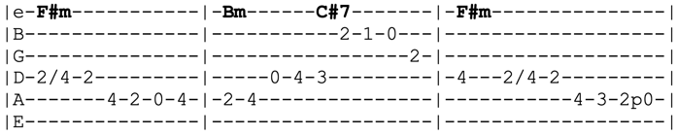
Intro F^{#m} Bm C^{#7} F^{#m}
F^{#m} C^{#7} Em G
I turn and walk away then I come 'round again
D A C^{#7} F^{#m}
It looks as though tomorrow I'll do pretty much the same

C^{#7} Em G
I must turn down your offer but I'd like to ask a break
D A

You know I'm ready to give everything
C^{#7} F^{#m} F# Bm C^{#m} D A D A D
For anything I take
Verse 1 E D A D A
^{(half)} Someone called my name you know I turned around to see
Bm E A D E D E
It was midnight in the Mission and the bells were not for me, come again
Chorus Bm C^{#m} D A G D
Walking along in the Mission in the rain, come again
Bm C^{#m} D A
Walking along in the Mission in the rain
Verse 2 Ten years ago I walked this street my dreams were riding tall
Tonight I would be thankful, Lord, for any dream at all
Some folks would be happy just to have one dream come true
Bm E A D E D E
But everything you gather is just more that you can lose, come again (Chorus)
Lead=Verse 2 ¢ Chorus
Verse 3 All the things I planned to do I only did half way
Tomorrow will be Sunday born of rainy Saturday
There's some satisfaction in the San Francisco rain
No matter what comes down, the Mission always looks the same, come again
Chorus (x2)
Lead=Chorus
Mississippi Half-Step Uptown Toodleloo (C)
Intro Am⁼⁵⁷⁷⁵⁵⁵ Am^{maj7=576555} A^{m7=575555} D^{9=x04555} D⁷ G⁷
Verse 1 C E⁷ F Am
On the day when I was born Daddy sat down and cried
F C G D⁷ G⁷
I had the mark just as plain as day which could not be denied
C E⁷ F Am
Say that Cain caught Abel rolling loaded dice
F C G F E⁷
Ace of spades behind his ear, him not thinking twice
Chorus Am
Half-step Mississippi uptown toodleloo
F C G F C G
Hello baby, I'm gone goodbye, half a cup of rock and rye
F C G Am E⁷
Farewell to you, old southern skies, I'm on my way, on my way
Lead Am⁼⁵⁷⁷⁵⁵⁵ Am^{maj7=576555} A^{m7=575555} D9^{=x04555}
F D7 B7 E⁷
Am Am^{maj7} A^{m7} D9
F Am D7 G G⁷
Verse 2 If all you got to live for is what you left behind
Get yourself a powder charge and seal that silver mine
Lost my boots in transit, babe, pile of smoking leather
Nailed a retread to my feet and prayed for better weather (Chorus)
Lead=Verse
Verse 3 They say that when your ship comes in, first man takes the sails
Second takes the afterdeck, the third the planks and rails
What's the point to calling shots, this cue ain't straight in line
Cue ball's made of styrofoam and no one's got the time
Chorus (After chorus, Jerry sang one more "on my way!" and then transition to outro chords)
Lead A D
Outro A D A D
Across the Rio Grandeo, across the lazy river (x8)
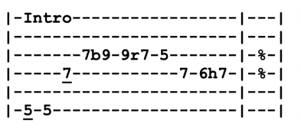
Lead A D
Mr. Charlie (A)
Intro A⁷ (x4)
Verse 1 A⁷
I take a little powder, take a little salt
Put it in my shotgun and I go walking out
Chorus D
Jubba jubba (jubba jubba), wooley-booly (wooley-booly)
A⁷
Looking high (looking high), looking low (looking low)
E⁷ D⁷ (stop!) A⁷
Gonna scare you up and shoot ya, Mr. Charlie told me so

Verse 2 I won't even take your life, won't even take a limb
Just unload my shotgun, take a little skin (Chorus)
Lead=Verse (solo in A Blues Scale)

Break C C# D C C# D
Well, you take a silver dollar, take a silver dime
E
Mix it up together in some alligator wine
Verse 3 I can hear the drums, voodoo all night long
Mister Charlie telling me I can't do nothing wrong (Chorus)
Verse 4 Well, Mr. Charlie told me, thought you'd like to know
Give you little warning before I let you go
Chorus (after singing chorus, repeat last line with slight alteration)
Gonna scare you up and shoot ya, Mr. Charlie told me, Mr. Charlie told me so
A Blues Scale
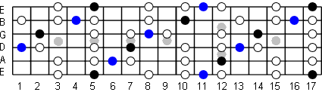

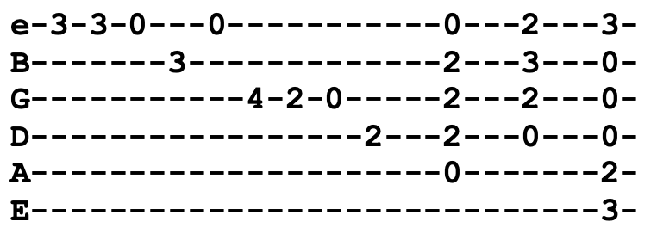
Monkey and the Engineer (G)
Intro Riff G A D G
Verse 1 G C G
Once upon a time there was an engineer
A D
Drove a locomotive both far and near
G C
Accompanied by a monkey that would sit on a stool
G A D G
Watching everything the engineer would do
Verse 2 One day the engineer wanted a bite to eat
He left the monkey sitting on the driver's seat
The monkey pulled the throttle, locomotive jumped the gun
And did 90 miles an hour down the mainline run

Chorus Big locomotive right on time
Big locomotive coming down the line
Big locomotive number 99 left the engineer with a worried mind (Riff)

Verse 3 The engineer called up the dispatcher on the phone
Tell him all about his locomotive was gone
Get on the wire, switch operator to the right
'Cause the monkey's got the mainline sewed up tight
Verse 4 Switch operator got the message on time
Said there's a northbound living on the same mainline
Open up the switch, I'm gonna let him through the hole
'Cause the monkey's got the locomotive under control (Chorus)
Lead=Verse
Chorus (repeat "left the engineer with a worried mind" x3) (Intro Riff)
Morning Dew (G)
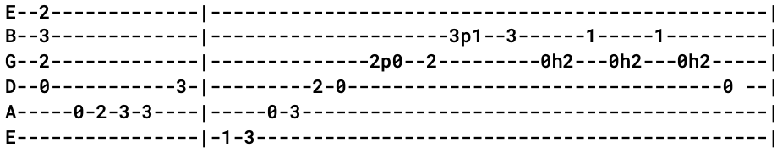
Intro D C F D C D C F D C D
Verse 1 D C G D
Walk me out in the morning dew, my honey
Walk me out in the morning dew today
F C Em D
I can't walk you out in the morning dew, my honey
F C Em D C G D C G D
I can't walk you out in the morning dew today
Verse 2 I thought I heard a baby cry this morning
I thought I heard a baby cry today
You didn't hear no baby cry this morning
You didn't hear no baby cry today
Verse 3 Where have all the people gone, my honey?
Where have all the people gone today?
There's no need for you to be worrying about all those people
You never see those people anyway
Verse 4 I thought I heard a young man mourn this morning
I thought I heard a young man mourn today
I thought I heard a young man mourn this morning
I can't walk you out in the morning dew today (two octave chromatic climb in D)
Lead=Verse (seering lead in D Mixolydian)
Verse 5 Walk me out in the morning dew, my honey
Walk me out in the morning dew today
I'll walk you out in the morning dew, my honey
I guess it doesn't matter anyway (x4)
Lead F C Em D
Outro F C Em D
I guess it doesn't matter anywayyyy
Mountains of the Moon (G)
Intro G^{sus2} G F^{/G} Dm^{/G} G F^{/G}
Dm^{/G} G F^{/G} G F Dm G

Verse 1 G F Dm G
Cold mountain water, the jade merchant's daughter
Mountains of the moon, Electra bow and bend to me
Hi ho the carrion crow fol de rol de riddle
Hi ho the carrion crow bow and bend to me

Chorus C G C G
Hey, Tom Banjo, hey a laurel
Dm G
More than laurel you may sow (x2)
Dm⁷ C G^{/B} Am D^{/F#} G
Hey, the laurel, hey the city in the rain
C G^{/B} F C^{/G} G^{/F} Em Dm⁷
Hey, hey, hey the wild wheat waving in the wind

Verse 2 Twenty degrees of solitude, twenty degrees in all
All the dancing kings and wives assembled in the hall
Lost is the long and loneliest town, fairly Sybil flying
All along the, all along the mountains of the moon

Chorus Hey, Tom Banjo, it's time to matter
The earth will see you on through this time
The earth will see you on through this time
Down by the water, the Marsh King's daughter, did you know?
Clothed in tatters always will be, Tom, where did you go?

Verse 3 Mountains of the moon, Electra, mountains of the moon
All along the, all along the mountains of the moon
Hi ho the carrion crow fol de rol de riddle
Hi ho the carrion crow bow and bend to me

Outro Dm
Bend to me (da da da da da da)
Music Never Stopped (E)
Intro Riff (x8) E A C
V1 E A C E A C
There's mosquitoes on the river, fish are rising up like birds
E A C
It's been hot for seven weeks now, too hot to even speak now
E
Did you hear what I just heard?
Say, it might have been a fiddle (oooooo), or it could've been the wind (oooooo)
But there seems to be a beat now, I can feel it my feet now, listen here it comes again
A^{7=xx7989} A^{dim7=xx7878} B^{m7-5 =xx7767} A^{=xx7655}
There's a band out on the highway, they're high stepping into town
It's a rainbow full of sound, it's fireworks, calliopes and clowns
A^{6=xx7670} B^{m7-5=xx7767} A^{=xx7650} D^{#dim7=xx7878} Dm A D E
Everybody dancin' (short Jerry solo)
Bridge A^{6=xx7670} B^{m7-5 =xx7767} A^{=xx7650} D^{#dim7=xx7878} D^{/E} E
C'mon children, c'mon children, c'mon on clap your hands
V2 A A⁷ D F G A A⁷ D F G
Sun went down in honey and the moon came up in wine
A A⁷ D F G
You know stars were spinning dizzy, Lord, the band kept us so busy
D E A
We forgot about the time
V3 They're a band beyond description like Jehovah's favorite choir
People joining hand in hand while the music plays the band, Lord, they're setting us on fire
Crazy rooster crowing midnight (oooooo), balls of lighting roll along (oooooo)
Old men sing about their dreams (oo), women laugh and children scream (oooooo)
And the band keeps playing on
A^{7=xx7989} A^{dim7=xx7878} B^{m7-5 =xx7767} A^{=xx7655}
Keep on dancing through to daylight, greet the morning air with song
No one’s noticed but the band's all packed and gone, was it ever here at all?
A^{6=xx7670} B^{m7-5=xx7767} A^{=xx7650} D^{#dim7=xx7878} Dm A D E
But they kept on dancin' (short Jerry solo) (Bridge)
V4 Well, the cool breeze came on Tuesday and the corn's a bumper crop
And the fields are full of dancing, full of singing and romancing
The music never stopped E F# B
Jam 1 (6/8 Time) B A B A (x16-ish)
Jam 2 (main theme) E A C
Outro=Intro
My Sisters and Brothers (A)

Intro A

Verse 1 A D
I wanna say to my sisters and my brothers, “Keep the faith”
A E
When the storm flies and the wind blows, go on at a steady pace
A
When the battle is fought and the victory's won
D
We can all shout together,“We have overcome”
A D A
We'll talk to the father and the son when we make it to the Promised Land

Chorus (If we) walk together little children, we don't ever have to worry
Through this world of trouble we gotta love one another
Let us take our fellow man by the hand, try to help him to understand
We can all be together forever and ever
When we make it to the Promised Land

Verse 2 Our bible reads, thou shall not be afraid
Of the terror by night or the arrow that flies by day
Nor for the pestilence, waiteth in the darkness
Nor for the destruction that walketh in the noon day hour (Chorus)
Lead=Verse
Verse 3 This world is not our home, we are only passing through
Our trail is all made up way beyond the blue
Let us do the very best that we can while we're traveling through this land
We can all be together shaking our hands
When we make it to the Promised Land
Outro Make it to the Promised Land (x3) (children/people)
Make it to the Promised Land (x3)
We can all be together forever and ever when we make it to the Promised Land (x2)

Mystery Train (E)
Jerry regularly interchanged the lyrics of this song
Intro Riff E A E A E (x8)
Verse 1 A E (riff)
Train I ride, sixteen coaches long (x2)
B⁷ A E
Well the woman I love, she's on that train and gone
Chorus 1 Train train, rolling down the track (x2)
Took away my baby, you know it ain't bringing her back

Bridge D D# E D D# E
Well I went down to the station, meet my baby at the gate
Asked the stationmaster, “Is the train a-running late?”
He said, “If you been waiting for the four-fourty-fo
I hate to tell you, boy, that train don't run here anymore”

Chorus 2 Train train, rolling 'round the bend (x2)
Took away my baby, I'll never see her again

Lead=Verse

Bridge
Chorus 2 (repeat last line x3)
New Minglewood Blues (E)
Verse 1 A G E
I was born in the desert, raised in a lion's den
Said, I was born in the desert, raised in a lion's den
B E
Yes, and my number one occupation is stealing women from their men
Verse 2 Well, I'm a wanted man in Texas, busted jail and I'm gone for good
Said, I'm a wanted man in Texas, busted jail and I'm gone for good
Well, the sheriff couldn't catch me but his little girl sure wish she would
Lead=Verse
Verse 3 Well, now the doctor call me crazy, sometimes I am, sometimes I ain't
Said now the doctor call me crazy, sometimes I am, sometimes I ain't
Yes, and the preacher man call me sinner, but his little girl call me saint
Verse 4 Well, a couple shots of whiskey, women 'round here start looking good
I said a couple shots of whiskey, women 'round here start looking good
A couple more shots of whiskey, I'm going down to Minglewood
Lead=Verse
Verse 5 Well, it's tea for Texas, yes and it's tea for Timbuktu
Well, it's tea for Texas, yes and it's tea for Timbuktu
And it's tea for New York City where the little girls know what to do
Verse 6 Said, I was born in the desert, raised in a lion's den
Said, I was born in the desert, raised in a lion's den
Yes, and my number one occupation is stealing women from their men
Oh, my number one occupation is stealing women from their men
New Speedway Boogie (E)
Below is Workingman's Dead version. Once song returned in 1991, they say "one way or another" after verses. Jerry regularly mixed up the lyrics to these verses.
Intro

Verse 1 E E D E
Please don't dominate the rap, Jack, if you've got nothing new to say
If you please, don't back up the track, this train is got to run today
E E⁷⁼⁰⁷⁶⁷⁵⁰ E
I spent a little time on the mountain, spent a little time on the hill
G D A
I heard someone say, “Better run away,” others say, “Better stand still”
Now, I don't know but I been told, “It's hard to run with the weight of gold”
Other hand I've heard it said, “It's just as hard with the weight of lead”
Jam in E
Verse 2 Who can deny, who can deny, it's not just a change in style
One step down and another begun and I wonder how many miles
I spent a little time on the mountain, spent a little time on the hill
Things went down we don't understand but I think in time we will
Now I don't know but I was told, “In the heat of the sun a man died of cold”
Keep on running or stand and wait with the sun so dark and the hour so late
Jam in E
Verse 3 You can't overlook the lack, Jack, of any other highway to ride
It's got no signs or dividing lines and very few rules to guide
I spent a little time on the mountain, I spent a little time on the hill
I saw things getting out of hand, I guess they always will
I don't know but I been told, “If the horse don't pull you got to carry the load”
I don't know whose back's that strong, maybe find out before too long
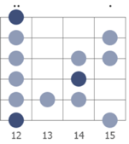
Chorus One way or another (x3), this darkness got to give (repeat x4)
E Blues
Vocal Jam This darkness got to give (x4)

Next Time You See Me (A)
Intro E D A D E

Verse 1 A D A
Next time you see me, things won't be the same
D A
Next time you see me, things won't be the same
E D A E
If it hurts you, my darling, you only got yourself to blame

Verse 2 Well, it's a true, true saying– “all that shines is not gold” (x2)
Like the good book says, “You gotta reap just what you sow”

Chorus A A A (stop!) A
Well, you lied, cheated, whoa-oh, for so long
D D D (stop!) A
Well, you lied, cheated, whoa-oh, for so long
E D A
You were wrong to do it, woman, and another queen is on your throne

Lead=Verse (solo in A Major Pentatonic)
Chorus
Verse 1
Verse 2
A Major Pentatonic
The Night They Drove Old Dixie Down (C)

Verse 1 Am C^{/G} F C^{/E} Dm
Virgil Caine is the name and I served on the Danville train
Till Stoneman's cavalry came and tore up the tracks again
Am^{/E} F C^{/G} F
In the winter of '65, we was hungry, just barely alive
Am^{/E} F C^{/G} F D^{7/F#}
By May the tenth, Richmond had fell, it was a time I remember oh so well

Chorus C^{/G} F C^{/G} F
The night they drove old Dixie down, and all the bells were ringing
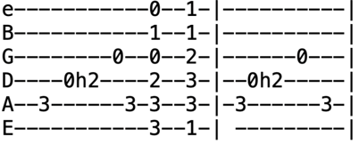
The night they drove old Dixie down, all the people were singing
C^{/G} Am G B^{b} F C F C
Nah na na nah na na, nah na na na na, nah na na na

Verse 2 Back with my wife in Tennessee, one day she called for me
“Virgil, quick come see there goes Robert E. Lee”
I don't mind chopping wood
And I don't care if the money's no good
Take what you need and you leave the rest
They should never have taken the very best (Chorus)
Lead=Verse ¢ Chorus
Verse 3 Like my father before me, I'm a peaceful man
Like my brother before me, I took a rebel stand
Just eighteen, proud and brave
But a Yankee laid him in his grave
Swear by the mud runs on my feet
You can't raise a Caine back up when he's in defeat (Chorus)
Outro C C^{/B} B^{b} A⁵ G G^{/Gb} B^{b/F} F

Chorus The night they drove old Dixie down
The night they drove old Dixie down
Nah na na nah na na, nah na na na na, nah na na na

Not Fade Away (E)
Intro E E E A E (x4)
E A E E E (x4)
Verse 1 E A D A
I wanna tell you how it's gonna be
E E A E
You're gonna give your love to me
I wanna love you night and day
You know our love not fade away (x2)
Not fade away!
Break A D A | A D A | E A E | E A E | (x2)
Verse 2 My love is bigger than a Cadillac
I try to show you but you drive me back
Your love for me has got to be real
You're gonna know just how I feel
Love is real, not fade away, not fade away! (Break)
Jam in E (solo in E Mixolydian)
Verse 1
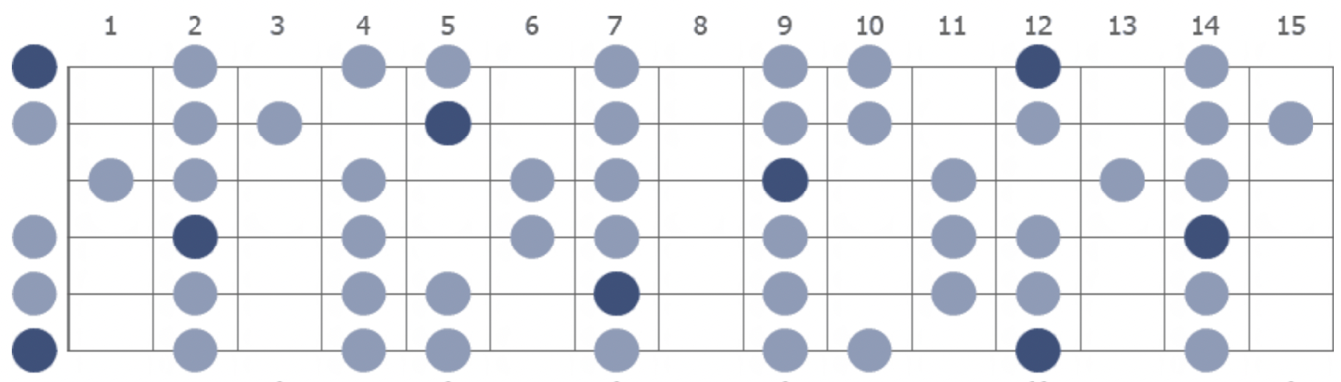
Vocal Jam You know our love not fade away (x8)
(alternate between the two vocal jam parts)
a) Not fade away (not fade away), not fade away (not fade away)
You know our love not fade away
b) (Mbop bop, bop bop), you know our love not fade away (x4)
E Mixolydian

Off To Sea Once More (Dm) 3/4 Time
Intro (first line of verse)
Verse 1 Dm C Am Dm C Dm
When first I came to Liverpool, I went upon a spree
F C A
Me money alas, I spent too fast, got drunk as drunk could be
Dm F C A
And when my money was all gone, 'twas then I wanted more
Dm C Am Dm C Dm (Intro)
But a man must be blind to make up his mind to go to sea once more
Verse 2 I spent the night with Angeline, too drunk to roll in bed
My watch was new and money too, in the morning with 'em she fled
And as I roamed the streets about, the whores they all would roar
Here comes Jack Rack, the young sailing lad, he must go to sea once more
Instrumental=Verse
Verse 3 As I was walking down the street, I met with Rapper Brown
I asked for him to take me in and he looked at me with a frown
He said, “Last time you was paid off with me you jobbed no score
But I'll take your advance and I'll give ya's a chance
And I'll send you to sea once more” (Intro)

Verse 4 I hired me aboard of a whaling ship bound for the Artic seas
Where the cold winds blow through the frost and the snow
And Jamaican rum would freeze
And worst and bear I'd no hard weather gear for I'd lost all my money ashore
'Twas then that I wished that I was dead so I'd gone to sea no more
Instrumental=Verse
Verse 5 Some days we're catching whales, me lads, and some days we're catching none
With a twenty-foot oar cocked in our hands from four o'clock in the morn
And when the shades of night come in we rest on our weary oar
'Twas then I wished that I was dead or safe with the girls ashore (Intro)

Verse 6 Come all, you bold seafaring men, and listen to my song
If you come off of them long trips, I'd have ya's not go wrong
Take my advice, drink no strong drink, don't go sleeping with no whores
Get married, lads, and have all night in so you'll go to sea no more (Intro)
Oh, Babe It Ain't No Lie (C)
Intro=Verse ¢ Chorus
Verse 1 C F C F G C
One old woman, Lord, in this town keep a-telling her lies on me
Wish to my soul that old woman would die, keep a-telling her lies on me

Chorus G C E E⁷ F
oh, babe it aint no lie, oh, babe it ain't no lie
C^{=x32013} C^{#=x43024}
Oh, babe it aint no lie
D C G C
You know this life I'm living is mighty fine
Instrumental=Verse ¢ Chorus
Verse 2 Been all around this whole round world

And I just got back today
Work all the week, honey, I'd give all to you
Honey, baby, what more can I do?
Chorus
On the Road Again (C)
Intro (Jerry played riff in low register when acoustic like Reckoning; on electric, he played in high register)
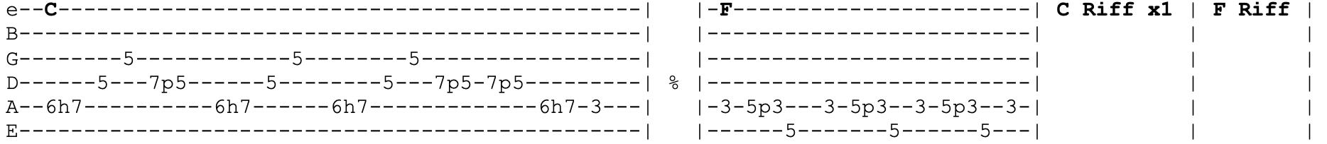

Verse 1 C⁷
Would not my fat girl tell you the reason why?
Fat girls will even do things on the sly
Look for your supper to be good and hot
She never even put a stewbone in the pot
Chorus 1 F
She's on the road again (sure as you're born)
C
Natural born easy on the road again
F
On the road again (sure as you're born) (C Riff x2)
Verse 2 Friend come by, say he's looking for his hat
Wants to know where your husband's at
She said, “I don't know, he's on his way to the pen”
Come on, pretty mama, let's get on the road again
Chorus 2 ("On the road again")
Lead=Chorus
Verse 3 Went to my house, the front door was locked
^{(add'l line)} Went 'round to my window but my window was locked
Jumped right back, shook my head, big old rounder in my folding bed
Shot through the window, broke the glass
Never seen that little rounder run so fast

Chorus 3 ("He's on the road again")
Chorus 2
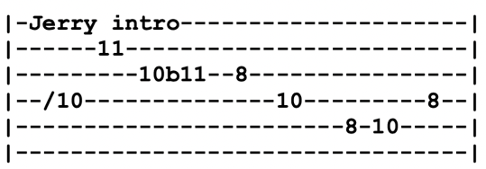
One More Saturday Night (C)
Intro Riff (x4)
Verse 1 C⁷
I went down to the mountain, I was drinking some wine
Looked up into heaven, Lord, I saw a mighty sign
Writ in fire across the heaven plain as black and white
Get prepared there's gonna be a party tonight
Chorus F⁷ C⁷
Uh huh, hey Saturday night
G⁷ B^{b} F⁷ C⁷
Hey uh huh, one more Saturday night, hey Saturday night
Verse 2 Everybody's dancing down the local armory
With a basement full of dynamite and live artillery
Temperature keeps rising, everybody getting high
Come the rockin' stroke of midnight, the place is gonna fly (Chorus)
Lead=Verse ¢ Chorus
Verse 3 Turn on channel six, the president comes on the news
Says, “I get no satisfaction, that's why I sing the blues”
His wife say, “Don't get crazy, Lord, you know just what to do
Crank up that old Victrola, put on your rockin' shoes” (Chorus)
Verse 4 Then God way up in heaven for whatever it was worth
Thought he'd have a big old party, thought he'd call it planet Earth
Don't worry about tomorrow, Lord, you'll know it when it comes
When the rock and roll music meets the rising shining sun (Chorus)
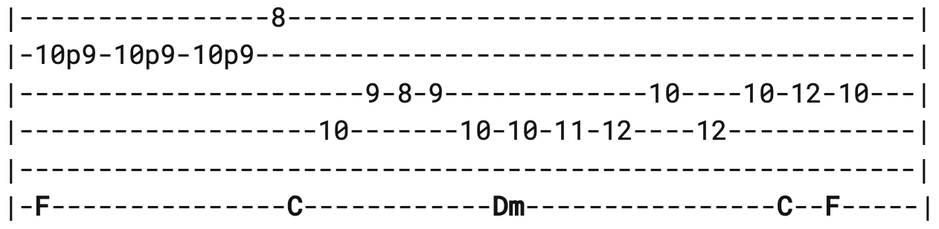
Intro Riff (x4)
Jam | C E^{b} B^{b} F | C E^{b} B^{b} F | F F# G | G G# A B^{b}
Outro Playing on a Saturday night (one more saturday night) (x2)
Everybody getting high (one more saturday night)
Playing on a Saturday night (one more saturday night)
One more Saturday, one more Saturday night
Operator (F)
Intro

Verse 1 F
Operator, can you help me, help me if you please?
B^{b} F F#
Give me the right area code and the number that I need
G C
My rider left upon the midnight flyer
Dm F
Singin' like a summer breeze

Verse 2 I think she's somewhere down south, down about Baton Rouge
But I just can't remember no number, a number I can use
Directory don't have it, central done forgot it
Got to find a number to use (Intro)
Verse 3 Tryin' to check out her number, tryin' to run down her line
Operator said that's privileged information and it ain't no business of mine
It's floodin' down in Texas, the poles are out in Utah
Got to find a private line

Verse 4 She could be hangin' round the steel mill
Workin' in the house of blue lights
Ridin' a getaway bus out of Portland, talkin' to the night
I don't know where she's goin', I don't care where she's been
As long as she's been doin' it right
Lead=Verse
Outro=Intro (play intro riff twice, at end of second one, repeat last line)
As long as she's been doin' it right

The Other One (E) 12/8 Time

Intro E D

Verse 1 Spanish lady comes to me, she lays on me this rose
It rainbow spirals round and round, it trembles and explodes
It left a smoking crater in my mind, I like to blow away
But the heat come 'round and busted me for smiling on a cloudy day
Chorus E E D C A G
Comin', comin', comin' around, comin' around
E D C A G
Comin' around, comin' around
Comin', comin', comin' around, comin' around
Comin' around, comin' around
Jam=Intro

Verse 2 Skipping through the lily fields, I came across an empty space
It trembled and exploded, left a bus stop in it's place
The bus came by and I got on, that's when it all began
There was cowboy Neal at the wheel of the bus to never ever land
Chorus
Peggy-O (A)
Initially in Key of G for first four years, and then on 2/27/77 it shifted to Key of A where it remained
Intro A
Verse 1 A D A F^{#m} C^{#m}
As we rode out to Fennario, as we rode out to Fennario
D A F^{#m}
Our captain fell in love with a lady like a dove
A D A
And he called her by name, pretty Peggy-O
Verse 2 Will you marry me, pretty Peggy-O? (x2)
If you will marry me I will set your cities free
And free all the ladies in the area-o
Verse 3 I would marry you, sweet William-O (x2)
I would marry you but your guineas are too few
And I fear my mama would be angry-o
Verse 4 What would your mama think, pretty Peggy-O? (x2)
What would your mama think if she heard my guineas clink
Saw me marching at the head of my soldiers-o
Lead (solo in A Major Pentatonic)
Verse 5 If ever I return, pretty Peggy-O (x2)
If ever I return your cities I will burn
Destroy all the ladies in the area-o
Verse 6 Come stepping down the stairs, pretty Peggy-O (x2)
Come stepping down the stairs combing back your yellow hair
Bid a last farewell to your William-O
Verse 7 Sweet William he is dead, pretty Peggy-O (x2)
Sweet William he is dead and he died for a maid
And he's buried in the Louisiana country-o
Verse 1

Pig In A Pen (A)
Intro=Verse
Chorus A D
I got a pig home in a pen, corn to feed him on
A E A
All I need is a pretty little girl to feed him when I'm gone

Verse 1 Dark clouds are rising
Sure sign of rain
Get your old grey bonnet on
Sweet little Liza Jane (Chorus)

Lead=Verse

Verse 2 Bake them biscuits, baby
Bake 'em good and brown
When you get them biscuits baked
We're Alabama bound (Chorus)

Lead=Verse

Verse 3 Going on a mountain to sow a little cane
Raise a barrel of sorghum
Sweet little Liza Jane (Chorus)

Playing in the Band (D) 10/4 Time

e----------------------------------
B-----3-----3-----3--3-3-3---------
G---2-----2-----2------------------
D-0-----0-----0-------------------0
A--------------------3-3-2-0h2p0---
E-- Bob Intro----------------------

e--5--5--3--2h3p2-----
B-----------------5-3-
G---------------------
D---------------------
A---------------------
E- Jerry Intro -------

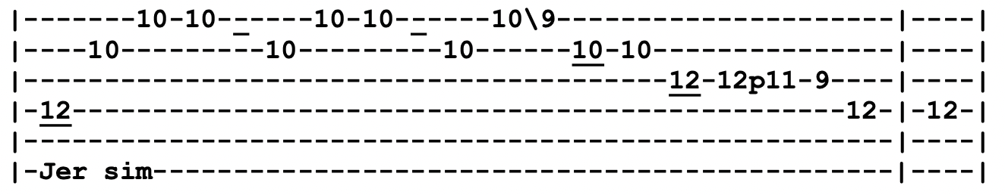
Intro Riff (x4)
Verse 1 D A
Some folks trust reason, others trust to might
I don't trust nothing but I know it come out right
Say it once again now, whoa, I hope you'll understand
When it's done and over, Lord, a man is just a man
Chorus Playing, playing in the band
Daybreak, daybreak on the land

Verse 2 Some folks look for answers, others look for fights
Some folks up in treetops just a-looking for their kites
Whoa, I can tell your future, just look what's in your hand
But I can't stop for nothin', I'm just playing in the band (Chorus)

Break || A / E A | A E / A | A / E A | A / G D :|| (x2)
| A / / / | A / / / |Bm G D Gm|
Verse 3 Standing on a tower, world at my command
You just keep a turning while I'm playing in the band
And if a man among you got no sin upon his hand
Let him cast a stone at me for playing in the band (Chorus)
Jam in D
Positively 4th Street (G)
Intro G
e------------------------3-
B------------------------0-
G------------------------0-
D--0h2--0----------------0-
A-----------0h2--0-------2-
E--------------------3---3-
Verse 1 G Am C G
You got a lotta nerve to say you are my friend
D C Em D
When I was down you just stood there grinning
You got a lotta nerve to say you got a helping hand to lend
You just want to be on the side that's winning
Verse 2 You say I let you down, you know it's not like that
If you're so hurt why then don't you show it?
You say you lost your faith but that's not where it's at
You had no faith to lose and you know it (Lead=Verse)
Verse 3 I know the reason that you talk behind my back
I used to be among the crowd you're in with
Do you take me for such a fool to think I'd make contact
With the one who tries to hide what he don't know to begin with?

Verse 4 You see me on the street, you always act surprised
You say, “How are you? Good luck” but you don't mean it
When you know as well as me, you'd rather see me paralyzed
Why don't you just come out once and scream it? (Lead=Verse)

Verse 5 No, I do not feel that good when I see the heartbreaks you embrace
If I was a master thief perhaps I'd rob them
I know you're dissatisfied with your position and your place
Don't you understand it's not my problem?

Verse 6 I wish that for just one time you could stand inside my shoes
And just for that one moment, I could be you
Yes, I wish that for just one time you could stand inside my shoes
You'd know what a drag it is to see you (Lead=Verse)

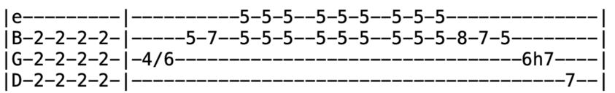
Promised Land (C)
Intro

V1 C F
I left my home in Norfolk Virginia, California on my mind
G C
Straddled that Greyhound, it rode me past Raleigh and on across Caroline
Stopped in Charlotte and bypassed Rock Hill and we never was a minute late
We was ninety miles out of Atlanta by sundown, rolling 'cross the Georgia state
Had motor trouble, it turned into a struggle half way across Alabam
The 'hound broke down, left us all stranded in downtown Birmingham
Lead=Verse

V2 Straight off bought me a through train ticket, right across Mississippi clean
And I was on that midnight flyer out of Birmingham, smoking into New Orleans
Somebody help me get outta Louisiana, help me get to Houston town
There's people there who care a thing about me
And they won't let the poor boy down
Sure as she bore me, she bought me a silk suit, put luggage in my hands
And I woke up high over Albuquerque on a jet to the Promised Land

Lead=Verse
V3 Working on a T-bone steak a-la-carte, flying over to the Golden State
When the pilot told us in thirteen minutes we'd be heading in the terminal gate
Swing low sweet chariot, come down easy, taxi to the terminal zone
Cut your engines, cool your wings and let me make it to the telephone
Los Angeles, give me Norfolk Virginia, Tidewater four ten-o-nine
Tell the folks back home this is the Promised Land calling, poor boy's on the line
Lead=Verse
The Race Is On (G)

Verse 1 G G
I feel tears welling up from down deep inside
C G
Like my heart's got a big break A D
And a stab of loneliness, sharp and painful that I may never shake
G C G
You might think that I'm taking it hard since you broke me off with a call
G
You might wager that I'll hide in sorrow
D G C G (stop!)
And I might lay right down and bawl

Chorus G
Now, the race is on and here comes pride up the back stretch C
Heartaches a-going to the inside
G A D
My tears are holding back, trying not to fall
G C G
My heart's out of the running, true love's scratched for another's sake
D G
The race is on and it looks like heartaches and the winner loses all

Lead=Verse
Verse 2 One day I ventured in love
Never once suspecting what the final result would be
Now I live in fear of wakin up each morning
And finding that you're gone from me
There's an aching pain in my heart
For the name of the one that I hated to face
Someone else came out to win her
And I came out in second place (Chorus)
Lead=Verse
Chorus (repeat last line)
Ramble On Rose (D)
Intro D
Verse 1 D E
Just like Jack the Ripper, just like Mojo Hand
F^{#m} G D G A
Just like Billy Sunday in a shotgun ragtime band
Just like New York City, just like Jericho
Pace the halls and climb the walls, get out when they blow
Chorus D G E
Did you say your name was Ramblin' Rose?
G D A D
Ramble on, baby, settle down easy, Ramble On Rose
Verse 2 Just like Jack and Jill, mama told the sailor
One heat up and one cool down, leave nothing for the tailor
Just like Jack and Jill, papa told the jailer
One go up and one come down, do yourself a favor (Chorus)
Bridge Bm C
I'm gonna sing you a hundred verses in ragtime
Bm C G
I know this song, it ain't never gonna end
Bm C
I'm gonna march you up and down the local county line
D A Bm E E A A
Take you to the leader of the band
Lead=Verse
Verse 3 Just like Crazy Otto, just like Wolfman Jack
Sitting plush with a royal flush, aces back to back
Just like Mary Shelly, just like Frankenstein
Clank your chains and count your change and try to walk the line (Chorus ¢ Bridge)
Verse 4 Goodbye, Mama and Papa. Goodbye, Jack and Jill
The grass ain't greener, the wine ain't sweeter either side of the hill
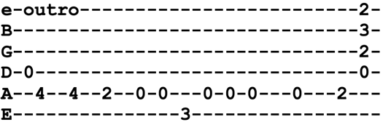
Chorus (after singing chorus, repeat "ramble on Rose")
Outro

Reuben and Cherise (B)
Intro B F# E (x4) F#

Verse 1 B F# E B F#
Cherise was brushing her long hair gently down
B F# E B F#
It was the afternoon of carnival as she brushes it gently down
B F# E B F#
Reuben was strumming his painted mandolin
B F# E B F# E
It was inlaid with a pretty face in jade, played the carnival parade

Verse 2 B F# E B F#
Cherise was dressing as Pirouette in white
B F# E B F#
When a fatal vision gripped her tight, Cherise beware tonight
B F# E B F#
Reuben Reuben tell me truly true
B F# E B F# E
I feel afraid and I don't know why I do, is there another girl for you?

Chorus C^{#m} F# E B B^{sus4} B
If you could see in my heart you would know it's true
E B A A^{sus4} A G#
There's none Cherise except for you, except for you
C^{#m} B F# B F# E EEEEEE F#
I'd swear to it on my very soul, if I lie may I fall down cold

Verse 3 B F# E B F#
When Rubin played on his painted mandolin
B F# E B F#
The breeze would pause to listen in, before going its way again
B F# E B F#
Masquerade began when nightfall finally woke
B F# E B F# E
Like waves against the bandstand, dancers broke to the painted mandolin

Chorus C^{#m} F# E B B^{sus4} B
Looking out on the crowd who was standing there
E B A A^{sus4} A G#
Sweet Ruby Claire at Rubin stared, at Rubin stared
C^{#m} B F# B F# E EEEEEE F#
She was dressed as Pirouette in red and her hair hung gently down

Reuben and Cherise (Page 2)
Verse 4 B F# E B F#
The crowd pressed round, Ruby stood as though alone
B F# E B F#
Reuben's song took on a different tone, and he played it just for her
B F# E B F#
The song that he played was the carnival parade
B F# E B F# E
Each note cut a thread of Cherise's fate, it cut through like a blade
Verse 5 B F# E B F#
Reuben was playing his painted mandolin
B F# E B F#
When Ruby froze and turned to stone, for the strings played all alone
B F# E B F#
The voice of Cherise from the face of the mandolin
B F# E B F# E
Singing Reuben, Reuben, tell me true, for I have no one but you

Chorus C^{#m} F# E B B^{sus4} B
If you could see in my heart, you would know it true
E B A A^{sus4} A G#
There's none, Cherise, except for you, except for you
C^{#m} B F# B F# E
I'd swear to it on my very soul, if I lie, may I fall down cold

Verse 6 B F# E B F#
The truth of love an unsung song must tell
B F# E B F#
The course of love must follow blind without a look behind
B F# E B E
Reuben walked the streets of New Orleans till dawn
B F# E B F# E E E E E E E E E F# B
Cherise so lightly in his arms, and her hair hung gently down
Jam B F# E (x16 ) (riff)
Ripple (G)
Intro=Verse
Verse 1 G C
If my words did glow with the gold of sunshine
G
And my tunes were played on the harp unstrung
C
Would you hear my voice come through the music?
G D C G
Would you hold it near as it were your own?

Verse 2 It's a hand-me-down, the thoughts are broken
Perhaps they're better left unsung
I don't know, don't really care
Let there be songs to fill the air
Bridge Am D G C Am D
Ripple in still water, when there is no pebble tossed nor wind to blow
Verse 3 Reach out your hand if your cup be empty
If your cup is full may it be again
Let it be known there is a fountain
That was not made by the hands of men

Verse 4 There is a road, no simple highway
Between the dawn and the dark of night
And if you go, no one may follow
That path is for your steps alone (Bridge)

Verse 5 You who choose to lead must follow
But if you fall you will fall alone
If you should stand then who is to guide you?
If I knew the way I would take you home

Outro La da da da (sing the whole verse using these "words")
Road Runner (E)
V1 E A E A
Money, who needs it? Let me live a life free and easy
E A E D D A A
Put a toothbrush in my hand. Let me be a traveling man
B
I'm a road runner, baby
Jam B E B EE F#F# | E B DD AA

V2 E A E E/^{G#} E/^{G#} A A
I'm a road runner, baby, can’t stay in one place too long
E A E E/^{G#} E/^{G#} AA
I'm a road runner, baby, you might look at me and I’ll be gone
E D D A A
You can love me if you want
E D D A A E D D A A
But I do declare, when I get restless
E D D A A
I got to move somewhere
Chorus E A E E/^{G#} E/^{G#} A A
I'm a road runner, baby, anyplace is my home
E A E D D A A
And I love the life I live and I'm gonna live the life I love
B
Road runner, baby

Jam B E B EE F#F# | E B DD AA
V4 Don't want no woman to tie me down
Gotta be free, baby, to roam around
All my life I've been like this, if you love me it’s your risk
When the dust hits my shoes, I got the urge to move
Chorus
Lead B E B EE F#F#
Rosa Lee McFall (E)
Intro e-----------------------------|------------------------------
B-----------------------------|------------5-----------------
G-------4----4--4h6--4--------|------4--6----6-----4---------
D--4h6------------------6-----|---6-------------6------------
A--------------------------7--|------------------------------
E-----------------------------|------------------------------

e-------------------------------------|----------------------
B--------5----5----5------------------|----------------------
G--4--6----6----6-----6----4h6p4------|---6--4-----4--6------
D--------------------------------6----|---------6--------6---
A----------------------------------7--|---------------------7
E-------------------------------------|----------------------
Intro=Verse
Verse 1 E C^{#m} E
Out on the lonely hillside in a cabin low and small

C^{#m} E B E
Lived the sweetest rose of color, my Rosa Lee McFall

Verse 2 Her hair was brightsome color and her voice was sweet to me
I knew that I would always love her and I hoped that she loved me

Lead=Verse

Verse 3 I asked her to be my darling and this is what she said
You know that I will only be happy when you and I are wed

Verse 4 Then God way up in heaven, one day for her did call

I lost my bride, oh how I loved her, my Rosa Lee McFall

Lead=Verse

Verse 5 I searched the wide world over through cities great and small
But I never found another like my Rosa Lee McFall
Lead=Verse

Verse 1
Rosemary (E)
Verse 1 E D
Her boots were of leather a breath of cologne
A Bm A E
Her mirror was the window she sat quite alone
Verse 2 E D
All around her the garden then grew
A Bm A B
Scarlet and purple and crimson and blue

Verse 3 E D
She came and she went and at last went away
A Bm A E ^{(stop!)}
Her garden was sealed when the flowers decayed
Verse 4 E D
On the wall of the garden a legend did say
A Bm A Bm
No one may come here since no one may stay

Instrumental=Verse (x2)

Jerry picking pattern throughout song
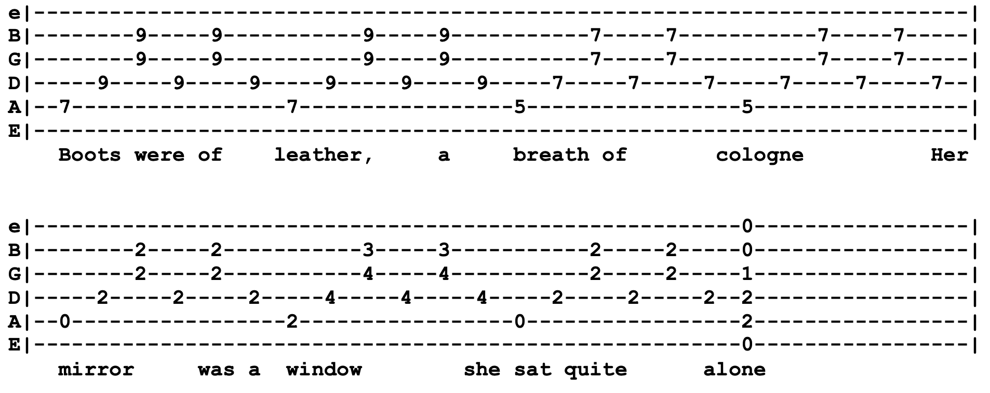

Row Jimmy (A)
Intro G^{=x 10 9 7 6 x} D A G D A
Verse 1 A G D A Bm A G D
Julie catch a rabbit by his hair, come back stepping like to walk on air
A E A E A E A
Get back home where you belong and don't you run off no more
Verse 2 A G D A Don't hang your head and let the two time roll
Bm A G D
Grass shack nailed to a pine wood floor
A E D
Ask the time, baby, I don't know, come back later, gonna let it show
Chorus A E D A E D
I say row, Jimmy row, gonna get there, I don't know
A E D A E A
Seems a common way to go, get down row, row row, row row
Lead=Verse (first line of verse only) (x4)
Verse 3 Here's a half dollar if you dare, double twist when you hit the air
Look at Julie down below, the levee doing the dopaso (Chorus)
Lead=Verse (first line of verse only) (x4)
Verse 4 Broken heart don't feel so bad
You ain't got half of what you thought you had
Rock your baby to and fro, not too fast and not too slow (Chorus)
Bridge A Bm A D A G D
That's the way it's been in town, ever since they tore the jukebox down
A Bm A D E D
Two bit piece don't buy no more, not so much as it done before
Chorus (change chords slightly first time around) A G D (x3) A E D
Chorus (x3) (back to normal chorus progression) A E D (x3) A E D
Outro Bm A G D A
Run For The Roses (A)
Intro | A A^{sus4} A G | A G D | A A^{sus4} A G | A G D A |

Chorus A A^{sus4} A G
Run, run, run for the roses
A G D
The quicker it opens, the sooner it closes
A G D
Man, oh man, oh friend of mine
A G D A A D A (x3)
All good things in all good time
Verse 1 E A D A E A
Reach for the sun, catch hold of the moon
They're both too heavy but what can you do
F^{#m} E D A E A
Reach for the stars, smack into the sky
E A D
You don't want to live but you're chicken to die
F^{#m} E D

Ohhh, you're chicken to die (Chorus)
Verse 2 Run for the money, caught short on the rent
Big ideas but the cash is all spent
The trouble with love is it's other face
You just want a cup but you don't want the race
No, you don't want the race (Chorus)

Lead=Verse ¢ Chorus
Verse 3 Run for the rose, get caught on the briar
Your warming to love, next thing there's a fire
You got the do re, I got the mi
I got the notion we're all at sea, ooo, we're all at sea
Chorus (repeat last line)
Queen Jane Approximately (D)
Intro D G (x4)
Verse 1 D G F^{#m} Em D D^{sus4} D
Now, when your mother sends back all your invitations
G F^{#m} Em A A^{sus4} A
And your father to your sister he explains
D G D Bm
That you’re tired of yourself and all of your creations

Chorus D G D G
Won’t you come and see me, Queen Jane
D G D D^{sus4} D
Won’t you come and see me, Queen Jane

Verse 2 Now, when the flower ladies
Wants back all that she has lent you
And the smell of her roses does not remain
When all of your children, they all start to resent you (Chorus)
Lead=Verse ¢Chorus

Verse 3 Now, when all the clowns that you have commissioned
Have died in battle or in vain
And you find yourself sick of all this repetition (Chorus)
Lead=Verse ¢Chorus

Verse 4 Now, when all of your advisers they all heave their plastic
At your feet to convince you of your pain
Trying to prove that your conclusions should be more drastic (Chorus)
Verse 5 Now, when all the bandits that you turned your other cheek to
All throw down their bandanas and complain
And maybe you want somebody you don’t have to speak to (Chorus)

Outro Won't you come and see me, Queen Jane (x4)

St. Stephen (A)
Intro B D A E | D A B B | A D E E | D A B B |
Riff/Jam E D A E (x4)
Verse 1 E D A E
St. Stephen with a rose, in and out of the garden he goes
D
Country garden in the wind and the rain
A (stop)
Wherever he goes the people all complain (Riff/Jam x4)

Verse 2 E D A E
Stephen prospered in his time, well he may and he may decline
D A (stop!) B (riff)
Did it matter, does it now? Stephen would answer if he only knew how (Riff/Jam x4)

Verse 3 Wishing well with a golden bell, bucket hanging clear to hell
Hell halfway twixt now and then
G (begin 3/4 Time) A E
Stephen fill it up and lower down, and lower down, again

Bridge E D A E D A E D
3/4 Time Lady finger, dipped in moonlight, writing “what for?” across the morning sky
E D A E D A E D
Sunlight splatters, dawn with answer, darkness shrugs and bids the day goodbye
Speeding arrow, sharp and narrow, what a lot of fleeting matters you have spurned
Several seasons with their treasons, wrap the babe in scarlet colors, call it your own (Riff x2)
Verse 4 Did he doubt or did he try? Answers a-plenty in the bye and bye
Talk about your plenty, talk about your ills
One man gathers what another man spills
Jam in E
Riff (x2)
Verse 5 St. Stephen will remain, all he's lost he shall regain
Seashore washed by the suds and the foam
Been here so long, he's got to calling it home
Outro E D A E
Fortune comes a crawling, calliope woman, spinning that curious sense of your own
D A E D
Can you answer? Yes I can, but what would be the answer to the answer man?
Samson and Delilah (G)
Intro G C G D G (x4)
Verse 1 G C G
Delilah was a woman, she was fine and fair
D G
Oh, she had good looks, God knows, and coal black hair
Delilah she gained old Samson’s mind
When first he saw this woman, Lord, she looked so fine
Verse 2 Delilah, she climbed up on Samson's knee
Said, “Tell me where your strength lies if you please”
Then she spoke so kind and she talked so fair
Well, Samson said, “Delilah cut off my hair”
You can shave my head, clean as my hand
My strength come natural as any old man
Chorus G G^{=x 10 12 12 12 x} G C G G^{=x 10 12 12 12 x} G F C
If I had my way, if I had my way, if I had my way
G7^{=xx9787} C^{=x x 10 9 8 8} C^{#dim=xx8686} D7^{=xx7575} G^{=xx5433}
I would tear this old buil- ding down
Verse 2 You read about Samson, all from his works
He was the strongest man that ever had lived on earth
One day while Samson was walking along
Looked down on the ground, he saw an old jawbone
He stretched out his arm, chains broke like thread
When he got to moving, ten thousand was dead (Chorus)
Lead=Verse
Verse 3 Now, Samson and the lion, they got in attack
Samson he crawled up on the lion's back
You read about this lion, he killed a man with his paws
Samson got his hands up around that lion's jaws
He ripped that beast, God knows, killed him dead
And the bees made honey in the lion's head (Chorus)
Lead=Verse
Chorus (x2)(repeat "I would tear this old building down" after 2nd chorus) (drum fill)
Chorus
Scarlet Begonias (E)
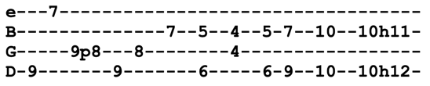
Intro B E B A (x8)

Verse 1 E B E B
As I was walking 'round Grosvenor Square, not a chill to the winter but a nip to the air
A E B A E
From the other direction, she was calling my eye
A E B A E B E B A
It could be an illusion but I might as well try, might as well try
Verse 2 She had rings on her fingers and bells on her shoes
I knew without asking she was into the blues
She wore scarlet begonias tucked into her curls
I knew right away she was not like other girls, other girls
Verse 3 In the heat of the evening when the dealing got rough
Too pat to open and too cool to bluff
As I picked up my matches and was closing the door
I had one of those flashes, I'd been there before, been there before
Chorus F#
Well, I ain't often right but I've never been wrong
B A E
It seldom turns out the way it does in the song
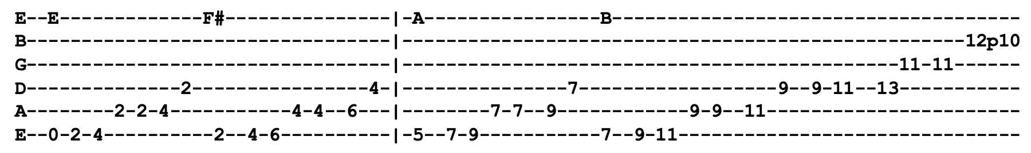
Once in a while you get shown the light
In the strangest of places, if you look at it right (ascending riff) F# A B

Verse 4 Well, there ain't nothing wrong with the way she moves
Scarlet begonias or a touch of the blues
And there's nothing wrong with the look that's in her eyes
I had to learn the hard way to let her pass by, let her pass by
Lead=Verse (solo in B Mixolydian)
Verse 5 Wind in the willow's playing Tea for Two
Sky was yellow and the sun was blue
Strangers stopping strangers just to shake their hand (stop!)
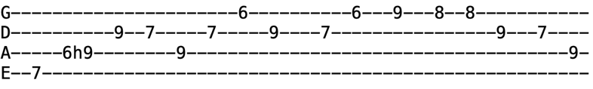
Everybody's playing in the Heart of Gold Band, Heart of Gold Band
Outro Riff (x4)

Outro=Jam in B Mixolydian
Shady Grove (Dm)

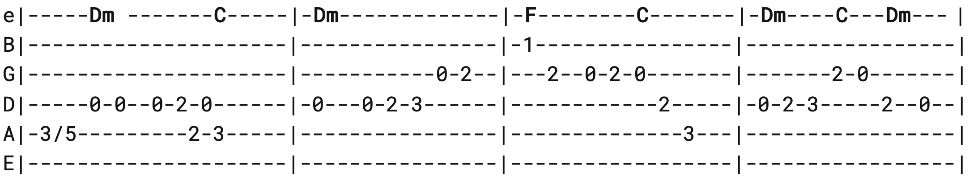
Intro
(x2)

Verse 1 Dm C Dm
Peaches in the summertime, apples in the fall
C Dm C Dm
If I can't get the girl I love I don't want none at all

Chorus Shady Grove, my little love
Shady Grove I know
Shady Grove, my little love
I'm bound for Shady Grove

Verse 2 Wish I had a banjo string made of golden twine
Every tune I'd play on it, I wish that girl was mine (Chorus)

Lead=Verse
Verse 3 Wish I had a needle and thread, fine as I could sew
I'd sew that pretty girl to my side and down the road I'd go (Chorus)
Lead=Verse
Verse 4 Some come here to fiddle and dance, some come here to tarry
Some come here to fiddle and dance, I come here to marry (Chorus)
Lead=Verse
Verse 5 Every night when I come home, my wife I try to please her
The more I try the worse she gets, damned if I don't leave her (Chorus)
Lead=Verse
Chorus
Outro=Intro
Shakedown Street (C)

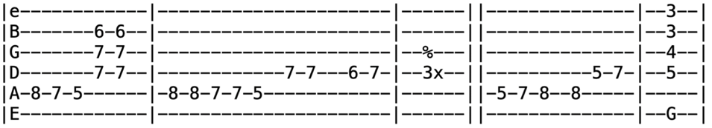
Intro Dm
(x4)
V1 G C^{/G} F C^{9=x32330} Dm C^{/D=xx0010} Dm C^{/D} Dm
You tell me this town ain't got no heart (well, well, well, you can never tell)
The sunny side of the street is dark (well, well, well, you can never tell)
F^{maj7} Em⁷⁼⁰²⁰⁰⁰⁰
Maybe that's cause it's midnight in the dark of the moon besides
Maybe the dark is from your eyes (maybe the dark is from your eyes)
Em⁷ E^{bm7=xx1322} Dm⁷
Maybe the dark is from your eyes (maybe the dark is from your eye-s)
Dm⁷
Maybe the dark is from your eyes (maybe the dark is from your eyes)
G
You know you got such dark eyes (woooh!)
Chorus C^{7sus4=8 10 8 10 8 8} C⁷⁼⁸ ¹⁰ ⁸ ⁹ ⁸ ⁸ C^{7sus4} C⁷
Nothing shaking on Shakedown Street, used to be the heart of town
Don't tell me this town ain't got no heart, you just gotta poke around (Intro)
V2 You think you've seen this town clear through (well, well, well, you can never tell)
Nothing here that could interest you (well, well, well, you can never tell)
It's not because you missed out on the things that we had to start
Maybe you had too much too fast, (maybe you had too much too fast) (x3)
Or just over played your part (woooh!) (Chorus)
Lead=Verse ¢ Chorus

V3 Since I'm passing your way today (well, well, well, you can never tell)
I just stopped by 'cause I want to say (well, well, well, you can never tell)
I recall your darkness when it crackled like a thundercloud
Don't tell me this town ain't got no heart (don't tell me this town ain't got no heart) (x3)
When I can hear it beat out loud!
Chorus (x4)
Vocal Jam Just gotta poke around (x16)
Jam in C7
Outro=Intro Riff (x4) (do lick and then land on G7 chord)
She Belongs To Me (C)
Intro C F C (x4)
Verse 1 C F C F C
She's got everything she needs, she's an artist, she don't look back
F C F C
She's got everything she needs, she's an artist, she don't look back
D⁷ F C F C
Takes the dark out of the nighttime, paints the daytime black

Verse 2 Start out standing, proud to steal her anything she sees
You will start out standing, proud to steal her anything she sees
But you will wind up peeking through a key hole
Down upon your bended knees (Lead=Verse)
Verse 3 She never stumbles, she's got no place to fall
She never stumbles, she's got no place to fall
She's nobody's child, the law can't touch her at all (Lead=Verse)

Verse 4 She wears an Egyptian ring that sparkles before she speaks
She wears an Egyptian ring that sparkles before she speaks
She's a hypnotist collector, you are a walking antique (Lead=Verse)
Verse 5 Bow down to her on Sunday, salute her when her birthday comes
Bow down to her on Sunday, salute her when her birthday comes
For Halloween buy her a trumpet
And for Christmas, give her a drum (Lead=Verse)
Verse 1 (sing the last line x3)

Outro D7 F C
Shendandoah Lullaby (D)
Verse 1 D G D
Oh, Shenandoah, I long to hear you
G Em D
Away you rolling river
G A Bm G
Oh, Shenandoah, I long to hear you
Chorus D G D Bm A D
Away, I'm bound away across the wide Missouri

Verse 2 This trader loved an Indian maiden
Away you rolling river
With notions his canoe was laden (Chorus)

Lead=Verse ¢ Chorus
Verse 3 Oh, Shenandoah, I love your daughter
Away you rolling river
For I've crossed the rolling water (Chorus)
Verse 4 Oh, Shenandoah, I'm bound to leave you
Away you rolling river
Oh, Shenandoah, I'll not deceive you (Chorus)

Lead=Verse ¢ Chorus
Verse 1

Chorus
Outro (instrumental melody of last part of chorus, "across the wide Missouri")

Shining Star (B)
Intro B E^{maj7=079897} (x8)
Chorus B E^{maj7} B E^{maj7}
Honey you are my shining star, don’t you go away (oh, baby)
I wanna be right here where you are till my dying day (oh, baby)
Verse 1 So many have tried, tried to find
A love like yours and mine (oh, baby)
Don’t you realize how you hypnotize
Make me love you more each time (oh, baby)

Prechorus A E F# B F# G#
Honey, I’ll never leave you lonely
A E F# B F# F^{#7} G⁷ F^{#7}
I'll give my love to you only, to you only, to you on- ly
Chorus

Lead=Intro

Verse 2 Feels so good when we're lying next to each other
Lost in love (oh, baby)
Honey when we touch, I love you so much
You’re all I ever dream of (oh, baby)
Prechorus (after singing prechorus, modulate up half-step to C)
Chorus (x3) (in Key of C)

Chorus C F C F
Honey you are my shining star, don’t you go away (oh, baby)
I wanna be right here where you are till my dying day (oh, baby)

Ship of Fools (B^{b})

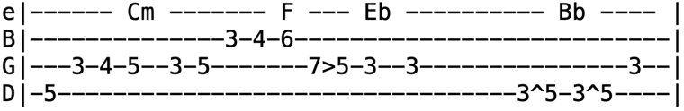
Intro (from debut until 1977) Intro (from 1977 onwards)
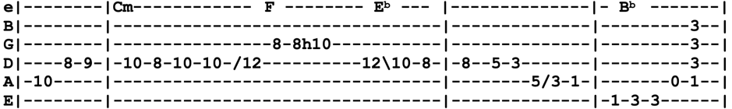
Verse 1 B^{b} F E^{b} E^{dim7=078686} B^{b}
Went to see the captain, strangest I could find
D E^{b} Cm F
Laid my proposition down, laid it on the line
E^{b} B^{b} Dm Cm
I won't slave for beggar's pay, likewise gold and jewels
E^{b} B^{b} F E^{b} B^{b}
But I would slave to learn the way to sink your ship of fools
Chorus F E^{b} B^{b} F E^{b} Gm
Ship of fools on a cruel sea, ship of fools sail away from me
E^{dim7=078686}
It was later than I thought when I first believed you
Cm F E^{b} B^{b}
Now I cannot share your laughter, ship of fools
Verse 2 Saw your first ship sink and drown from rocking of the boat
And all that could not sink or swim was just left there to float
I won't leave you drifting down but whoa it makes me wild
Thirty years upon my head to have you call me child (Chorus)
Lead=Verse
Chorus
Verse 3 The bottle stands as empty as it was filled before
Time there was a-plenty but from that cup no more
Though I could not caution all, I still might warn a few
Don't lend your hand to raise no flag atop no ship of fools
Chorus (repeat last two lines beginning with "it was later")
Outro=Intro
Short Life of Trouble (E) 3/4 Time
Lead=Verse

Chorus E A E
Short life of trouble, a few more words to part
A E C^{#m} E B E
Short life of trouble, dear girl, for a boy with a broken heart

Verse 1 Remember what you promised
Not more than a week ago
You promised that you'd marry me
Standing in your mama's door (Chorus)

Lead=Verse

Verse 2 Now you broke your promise
Go marry whom you may
For this old world, so big and so wide
I'll ramble back some day (Chorus)

Lead=Verse

Verse 3 Now you've gone and left me
I don't know what I'll do
I'd give this world and half of my life
Just to be married to you (Chorus)

Outro E B E
Simple Twist of Fate (D)
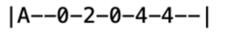
Intro
¢ Verse
Verse 1 D F^{#m}
They sat together in the park as the evening sky grew dark
D7 G
She looked at him and he felt a spark tingle to his bones
Gm D F^{#m} G
'Twas then he felt alone and wished that he'd gone straight
D G D G D A
And watched out for a simple twist of fate
Verse 2 They walked along by the old canal, a little confused, I remember well
And checked into a cheap hotel with the neon burning bright
He felt the heat of the night hit him like a freight train
Moving with a simple twist of fate (Lead=Verse)
Verse 3 A saxophone somewhere far off played as she walked along the arcade
The sun bust through a beat-up shade where he was waking up
She dropped a coin into the cup of a blind man at the gate
And forgot about a simple twist of fate
Verse 4 He woke up, the room was bare, he didn't see her anywhere
He told himself that he didn't care, threw the window open wide
Felt the emptiness inside, to which he just could not relate
Brought on by a simple twist of fate (Lead=Verse)
Verse 5 He hears the ticking of the clock, walks along with a parrot that talks
Went down by the waterfront docks where the sailors all come in
Maybe she'll pick him out again, how long must he wait?
One more time for a simple twist of fate
Verse 6 People tell me it's a sin to know and feel too much within
I still believe she was my twin but I lost the ring
She was born in spring but I was born too late
Blame it on a simple twist of fate (x3)
Sing Me Back Home (A)
Intro A (intro riff x8)
Verse 1 A E D A
The warden led the prisoner down the hallway to his doom
A^{sus4} A E B⁷ E ¢
I stood up to say goodbye like all the rest
A E D A
And I heard him tell the warden just before they reached my cell
E A
Let my guitar-playing friend sing my request

Chorus Sing me back home a song I used to hear
Make my old memories come alive
Sing me away and turn back the years
Sing me back home before I die

Verse 2 I recall last Sunday morning
When a choir from off the street
Came in to sing a few old gospel songs
And I heard him tell the singers
There's a song my mama sang
Could I hear it once before you travel on? (Chorus)

Lead=Verse

Verse 2
Chorus Sing me back home a song I used to hear
Make my old memories come alive
Sing me away and turn back the years
Sing me back home before I die
A E D A
Sing me back home before I diiiiiiiie

Sitting In Limbo (C)

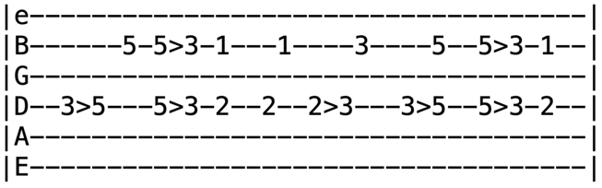
Intro Riff
(x2)
Verse 1 C (riff) C7
Sitting here in limbo like a bird without a song
F C (riff)
Sitting here in limbo but I know it won't be long
G F G C (riff)
Well, they're putting up resistance but I know my faith will lead me on
Verse 2 Sitting here in limbo waiting for the dice to roll
Sitting here in limbo got some time to search my soul
Well, they're putting up resistance but I know my faith will lead me on
Bridge F C F C
I don't know where life will lead me but I know where I've been
I can't say what life will show me but I know what I've seen
E⁷ Am
Tried my hand at love and friendship
E⁷ Am ¢D⁷ C^{6/9=xx0210} G
But all that is passed and gone, this little boy is moving on

Verse 3 Sitting here in limbo waiting for the tide to flow
Sitting here in limbo knowing that I have to go
Well, they're putting up resistance but I know my faith will lead me on
Lead=Verse

Bridge

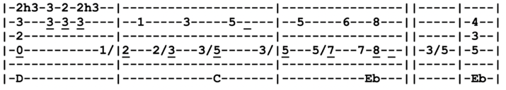
Verse 2 (repeat the last line... "well they're putting up resistance")
So Many Roads (F) Riff
Intro D^{sus2} D C (riff)
Verse 1 E^{b=xx534x} B^{b} F Dm
Thought I heard a blackbird singing up on Bluebird Hill
E^{b} B^{b} F
Call me a whining boy if you will
E^{b} B^{b} F Dm
Born where the sun don't shine and I don't deny my name
F C B^{b}
Got no place to go, ain't that a shame?
Verse 2 Thought I heard that KC whistle moaning sweet and low
Thought I heard that KC when she blow
Down where the sun don't shine underneath the Kokomo
Whining boy got no place to go
Chorus Gm C⁷ A⁷ Dm B^{b} F E^{b}
So many roads I tell you, so many roads I know, so many roads, so many roads
Mountain high, river wide, so many roads to ride, so many roads, so many roads (Intro)
Lead=Verse
Verse 3 Thought I heard a jug band playing "If You Don't, Who Else Will?"
Over on the far side of the hill
All I know the sun don't shine and the rain refuse to fall
You don't seem to hear me when I call
Verse 4 Wind inside and the wind outside tangled in the window blind
Tell me why you treat me so unkind
Down where the sun don't shine, lonely and I call your name
No place left to go, ain't that a shame?

Chorus So many roads I tell you, New York to San Francisco, all I want is one to take me home
From the high road to the low, so many roads I know, so many roads, so many roads
Verse 5 From the land of the midnight sun where the ice blue roses grow
'Long those roads of gold and silver snow
Howling wide or moaning low, so many roads I know
So many roads to ease my soul (x16-ish)
Outro (end by arpeggiating chords once)
Stagger Lee (G)
Intro c d e
Verse 1A F C B^{b} F B^{b}
1940 Xmas eve with a full moon over town
Stagger Lee met Billy DeLions and he blew that poor boy down
Do you know what he shot him for? What do you make of that?
G A
Billy DeLions threw the lucky dice, won Stagger Lee's Stetson hat
Verse 2B C^{6sus2\D=xx021x} D C^{6sus2\D} D G C G
Baio, Baio, tell me how can this be?
C G D C
You arrest the girls for turning tricks but you're scared of Stagger Lee
G C G D
Stagger Lee is a bad man and he shot my Billy D
C G C G C D C G C D
Baio, go get him or give the job to me

Verse 3B Delia DeLions, dear sweet Delia-D
How the hell can I arrest him, he's twice as big as me
Well, don't ask me to go downtown, I won't come back alive
Not only is that mother big, he packs a .45
Verse 4A F C B^{b} F B^{b}
“Baio,” Delia said, “Just give me a gun”
He shot my Billy dead, now I'm gonna see him hung
She went down to DeLion's club through Billy DeLions blood
Stepped up to Stagger Lee at the bar and said, “Buy me a gin fizz, love”

Lead=Verse B (x2)
Verse 5B As Stagger Lee lit a cigarette, she shot him in the balls
Blew the smoke off her revolver, had him dragged to city hall
Baio, Baio, see you hang him high
He shot my Billy dead and now he's got to die
Verse 6B Delia went a-walking down on Singapore Street
A three-piece band on the corner played "Nearer My God to Thee"
Delia whistled a different tune, what tune could that be?
C G C G C D C G C D
The song that woman sung was "Look Out Stagger Lee"
The song that Delia sung was "Look Out Stagger Lee" (x2)
Jam (jam over chords of that last line)
Standing on the Moon (G)

Intro G C D C (x4) ¢ G C

Verse 1 D G D G
Standing on the moon, got no cobwebs on my shoe
D G C
Standing on the moon, I feel so lone and blue
D G C G
I see the Gulf of Mexico as tiny as a tear
C G D G C G C D C G (x2) C
The coast of California must be somewhere over here, over here
Verse 2 Standing on the moon, I see the battle rage below
Standing on the moon, I see the soldiers come and go
There's a metal flag beside me someone planted long ago
Old glory standing stiffly, crimson white and indigo
C G D G C G C
Old glory standing stiffly, crimson white and indigo, indigo

Bridge D Am D Am
I see all southeast Asia, I can see El Salvador
D G C ¢ Am
I hear the cries of children and the other songs of war
D Am D Am ¢ C
It's like a mighty melody that rings down from the sky, standing here upon the moon
G D G C ¢ Am F F# G C D C G (x2) C
I watch it all roll by, all roll by, all roll by, all roll by

Verse 3 Standing on the moon, I see a shadow on the sun
Standing on the moon, the stars go fading one by one
I hear a cry of victory, another of defeat
A scrap of age old lullaby down some forgotten street

Verse 4 Standing on the moon where talk is cheap and vision true
Standing on the moon but I would rather be with you
Somewhere in San Francisco on a back porch in July
Just looking up at heaven at this crescent in the sky, in the sky

Chorus D G C G
Standing on the moon with nothing left to do
C G D G C
A lovely view of heaven but I’d rather be with you
G D G C G
A lovely view of heaven but I’d rather be with you, be with you
C D C G
Be with you, I’d rather be with you (x4-10ish)
Lead G C D C G
Outro Be with you, I'd rather be with you (x4)
Stealin' (G)
Lead=Verse ¢ Chorus
Verse 1 G
Put your arms around me like a circle 'round the sun
C
I want ya to love me, mama, like my easy rider done

Chorus G
You don't believe I love you, look what a fool I've been
Don't believe I'm sinking, what a hole I'm in
G G⁷ C
Stealin', stealin', pretty mama, don't you tell on me
G D G
I'm stealin' back to my same old used to be

Lead=Verse ¢ Chorus
Verse 2 The woman I love, she's just my height and size
Married girl, come to see me some time (Chorus)
Lead=Verse ¢ Chorus

Verse 1

Chorus (repeat last two lines)
Stella Blue (E)
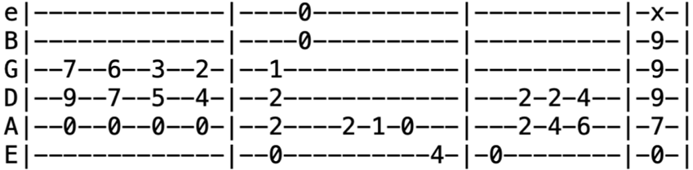
Intro

Verse 1 E ^{=07999x} E^{maj7=079797} A^{sus4=x0553x} A^{=x0543x} Em
All the years combine, they melt into a dream
C⁷ B⁷
A broken angel sings from a guitar
In the end there's just a song, comes crying up the night
Through all the broken dreams and vanished years
E A ¢ E A
Stella Blue, Stella Blue

Verse 2 When all the cards are down, there's nothing left to see
There's just the pavement left and broken dreams
In the end there's still that song, comes crying like the wind
Down every lonely street that's ever been
E A ¢ E (hold)
Stella Blue, Stella Blue
Bridge B E A E B
I've stayed in every blue-light cheap hotel (ooo ooo), can't win for trying
E D A E
Dust off those rusty strings just one more time (ooo ooo)
B (4 bar melodic ascent to E, begin Jerry solo)
Gonna make 'em shine (shine!)
Lead E / E^{maj7} / | A^{sus4} / A / | Em / C⁷ / | B⁷ / / / |
E E^{maj7} A^{sus4} A | Em C⁷ B⁷ / | B⁷ / / / |
Verse 3 It all rolls into one and nothing comes for free
There's nothing you can hold for very long
And when you hear that song come crying like the wind
It seems like all this life was just a dream
Stella Blue, Stella Blue
Jam E A (long solo capped by the intro progression)
Stop That Train (G)
Intro Riff G C D G
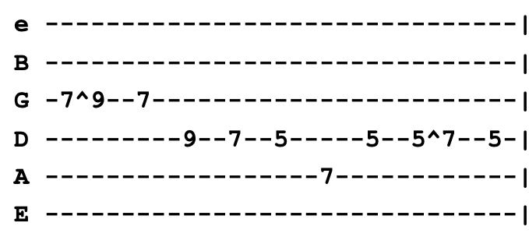
(x2)

Chorus G C
Stop that train, I’m leaving
G D
Stop that train, I’m leaving
G C
Stop that train, I’m leaving
G D
And it won’t be too long whether I’m right or wrong
G C E^{b} (intro lick x2)
Won’t be too long whether I’m right or wrong

Verse 1 G D
All my life I’ve been a lonely man
C G
Try to teach the people that don’t understand
Though I've tried to do my very best
Can’t seem to find no happiness (Chorus)

Verse 2 Some travel east and some travel west
Some try to do their best
Some living big but the most they're living small
Can't even find no food at all (Chorus)
Lead=Verse ¢ Chorus
Chorus (x2)
Struggling Man (C)
Intro C ¢ F Em ¢ C (x4)
Verse 1 B^{b} F C
Every man has the right to live
Love is all that we have to give
Together we struggle by the will to survive
B^{b} F C F
Together we fight just to stay alive

Chorus G C ¢ F
Strugglin' man has got to move
G C ¢ Am
Strugglin' man, no time to lose
F G C (Intro Riff x2)
I'm a strugglin' man and I've got to move on

Lead=Verse ¢ Chorus
Verse 2 As the sun lights the day and the moon lights the night
Strugglin' man keeps reaching for the higher heights
We plan for tomorrow while we live for today
Like the flowers we bloom and then later fade away (Chorus)

Stuck Inside of Mobile with the Memphis Blues (E)
Intro Riff (x4)
Verse 1 E C^{#m} E C^{#m} E C^{#m} A B
Oh, the ragman draws circles up and down the block, I'd ask him what the matter was but I know he don't talk
A E C^{#m} E C^{#m} E A E
And the ladies treat me kindly and furnish me with tape but deep inside my heart I know I can't escape
G^{#m} E B A E A E (riff x2)
Oh, Mama, can this really be the end? To be stuck inside of Mobile with the Memplis blues again
Verse 2 Shakespeare, he’s in the alley with his pointed-shoes and his bells
Speaking to some French girl who says she knows me well
And I would send a message to find out if she’s talked
But the post office has been stolen and the mailbox is locked (Refrain)
Verse 3 Mona tried to tell me to stay away from the train line
She said that all the railroad men just drink up your blood like wine
And I said, “Oh, I didn’t know that, but then again, there’s only one I’ve met”
He just smoked my eyelids and punched my cigarette (Refrain)
Verse 4 Grandpa died last week and they buried him in the rocks
But everyone still laughs about how badly then I shot
But me, I expected it to happen, I knew he’d lost control
When he built a fire on Main Street and they shot it full of holes (Refrain ¢ Lead)
Verse 5 Now, the senator came down here showing everyone his gun
Handing out free tickets to the wedding of his son
And me, I nearly got busted and wouldn’t it be my luck
To get caught without a ticket and be discovered beneath a truck (Refrain)
Verse 6 Now, the preacher looked so baffled when I asked him why he dressed
With twenty pounds of headlines stapled to his chest
But he cursed me when I proved it to him, then I whispered, “Not even you can hide”
You see, you’re just like me, I hope you’re satisfied (Refrain)
Verse 7 Now, the rainman gave me two cures, then he said, “Jump right in”
The first was Texas medicine, the second was just railroad gin
Like a fool I mixed them and it strangled up my mind
Now people just get uglier and I have no sense of time (Refrain ¢ Lead)
Verse 8 When Ruthie says come see her in her honky-tonk lagoon
Where I can watch her waltz for free 'neath her Panamanian moon
And I say, “Aw, come on now, you know about my debutante”
And she says, “Your debutante knows what you need but I know what you want” (Refrain)
Verse 9 Now, the bricks lay on Grand Street where the neon madmen climb
They all fall there so perfectly, it all seems so well-timed
Here I sit so patiently trying to find out what price
You have to pay to get out of going through all these things twice (Refrain x2)
Outro=Intro
Sugar Magnolia (A)
Intro A D A E A (x4) A E A
Verse 1 A D A G E A
Sugar Magnolia, blossoms blooming, heads all empty and I don't care
C^{#m} F^{#m} E D A E A
Saw my baby down by the river, knew she'd have to come up soon for air
Verse 2 Sweet blossom come on under the willow, we can have high times if you'll abide
We can discover the wonders of nature rolling in the rushes down by the riverside
Chorus D G D A D
She's got everything delightful, she's got everything I need
G D E A E A
Takes the wheel when I'm seeing double, pays my ticket when I speed
Lead A D A E A (x2) ¢ A E A
Verse 3 She comes skimming through rays of violet, she can wade in a drop of dew
She don't come and I don't follow, waits backstage while I sing to you
Verse 4 She can dance a cajun rhythm, jump like a willy's in four wheel drive
She's my summer love in the spring, fall and winter, she can make happy any man alive
Bridge A G D A G D A G D A
Sugar Magnolia, ringing that bluebell, caught up in sunlight
A E G D
Come on out singing, I'll walk you in the sunshine
A E A
Come on honey, come along with me
Chorus She's got everything delightful, she's got everything I need
Breeze in the pines in the summer night moonlight, crazy in the sunlight, yes indeed
Bridge A D A
Sometimes when the cuckoo's crying, when the moon is half way down
B E B
Sometimes when the night is dying
A E D A E B A E B (Lead=B E B F# E)
I take me out and wander 'round, I wander 'round
Outro B E B F# E B
Sunshine daydream, walk you in the tall trees
Going where the wind goes, blooming, blooming like a red rose
Now, come on over sweetly, ride out singing, “I got you in the morning sunshine”
B E B F# E
Sunshine daydream, (x8)
Sugaree (E)
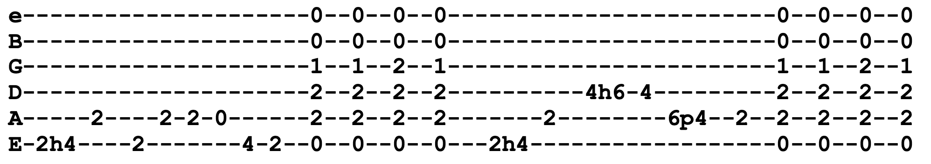
Intro B E A E (x4)

Verse 1 B E
When they come to take you down
When they bring that wagon 'round
When they come to call on you
And drag your poor body down
Chorus F^{#m} C^{#m} A E
Just one thing I ask of you, just one thing for me
B C^{#m} A E
Please forget you knew my name, my darling, Sugaree
B E E A E C^{#m} A E
Shake it, shake it, Sugaree, just don't tell 'em you know me (x2)

Lead=Verse
Verse 2 You thought you was the cool fool, never could do no wrong
Had everything sewed up tight
How come you lay awake all night long? (Chorus)

Lead=Verse
Verse 3 Well, in spite of all you gained
Still have to stand out in the pouring rain
One last voice is calling you and I guess it's time you go (Chorus)
Lead= Verse
Verse 4 Well, shake it up now, Sugaree
I'll meet you at the jubilee
And if that jubilee don't come, maybe I'll meet you on the run
Chorus (repeat last line total of four times)
Tangled Up In Blue (A)
Lyrics below are Bob Dylan's actual lyrics, Jerry would regularly sing slight modifications
Intro A A^{sus4} A (x8)
Verse 1 A G A G
Early one morning the sun was shining, I was laying in bed
A G D
Wondering if she'd changed at all if her hair was still red
Her folks, they said our lives together sure was gonna be rough
Never did like Mama's homemade dress, Papa's bankbook wasn't big enough
E F^{#m} A D
I was standing on the side of the road, rain falling on my shoes
E F^{#m} A D E G D A A^{sus4}
Heading out for the East Coast, Lord knows I've paid some dues getting through, tangled up in blue
Verse 2 She was married when we first met, soon to be divorced
I helped her out of a jam, I guess, but I used a little too much force
We drove that car as far as we could, abandoned it out west
Split up on docks that night night, both agreeing it was best
She turned around to look at me as I was walkin' away
I heard her say over my shoulder, “We'll meet again someday on the avenue” (Chorus)
Verse 3 I had a job in the great north woods working as a cook for a spell
But I never did like it all that much, and one day the axe just fell
So I drifted down to New Orleans where I was lucky to be employed
Working for a while on a fishing boat right outside Delacroix
But all the while I was alone, the past was close behind
I seen a lot of women but she never escaped my mind, and I just grew (Chorus ¢ Lead)
Verse 4 She was working in a topless place, I stopped in for a beer
I just kept looking at the side of her face in the spotlight so clear
Later on as the crowd thinned out I's just about to do the same
She was standing there in back of my chair, said to me, “Don't I know your name?”
I muttered something under my breath, she studied the lines on my face
Must admit I felt a little uneasy when she bent down to tie the laces of my shoe (Chorus)
Verse 5 She lit a burner on the stove and offered me a pipe
“I thought you'd never say hello,” she said,“You look like the silent type”
She opened up a book of poems and handed it to me
Written by an Italian poet from the thirteenth century
And every one of them words rang true and glowed like burning coal
Pouring off of every page like it was written in my soul from me to you (Chorus ¢ Lead)
Verse 6 I lived with them on Montague Street in a basement down the stairs
There was music in the cafes at night and revolution in the air
He started into dealing with slaves and something inside him died
She had to sell everything she owned and froze up inside
Later on when the bottom fell out, I became withdrawn
The only thing I knew how to do was to keep on keeping on like a bird that flew (Chorus)
Verse 7 Now I'm going back again, I got to get her to somehow
All the people we used to know, they're an illusion to me now
Some are mathematicians, some are carpenter's wives
Don't know how it all got started, I don't know what they're doing with their lives
But me, I'm still on the road heading for another joint
We always did feel the same, we just saw it from different point of view
Chorus (repeat last line x4)
Jam =Intro

Tears of Rage (G)
Dylan played in G, Jerry played in Key of A
Intro G C G
Verse 1 G Em C ¢ Am
We carried you in our arms on Independence Day
F C G
And now you'd throw us all aside and put us on our way-ay
Oh, what dear daughter beneath the sun would treat her father so?
To wait upon him hand-and-foot yet always tell him, “No”

Chorus B7 Em
Tears of rage, tears of grief
C G
Why must I always be the thief?
B7 Em C G
Come to me now, you know we're so alone and life is brief
Verse 2 We pointed out the way to go and scratched your name in sand
But though you thought it was nothing more than a place for you to stand
Now, I want you to know that while you watched Discovered that there was no one true
That I myself, I really thought, it was the only thing to do
Chorus
Verse 3 It was all very very pain-less when you ran out to receive
All that false instruction which we never could believe
And now the heart is filled with gold as if it was a purse
Oh, but what kind of love is this which goes from bad to worse?

Chorus
Tennessee Jed (C) Riff
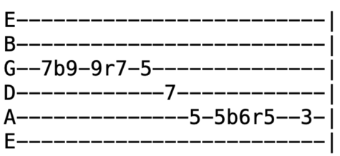
Jerry regularly mixed lines from different verses
Intro Riff C G C (x4)
Verse 1 C (riff) G C
Cold iron shackles and ball and chain
F G C (riff) G C
Listen to the whistle of the evening train
C C^{dim7=x34242} Dm^{7=x57565} C C7
You know you bound to wind up dead
F G C (riff) G C
Don't head back to Tennessee, Jed
Verse 2 Rich man step on my poor head
When you get back you better butter my bread
Well, you know, people, it's like I said
F G C Bb F G C
You better head back to Tennessee, Jed
Chorus F C G F
Tennessee, Tennessee, there ain't no place I'd rather be
C G F B F C G F G C (Lead=first line of verse x2)
Baby, won't you carry me, back to Tennessee
Verse 3 Drink all day and rock all night
The law come to get you if you don't walk right
Got a letter this morning, baby, all it read, “You better head back to Tennessee, Jed”
Verse 4 Dropped four flights and cracked my spine
Honey, come quick with the iodine
Catch a few winks, baby, under the bed
Then you head back to Tennessee, Jed (Chorus)
Verse 5 I run into Charlie Fog, blacked my eye and he kicked my dog
My doggie turned to me and he said, “Let's head back to Tennessee, Jed”
Verse 6 I woke up a-feeling mean, went down to play the slot machine
The wheels turned around, people, the letters read
“You better head back to Tennessee, Jed” (Chorus)
Lead First line of verse (x4) ¢ F (x8) F# ¢ G (x8) ¢ Bb F G C (Chorus)
Outro Bb F G C
Terrapin Station (G)
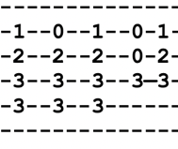
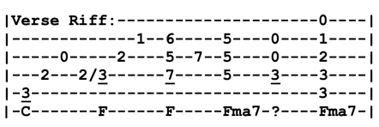
Intro F F^{maj7} F (x4)

Verse 1 G Dm C G F
Let my inspiration flow in token rhyme suggesting rhythm
C F C F F^{maj7} (riff)
That will not forsake you till my tale is told and done
While the firelights aglow, strange shadows from the flames will grow
Till things we've never seen will seem familiar

Verse 2 Shadows of a sailor forming, winds both foul and fair all swarm
Down in Carlisle he loved a lady many years ago
Here beside him stands a man, a soldier from the looks of him
Who came through many fights but lost at love
Verse 3 While the story teller speaks, a door within the fire creaks
Suddenly flies open and a girl is standing there
Eyes alight with glowing hair, all that fancy paints as fair
She takes her fan and throws it in the lion's den
Verse 4 Which of you to gain me tell will risk uncertain pains of hell?
I will not forgive you if you will not take the chance
Sailor gave at least a try, the soldier being much too wise
Strategy was his strength, not disaster (Lead=Verse)
Verse 5 Sailor coming out again, the lady fairly leapt at him
That's how it stands today, you decide if he was wise
The storyteller makes no choice, soon you will not hear his voice
His job is to shed light, not to master
Jam =Intro (x16) ¢ F Lick (x8) ¢ B (x2) ¢ Em (x2) ¢ C7 (x2)
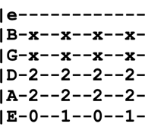
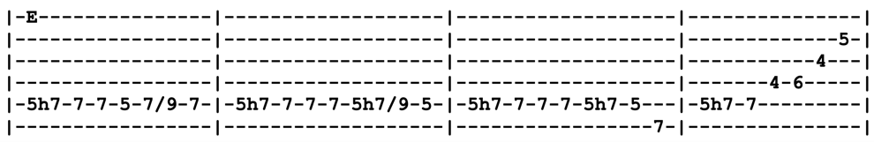
Bridge F^{maj7} C9^{=x7878x}
Since the end is never told, we pay the teller off in gold
F^{maj7} E ("Jaws riff")
In hopes he will come back but he can not be bought or sold
Jaws riff
Outro Riff

Terrapin Station (Part 2) (A)

Verse 1 A A7 D D^{maj7=xx0222}
Inspiration, move me brightly
E A
Light the song with sense and color, hold away despair
E A E
More than this I will not ask
C^{#m} G^{maj7=xx5777} D D^{maj7=xx0222}
Faced with mysteries dark and vast
E A D E^{bm7b5=xx1222}
Statements just seem vain at last
E A
Some rise, some fall, some climb to get to Terrapin
Verse 2 E A E C^{#m} D
Counting stars by candlelight, all are dim but one is bright
E A
The spiral light of Venus rising first and shining best
E A E C^{#m} G^{maj7=xx5777} D D^{maj7=xx0222}
Oh, from the northwest corner of a brand new crescent moon
E A D E^{bm7b5=xx1222}
Crickets and cicadas sing
E D A
A rare and different tune, Terrapin Station
Bm A E D A D E
In the shadow of the moon, Terrapin Station, and I know we'll be there soon
Bridge E
Terrapin, I can't figure out
Terrapin, if it's the end or beginning
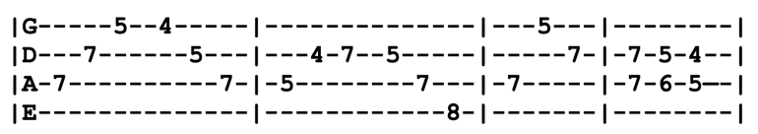
Terrapin, but the train's put it's brakes on
E D (riff)
Terrapin, and the whistle is screaming Terrapin
Outro Riff
(x8)
That’s All Right, Mama (E)
Intro E A E (x4)
Verse 1 E
That's all right, mama, that's all right with you
That's all right, mama, anyway you do
Chorus A D A A D A
But that's all right, that's all right
B E
That's all right now, mama, anyway you do

Verse 2 My mama told me
Papa done told me too
That gal you're fooling with she ain't no good for you (Chorus)

Lead=Verse ¢ Chorus (solo in E Major Pentatonic)
Verse 3 One and one is two
Two and two is four
Don't leave me, baby, when you walk right out the door (Chorus)
Lead=Verse
Verse 1 ¢ Chorus ¢ Verse 2
Chorus (repeat last line x2)
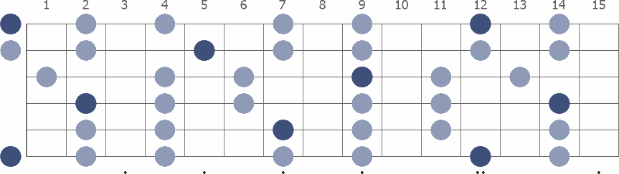
E Major Pentatonic
That’s What Love Will Make You Do (F)
Intro C⁷ F C⁷ G F C⁷
Verse 1 C⁷
When I hear your name, I start to shake inside
When I see you stroll, I lose my self control
Chorus F C⁷
That’s what love will do for you, that’s what love will make you do
G F⁷ C⁷
No matter how hard I fight it, baby, I’m still in love with you

Verse 2 Have your every need, there’s no limit to what I’ll do
Work eight days a week, baby, and give it all to you (Chorus)
Lead=Verse ¢ Chorus (solo in C Major Pentatonic)
Bridge C⁷
When they speak of beauty you can stand the test
When they talk about making love, baby, your the best
Don’t wanna brag about you too much, give others ideas
Trying hard to express myself ‘cause, baby, that’s the way I feel
Chorus
Lead=Verse ¢ Chorus
Bridge
Chorus (after singing chorus, repeat last line twice and tag it)
C Major Pentatonic
They Love Each Other (G) Riff
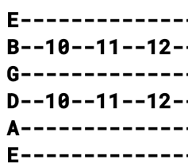
Intro G (riff) C G (x4)
Verse 1 G (riff) C G
Merry run around, sailing up and down
C
Looking for a shove in some direction
G (riff) C G
Got it from the top, nothing you can stop
C G
Lord, you know they made a fine connection, they love each other

Chorus F C G (riff)
Lord, you can see that it's true
Lord, you can see that it's true
F C G C G C G
Lord, you can see that it's true

Verse 2 He could pass his time, around some other line
But you know he chose this place beside her
Don't get in the way, there's nothing you can say
Nothing that you need to add or do
They love each other (Chorus)

Lead=Verse (solo in G Major scale)

Verse 3 It's nothing they explain, it's like a diesel train
Better not be there when it rolls over
And when that train rolls in
You won't know where it's been
You gotta try to see a little further
They love each other (Chorus x2)
Think (C)

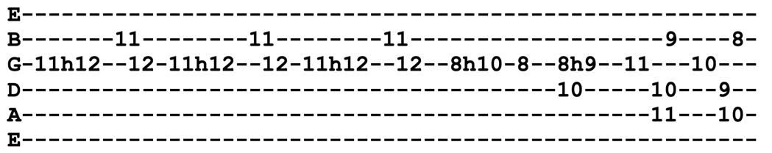
Intro C⁷ C G^{#7} G⁷

Verse 1 C⁷ F C⁷ F C⁷
I could give up my friends, I know
F C⁷
And in return, you could give up yours

Chorus F C⁷
Before we think, what would we do later on?
G⁷ F(stop!) C G^{#7} G⁷
What kind of life would we have, just in case we both were wrong?

Verse 2 I give up my woman, you give up your man
But it don't make sense to take a chance (Chorus)
Lead=Verse ¢Chorus (solo in C Major Pentatonic)

Verse 2
Chorus
C Major Pentatonic
Thrill Is Gone (Am)

Intro =Verse
Verse 1 Am
The thrill is gone, the thrill is gone away
Dm Am
The thrill is gone, the thrill is gone away
F⁷ E⁷ Am
You know you done me wrong and you'll be sorry someday

Verse 2 The thrill is gone, it's gone away for good (x2)
Someday I know I'll be over it all
Just like I know a good man should (Lead=Verse)

Verse 3 The thrill is gone, it's gone away from me (x2)
Although I'll still live on, so lonely I'll be
Verse 2 (Lead=Verse)
Verse 4 I'm free, baby, free from your spell (x2)
Now it's all over all I can do is wish you well (x2)
Throwing Stones (A)
Intro Riff (x4)
Verse 1 Bm A E A Bm G A
Picture a bright blue ball just spinning, spinning free, dizzy with eternity
Em7 A Em7 Bm A
Painted with a skin of sky, brush in some clouds and sea, call it home for you and me
Verse 2 A peaceful place or so it looks from space, a closer look reveals the human race
Full of hope, full of grace, is the human race, but afraid, we may lay our home to waste
Chorus 1 E D E D E
There's a fear down here we can't forget, hasn't got a name just yet
Always awake always around _{(stop!)}
Singing “Ashes ashes all fall down” (ashes ashes all fall down)
Verse 3 Now watch as the ball revolves as the nighttime calls
And again the hunt begins and again the blood wind calls
By and by again the morning sun will rise
But the darkness never goes from some man's eyes, no! no!
Verse 4 It strolls the sidewalk and it roams the streets, staking turf, dividing up meat
Nightmare spook, piece of heat, it's you and me, you and me
Chorus 2 Click flash blade in ghetto night, rudies looking for a fight
Rat-cat alley roll them bones, need that cash to feed that jones, and the politicians throwing stones
Singing, “Ashes ashes all fall down” (ashes ashes all fall down)
Break 1 C#m A E
Commissars and pinstripe bosses roll the dice
Bm A E A E
Anyway they fall guess who gets to pay the price?
A E Bm A
Money green or proletarian gray, selling guns instead of food today
Chorus 3 So the kids they dance to shake their bones, and the politicians throwing stones
Singing, “Ashes ashes all fall down” (ashes ashes all fall down) (Lead=Verse)
Verse 5 Heartless powers try to tell us what to think, if the spirit is sleeping then the flesh is ink
History's page will be neatly carved in stone, the future's here, we are it and we are on our own
Vocal Jam On our own, we are on our own (x8) ¢ Jam=A D A E A (x8) ¢ Bm A E A E (x2)
Break 2 And the game is lost and we are all the same, ^{(stop!)} no one left to place or take the blame
Will we leave this place an empty stone?
That shiny ball of blue we can call our home (Chorus 3)
Instrumental=Chorus
Chorus 4 Shipping powders back and forth, yes and black goes south and white comes north
And the whole world's full of petty wars, yes and I got mine and you got yours
And the current fashion set the pace, lose your step fall out of grace
The radical, he rant and rage, singing, “Someone's got to turn the page”
And the rich man in his summer home, singing “Just leave well enough alone”
But his pants are down, his cover's blown
And the politicians throwing stones, so the kids they dance, they shake their bones
'Cause it's all to clear we are on our own
Singing, “Ashes ashes all fall down” (ashes ashes all fall down)
Verse 8 Picture a bright blue ball just spinning, spinning free, dizzy with the possibilities
Vocal Jam Ashes ashes all fall down (ashes ashes all fall down) (x8)
To Lay Me Down (G) 3/4 Time
Intro (first line of verse)
Verse 1 G Em D C C ¢ G C ¢ G
To lay me down once more, to lay me down
Bm A E ¢ G
With my head in sparkling clover
D ¢ Am C (hold it)
Let the world go by, all lost in dreaming
C ¢ G F C C ¢ G C ¢ G
To lay me down one last time, to lay me down
Chorus Bm Am D C
To lay me down, oh-oh, to lay me down
C ¢ G F C C ¢ G C ¢ G
To lay me down one last time, to lay me down
Verse 2 To be with you once more, to be with you
With our bodies close together
Let the world go by like clouds a-streaming
To lay me down one last time, to lay me down (Chorus)
Lead=Verse
Verse 3 To lie with you once more, to lie with you
With our dre-eams entwined together
To wake beside you, my love still sleeping
To tell sweet lies one last time and say goodnight
Chorus Bm Am D C
To lay me down, oh-oh, to lay me down
C ¢ G F C C ¢ G F C
To lay me down one last time, to lay me down
C ¢ G F C C ¢ G F C
To lay me down one last time (repeat this line x3)

Tore Up Over You (C)

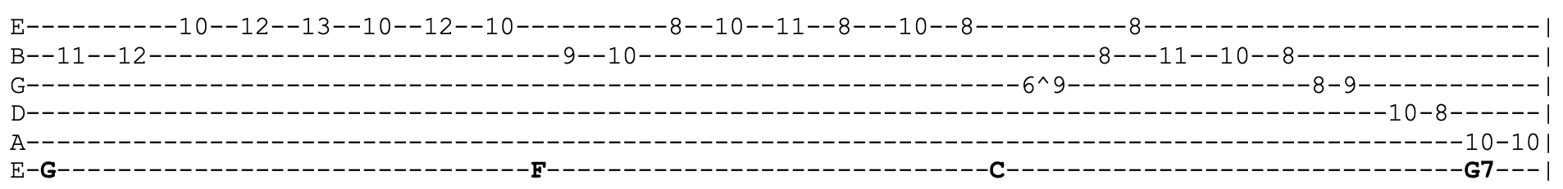
Intro

Verse 1 C
Ever since you’ve been gone, I just cried the whole night long
F C
Since the day you said, “Good bye,” hurt me so no lie, no lie
G F C
Tore up over you and I just can’t find my way

Chorus Tore up (yeah, yeah, yeah) tore up (wooooh)
Tore up (yeah, yeah, yeah) tore up
Tore up over you and I just can’t find my way

Verse 2 Tell me what did I do to make you go away
Tell me what can I do to make you come back to stay
Tore up over you and I just can't find my way (Chorus)
Lead=Verse
Verse 3 Ever loved me like you told me so? If you did how could you go
It was you not me that left, went away with someone else
Tore up over you and I just can’t find my way (Chorus)
Lead=Verse
Verse 4 Ever loved me like you told me so? If you did how could you go
It was you not me who left Went away with somebody else
Tore up over you and I just can’t find my way

Chorus (repeat last line)

Outro=Intro

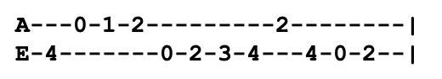
Touch of Grey (B) Turnaround Riff
Intro A E B F#
Verse 1 B F# B E A E
Must be getting early, clocks are running late
F# B E
Paint by numbers morning sky, looks so phony
Dawn is breaking everywhere, light a candle, curse the glare
Draw the curtains, I don't care 'cause it's, all right
Chorus F# B E (riff) F# B E (riff)
I will get by, I will get by
F# B A E F# E A E B F# B F#
I will get by- y- y, I will survive
Verse 2 I see you've got your list out, say your peace and get out
Yes, I get the gist of it but it's alright
Sorry that you feel that way, the only thing there is to say
Every silver lining's got a touch of grey (Chorus)
Bridge 1 C^{#m} C^{#7} F# C^{#m} C^{#7} F#
It's a lesson to me, the Ables and the Bakers and the C's
G^{#m} D^{#7} C^{#7} F# B⁷ E F#
The ABC's we all think of, try to win a little love
Lead=Verse ¢ Chorus
Bridge 2 It's a lesson to me, the Deltas and the East and the Freeze
ABC's, we all must face, try to keep a little grace
Verse 3 I know the rent is in arrears, dog has not been fed in years
It's even worse than it appears but it's alright
The cow is giving keroseen, kid can't read at seventeen
The words he knows are all obscene but it's all right (Chorus)
Verse 4 Shoe is on the hand that fits, really nothing much to it
Whistle through your teeth and spit 'cause it's alright
Oh well, a touch of grey kinda suits you anyway
That was all I had to say, it's all right (Chorus)
Chorus (x2) (sing "we" instead of "I")
Tough Mama (D)

Intro D Bm A (x2)

Verse 1 D Bm A
Tough Mama, meat shaking on your bones
I'm gonna go down to the river and get you stoned
Bm A
Sister's on the highway with that steel driving crew
Bm F^{#m} Em G
Papa's in the big house, his working days are through
C G A
Tough mama, can I blow a little smoke on you? (Lead=Verse)

Verse 2 Dark Beauty, won't you move it on over and give me some room?
It's my duty, take you down to the field where the flowers bloom
Ashes in the furnace, dust on the rise
You can see it all the way flying through the skies
Tough mama, long night's journey in your eyes (Lead=Verse)

Verse 3 Sweet Goddess, born of a blinding light and a changing wind
Don't be modest, you know who you are and where you've been
Jack the Cowboy went up north, he's buried in your past
Lone Wolf went out drinking, that was over fast
Tough mama, your perfect stranger's coming on in at last (Lead=Verse)

Verse 4 Silver Angel with the badge of the lonesome road written on your sleeve
I'd be grateful if this golden ring you would receive
Today on the countryside it was hotter than a crotch
I stood alone upon the ridge and all I did was watch
Tough mama, it must be time to carve another notch (Lead=Verse)

Verse 5 I'm crestfallen, the world of illusion is at my door
I ain't hauling any of my lambs to the marketplace anymore
Prison walls are crumbling down, there is no end in sight
I've gained some recognition but I lost my appetite
Tough mama, meet me at the border late tonight (Lead=Verse)
Outro=Intro
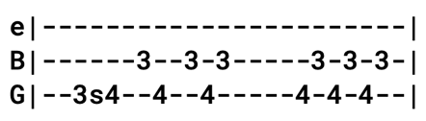
Truckin' (E)
Intro Riff

Chorus E A
Truckin', got my chips cashed in, keep truckin' like the doodah man
B A E
Together, more or less in line, just keep truckin' on-n
Verse 1 E
Arrows of neon and flashing marquees out on Main Street
Chicago, New York, Detroit, it's all the same street
Your typical city involved in a typical daydream, Hang it up and see what tomorrow brings
E A
Dallas, got a soft machine, Houston, too close to New Orleans
B A E
New York's, got the ways and means, just won't let you be, oh no
Verse 2 Most of the cats you meet on the streets speak of true love
Most of the time they're sitting and crying at home
One of these days they know they better get going
Out of the door and down on the streets all alone
Chorus Truckin' like the doodah man, once told me, “You got to play your hand”
Sometimes your cards ain't worth a dime if you don't lay 'em down, oh no

Bridge A A G D^{/F#} A D A G D^{/F#} A
Sometimes the light's all shining on me, other times I can barely see
D Bm F# Bm F# A E
Lately it occurs to me, what a long strange trip it's been

Verse 4 What in the world ever became of sweet Jane?
She lost her sparkle, you know she isn't the same.
Living on reds, vitamin C, and cocaine. All her friends can say is, “Ain't it a shame?”
Chorus Truckin', up to Buffalo, been thinkin', you gotta mellow slow
Takes time, pick a place to go, just keep truckin' on
Verse 5 Sitting and staring out of the hotel window. Got a tick they're gonna kick the door in again
I'd like to get some sleep before I travel, but if you got a warrant I guess you're gonna come in
Busted, down on Bourbon Street, set up like a bowling pin
Knocked down, gets you wearing thin, just won't let you be, oh no
Verse 6 You're sick of hanging around and you'd like to travel
Get tired of traveling and you want to settle down
I guess they can't revoke your soul for trying
Get out of the door and light out and look all around E¢ A (Bridge)
Chorus Truckin', I'm a going home, whoa-oh baby, back where I belong
Back home, sit down and patch my bones, get back truckin' on
Get back truckin' on (x8)
Jam in E
Turn on Your Love Light (E)
Lyrics changed significantly between Pigpen version and modern version. Below is modern version. While the song technically is using seventh chords, they alternate between major and seventh
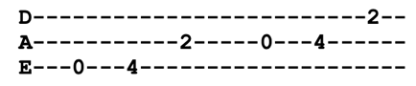
Intro E7 A7
Verse 1 E7 A7 E7 A7 E7 A7 E7
Without a warning, you broke my heart, taking it baby, tore it apart
Left me standing in the corner crying, told me your love was slowly dying
So I'm beggin you baby, baby please, begging you baby, I'm on my knees
Chorus E D A E D A
Turn on your light, let it shine on me
Turn on your love light, let it shine on me
E A E
Let it shine, let it shine, let it
Verse 2 When I get a little lonely in the middle of the night
Well, I need you babe to make things alright
So come on baby, baby please
I'm begging you baby, I'm on my knees
Chorus (at end of chorus, do the riff x4) E D A (x4)
Lead=Verse (use E Major Pentatonic)
Verse 1
Vocal Jam E7 A7 E7 A7
Turn on your light, let it shine on me
Turn on your love light, let it shine on me
A little bit higher, a little bit higher
Turn on your love light, let it shine on me
Feel alright, feel alright
Turn on your light, let it shine on me
Outro E D A (x8)
Two Soldiers (Blue-Eyed Boston Boy) (G) 3/4 Time
Intro=Verse
Verse 1 D C G
He was just a blue-eyed Boston boy, his voice was low with pain
I'll do your bidding, comrade mine, if I ride back again
D G D
But if you ride back and I am left, you'll do as much for me
C G
Mother, you know must hear the news, so write to her tenderly

Instrumental=Verse (first line only)

Verse 2 She's waiting at home like a patient saint, her fond face pale with woe
Her heart will be broken when I am gone, I'll see her soon I know
Just then the order came to charge, for an instant hand touched hand
They said, “Aye” and away they rode, that brave and devoted band

Instrumental=Verse
Verse 3 Straight was the track to the top of the hill, the rebels they shot and shelled
Ploughed furoughs of death through the toiling ranks
And guarded them as they fell
There soon came a horrible dying yell from heights they could not gain
And those that doom and death had spared, rode slowly down again

Instrumental=Verse (first line only)

Verse 4 But among the dead that were left on the hill was the boy with the curly hair
The tall dark man that rode by his side laid dead beside him there
There's no one to write to the blue-eyed girl, the words her lover had said
Mother, you know, awaits the news, she'll only know he's dead

Instrumental=Verse (first line only)

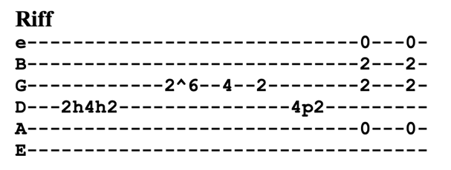
U.S. Blues (A)

Intro Riff (x4)
Verse 1 A
Red and white, blue suede shoes, I'm Uncle Sam, how do you do?
D E B E B E
Gimme five, I'm still alive, it ain't no luck, I learned to duck

Verse 2 Check my pulse, it don't change, stay seventy-two, come shine or rain
Wave the flag, pop the bag, rock the boat, skin the goat

Chorus B E
Wave that flag, wave it wide and high
Summertime done, come and gone, my oh my

Verse 3 I'm Uncle Sam, that’s who I am, been hiding out in a rock and roll band
Shake the hand that shook the hand of PT Barnum and Charlie Chan

Verse 4 Shine your shoes, light your fuse, can you use them ol' U.S. Blues?
Drink to health, share your wealth, run your life, I'll steal your wife

Chorus

Lead=Verse

Verse 5 Back to back, chicken shack, son of a gun, better change your act
We're all confused, what's to lose?
You can call this song "The United States Blues"

Chorus Wave that flag, wave it wide and high
Summertime done, come and gone my oh my
Summertime done, come and gone my oh my (my my oh my, my my oh my!)
Summertime done, come and gone my oh my

Unbroken Chain (C)
Intro F^{sus2=xx3013} C Am G (x2) ¢ Am C
Verse 1 D^{m7=xx0211} F C
Blue light rain, well unbroken chain
Am E^{b} F Em G Am C
Looking for familiar faces in an empty window pane
D^{m7} F^{sus4} C^{sus4=x33011} Am
Listening for the secret, searching for the sound
C G^{/B=x20003} Am G F Em G Am C
But I could only hear the preacher and the baying of his hounds
Verse 2 Dm⁷ F C
Willow sky, woah, I walk and wonder why
F G F Em G Am C
They say love your brother, but you will catch it when you try
D^{m7=xx0211} F^{sus4} C^{sus4} Am
Roll you down the line poor boy, drop you for a loss
C G^{/B} Am G F Am G C
Ride you out on the cold railroad and nail you to a cross

Interlude 1 F^{sus4} F G C (x3) ¢ F^{sus4} F Am C
Verse 3 D^{m7} F C^{sus4} C
November and more as I wait for the score
D^{m7} C^{maj7} F Em G Am C
They're telling me forgiveness is the key to every door
D^{m7} F^{sus4} C^{sus4} Am
A slow winter day, a night like forever
C G^{/B} Am G F Em Dm C Dm
Sink like a stone, float like a feather
Jam Gm C B^{b} (x4) (breakdown in 11/8)
Dm C Gm F Em (x4) (Jerry begins lead here)
Gm C B^{b} (x14) (breakdown in 11/8)
Dm C Gm F Em (x4) ¢ G C
Interlude 2 F^{sus4} F G C (x3)
F^{sus4} F C^{m7=x35343} F^{maj7} D^{m7} Em G
Bridge C^{m7=x35343} F^{maj7} D^{m7=xx0211} Em G
Lilac rain, unbroken chain, song of the saw-whet owl
Out on a mountain, it'll drive you insane, listening to the winds howl
Unbroken chain of sorrow and pearls, unbroken chain of sky and sea
Unbroken chain of the western wind, unbroken chain of you and me
Outro G A^{7b9=x02323} C D^{9=xx0210} D^{maj7#5=xx0322}
Ah ah, laa dada
D^{6sus2= xx0200} C^{M9/D= 10 10 10 12 12 10} D7 G^{sus4} Bm
Laa dada, Laa da da da da
Instrumental || Em C Em Bm | G A Em B⁵ | B^{sus2} Bm Em⁷ | E E^{sus4} E⁺⁵ E⁵ E⁶ C E⁵ ||
Uncle John's Band (G) Intro Lick
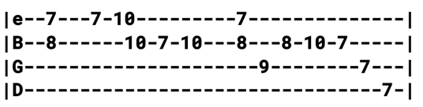
Intro G Bm C D (x8)
Verse 1 G C (one measure of 3/4) G
Well, the first days are the hardest days, don't you worry any more
'Cause when life looks like Easy Street, there is danger at your door
Am Em C D
Think this through with me, let me know your mind
C D G D C G D G
Whoa-oh what I want to know-o is are you kind?
Verse 2 It's a Buck Dancer's Choice, my friend, better take my advice
You know all the rules by now and the fire from the ice
Will you come with me? Won't you come with me?
Whoa-oh, what I want to know-o, will you come with me?
Bridge G C Am G D
Goddamn, well I declare, have you seen the like?
C G D C D
Their walls are built of cannonballs, their motto is Don't Tread On Me
Chorus G C Am G D
^{(1st half)} Come hear Uncle John's Band by the riverside
C G D C D
Got some things to talk about here beside the rising tide (Lead=Intro)
Verse 3 It's the same story the crow told me, it's the only one he knows
Like the morning sun you come and like the wind you go
Ain't no time to hate, barely time to wait
Whoa-oh, what I want to know-o, where does the time go?
Verse 4 I live in a silver mine and I call it Beggar's Tomb
I got me a violin and I beg you call the tune
Anybody's choice, I can hear your voice
Whoa-oh, what I want to know-o, how does the song go?
Chorus Come hear Uncle John's Band by the riverside
Got some things to talk about here beside the rising tide
Come hear Uncle John's Band playing to the tide
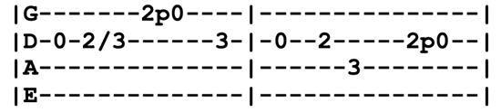
Come on along or go alone, he's come to take his children home
Jam in 7/4 G C Dm (x8) (Dm riff)
D C G
Whoa-oh, what I want to know-o, how does the song go?
Dm Riff
Chorus 2 (acapella for first half)
Jam in 7/4 Dm G C
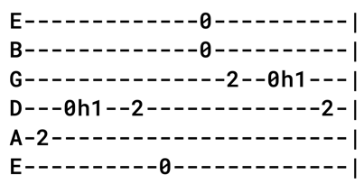
Valerie (E) Riff
Jerry regularly mixed lines from different verses
Intro E A E (riff) (x4)
Verse 1 A E A E A E
Hey Valerie, baby what's the matter with you?
I try to do all the things that you want me to do
Bm A E
I went downtown with my pocket knife
Cut your other man but I spared his life
Bm A E A E A E
Valerie, won't you be good to me?

Verse 2 Hey Valerie, baby, what's the matter with you?
Come on, come on, baby, tell me true
Hey now, baby, what did I do? I shot my dog 'cause he growled at you
Valerie, won't you be good to me?
Bridge B E A E
Valerie, what's the matter with me? I never ever done you no wrong
B E A
I sing the blues nearly all night long
B E A E
Valerie, what's the matter with me, you know I'd do anything you'd say
Bm A E A E A E
I can't understand why you tell me, “Please go 'way”
Lead=Verse
Verse 3 I ain't afraid of the cold cruel world outside
No Chicken Little running from a falling sky
Valerie, what's your complaint? I try to be everything I ain't
Valerie, won't you be good to me?
Verse 4 You got me down on the knees of my shaking feet
Can't play the blues for you 'cause I drop the beat
The only thing troubles me is you. If you leave me what will I do?
Valerie, won't you be good to me? (x3)

Viola Lee Blues (G)
Intro C7^{(#9)=x3234x} (thunders one time!)
Jam in G7
Verse 1 G
The judge decreed it, clerk he wrote it
Clerk he wrote it, down indeed-ay
C G
Judge decreed it, clerk he wrote it down
F C G
Give you this jail sentence, you'll be Nashville bound

Jam in G7 (solo in G Blues scale with chromatic runs)

Verse 2 Some got six months, some got one solid
Some got one solid year indeed-ay
Some got six months, some got one solid year
But me and my buddies all got lifetime here

Jam in G7

Verse 3 I wrote a letter, mailed it in the
Mailed it in the air indeed-ay
Wrote a letter, mailed it in the air
You may know by that Iiiiiiiii, I've, I've got a friend somewhere

G Blues Scale
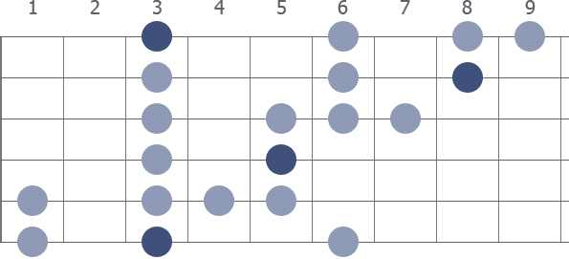
Visions of Johanna (A)
Intro A A^{sus4} A (x4)
Verse 1 A D E A A^{sus4} A
Ain't it just like the night to play tricks when you're trying to be so quiet?
We're sitting here stranded though we're all doing our best to deny it
E A A^{sus2} A
And Louise holds a handful of rain tempting you to defy it
D A D A
Lights flicker from the opposite loft in this room the heat pipes they cough
D A E
The country music station plays soft, but there's nothing, really nothing to turn off
A D E A A^{sus4} A
Just Louise and her lover so entwined
D C^{#m} E A A^{sus4} A A^{sus4} A
And these visions of Johanna that conquer my mind

Verse 2 In the empty lot where the ladies play blindman's bluff with the key chain
And the all-night girls whisper of escapades out on the D train
We can hear the night watchman click his flashlight, ask himself if it's him or them that's insane
Louise, she's alright, she's just near. She's delicate and seems like the mirror
She makes it all too concise and too clear that Johanna's not here
The ghost of electricity howls in the bones of her face
Where these visions of Johanna have now taken my place

Verse 3 Little boy lost, he takes himself so seriously. He brags of his misery, he likes to live dangerously
And when bringing her name up, he speaks of a farewell kiss to me
He's sure got alot of gall to be so useless and all
Muttering small talk at the wall while I'm in the hall
How can I explain it's so hard to get on
And these visions of Johanna they kept me up past the dawn (Lead=Verse)

Verse 4 Inside the museums infinity goes up on trial
Voices echo this is what salvation must be like after a while
But even Mona Lisa must have had the highway blues, you can tell by the way she smiles
See the primitive wallflower freeze when the jelly-faced women all sneeze
Hear the one with the mustache say, “Jeez, I can't find my knees”
Jewels and binoculars hang from the head of the mule
But these visions of Johanna they make it all seem so cruel

Verse 5 The peddler now speaks to the countess who's pretending to care for him
^{(extended)} Saying, “Name me someone that's not a parasite and I'll go out and say a prayer for him”
But like Louise always says, “Ya can't look at much can ya, man?” as she, herself, prepares for him
And Madonna, she still has not showed, we see this empty cage now corrode
Where her cape of the stage once had flowed, the fiddler he now steps to the road
He writes, “Everything's been returned which was owed”
On the back of the fish truck that loads while my conscience explodes
The harmonicas play the skeleton keys and the rain
And these visions of Johanna are now all that remain (x2)

Outro D C^{#m} E A
Waiting For a Miracle (E)

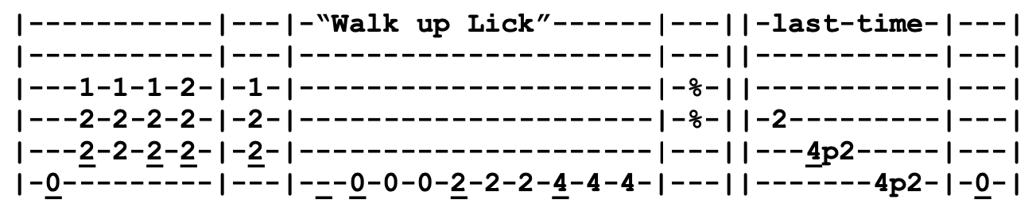
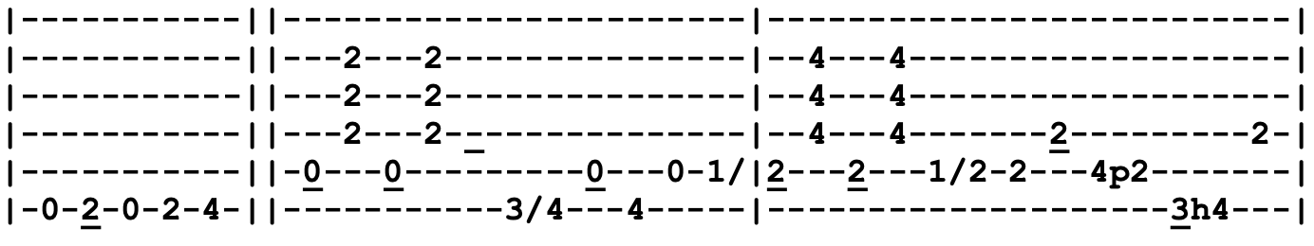
Intro A B E A E (x4)

Verse 1 A B E A E ("walk up lick")
Working and waiting, in the hot sun
With all the rich saints, and the forgotten ones
A F^{#7} E C^{#m}
Working and waiting for the night to come
A B E^{sus4} E A E
And the waiting for a, and the waiting for a, and the waiting for a miracle
Verse 2 Somewhere out there, there is a land that's cool
Where peace and balance are the rule
Working for the future like some kind of mystic jewel
And the waiting for a, and the waiting for a, and the waiting for a miracle
Bridge C^{#m} B F^{#m}
And rub the palm of your hand, on the ground in pain, in the hopes that you can see
Stand up tall, pretend your strong in the hopes that you can be
C^{#m} B A
Like the ones that cry, like the ones that die, trying to set the angel in us free
B E^{sus4} E
And the waiting for a, and the waiting for a, and the waiting for a miracle

Lead=Verse
Bridge

Verse 3 Struggle for a nickel, scuffle for a dime
Forget about the past, leave your troubles behind
How come the future has to take such a long, long time?
A B E^{sus4} E A E C#m
When you're waiting for a, when you're waiting for a, when you're waiting for a miracle (x3)
Outro=Intro

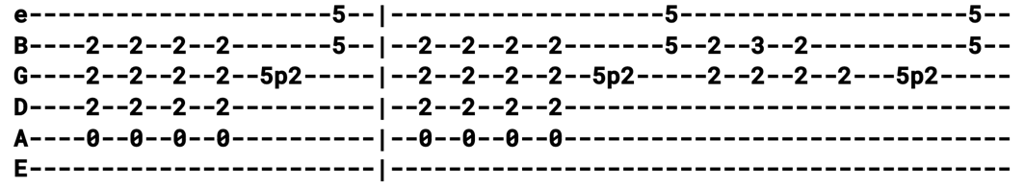
Walkin’ Blues (A)
Intro
Verse 1 A
Woke up this morning, I felt around for my shoes
That's when I knew I had them ol' walkin' blues
D A
Well, I woke up this morning and I look around and I felt around for my shoes
E D A
That's when I knew I had them mean ol', mean ol' walkin' blues

Verse 2 Feel like going out leave my old lonesome home
Woke up this morning what I had was gone, I wanna leave
Feel like going out, leave my old lonesome home
Woke up this morning what I had, what I had was gone
Lead=Verse (x2) (Jerry plays slide solo)
Verse 3 Some people tell you the walking blues ain't bad
Worst old feeling that I've ever had (repeat)

Verse 4 Leaving in the morning if I have to, ride the blind
Well, I've been mistreated and I, I don't mind dyin' (repeat)
Lead=Verse
Verse 5 She got the Elgin movement from her head down to her toes
Break in on a dollar over almost anywhere she goes (repeat)

Verse 1
Outro Walkin’ blues (x16)
That's when I knew I had them ol', mean ol' walkin' blues
The Way You Do the Things You Do (C)
Jerry played as upbeat funky shuffle in Key of D until early 90's when it became slow reggae in Key of C
Intro Riff C F C (x4)
Verse 1 C F C F C
You got a smile so bright, you know you could've been a camera
I'm holding you so tight, you know you could've been a hammer
F B F C F C
The way you swept me off my feet, you know you could've been a broom
F C F C
The way you smell so sweet, you know you could've been some perfume
Chorus G F G F ^{(stop!)}
Well, you could've been anything that you wanted to and I can te-ll
C F C C F C
The way you do the things you do, the way you do the things you do

Verse 2 As pretty as you are, you know you could've been a flower
Good looks was a minute, you know that you could've been a hour
The way you stole my heart, you know you could've been a cool crook
Baby, you're so smart, you know you could've been a school book

Chorus
Lead=Verse ¢ Chorus

Verse 3 You made my life so rich, you know you could've been some money
And baby you're so sweet, you know you could've been some honey
Chorus
Outro The way you do the things you do (x8)

Jam C F C
We Can Run (A)
Intro Riff A E F^{#m} D A E D
Verse 1 A E
We don't own this place though we act as if we did
D E
It belongs to the children of our children's kids
D E A
The actual owners haven't even been born yet
But we never tend the garden and we rarely pay the rent
Most of it is broken and the rest of it is bent
Put it all on plastic and I wonder where we'll be when the bills hit
Chorus A E
We can run, we can't hide from it
D E A
Of all possible worlds, we only got one, we gotta ride on it
E
Whatever we've done, we'll never get far from what we leave behind
F^{#m} D
Baby, we can run, run, run, but we can't hide

Verse 2 Well, I'm dumping my trash in your back yard
Making certain you don't notice really isn't so hard
You're so busy with your guns and all of your excuses to use them
Well, it's oil for the rich and babies for the poor
We've got everyone believing that more is more
If a reckoning comes, maybe we'll know what to do then
Chorus 2 (same chorus as above, but modified last line with turnaround)
F^{#m} D E A
Baby, we can run, run, run but we can't hide, oh no we can't hide
Bridge F^{#m} E D
All these complications seem to leave no choice
I heard the tongues of billions speak with just one voice
F^{#m} E D C^{#m}
Saying just leave all the rest to me, I need it worse than you, you see
Bm (stop!)
Then I heard the sound of one child crying (Intro)
Verse 3 Today I went out walking in the amber wind
There's a hole in the sky where the light pours in
I remember the days when I wasn't afraid of the sunshine
But now it beats down on the ashphalt land
Like a hammering blow from God's left hand
What little still grows cringes in the shade till the night-time (Chorus 2 x4)

Weather Report Suite (E)

Intro E^{add9=022102} A E^{add9} A
Verse 1 E C^{#m} D
Winter rain, now tell me why summers fade and roses die
C^{#m7=x42100} F^{#m} A E A E
The answer came, the wind and rain

Verse 2 Golden hills now veiled in gray
Summer leaves have blown away
And what remains, the wind and rain

Bridge E⁷ C# A G
And like a desert spring, my lover comes and spreads her wings
D G
Knowing, like a song that's born to soar the sky
Flowing, flowing till the waters all are dry
D C E^{add9} A E^{add9} A
Growing, the loving in her eyes
Lead=Verse (slide guitar plays melody)

Verse 3 Circle songs, sands of time
Seasons will end in tumbled rhyme
And little change, the wind and rain
Chorus B E
Winter gray and falling rain
We'll see summer come again
Darkness falls and seasons change (gonna happen every time)
Same old friends, the wind and rain (we'll see summer by and by)
Winter gray and falling rain (summers fade and roses die)
We'll see summer come again (it happens every time)
Darkness falls and seasons change (seasons change and roses die) Same old friends the wind and rain
A D C Am^{7=xx3141}
Just like a song that's born to soar the sky
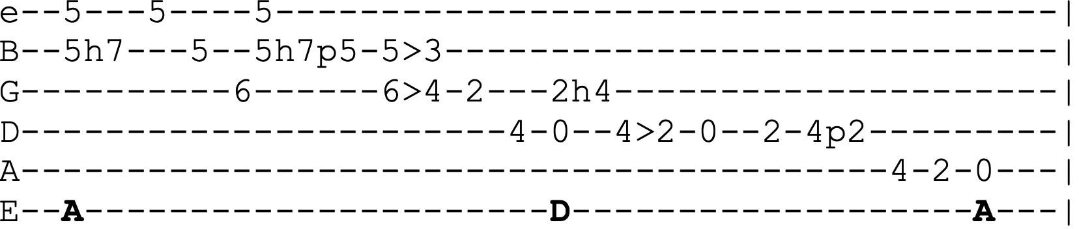
The Weight (A)
Intro Riff
Verse 1 A C^{#m} D A
^{(Jerry)} I pulled in to Nazareth, I was feeling about half past dead
I just need a place where I can lay my head
Said, “Mister, can you tell me where a man might find a bed?”
He just grinned, shook my hand, “No” was all he said
Chorus A C^{#m} D A C^{#m} D
Take a load off Fanny, take a load for free
A C^{#m} D D D 3 4
Take a load off Fanny and and and
D 2 3 A C^{#m} F^{#m} E D D (repeat turnaround)
You put the load, put the load right on me

Verse 2 I picked up my bag, I went looking for a place to hide
^{(Brent)} When I saw Carmen and the Devil walking side by side
I said, “Hey, Carmen, come on let's go downtown”
She said, “I gotta go but my friend can stick around” (Chorus)

Verse 3 Go down, Miss Moses, there's nothing that you can say
^{(Phil)} It's just old Luke and Luke's waiting on the judgement day
Well, Luke, my friend, what about young Anna Lee?
He said, “Do me a favor, son
Won't you stay and keep Anna Lee company?” (Chorus)

Verse 4 Crazy Chester followed me and he caught me in the fog
^{(Bob)} He said, “I will fix your rack if you'll take Jack, my dog”
I said, “Wait a minute, Chester, you know I'm a peaceful man”
He said, “That's okay, boy, won't you feed him when you can?” (Chorus)
Lead=Verse
Verse 5 Catch a cannonball, now take me down the line
^{(all)} My bag is sinking low and I do believe it's time
To get back to Miss Fanny, you know she's the only one
Who left me here with her regards for everyone (Chorus)
Werewolves of London (G)
Intro D C G (x4)
Verse 1 I saw a werewolf with a Chinese menu in his hand
Walking through the streets of Soho in the rain
He was looking for the place called Lee Ho Fook's
For to get a big plate of beef chow mein
Chorus Ah ooo, werewolves of London (ah ooo) (x2)

Verse 2 If you hear his howling around the kitchen door
You better not let him in
Little old lady got mutilated late last night
Werewolves of London again

Verse 3 He's the hairy-handed gent who ran amuck in Kent
Lately he's been overheard in Mayfair
You better stay away from him, he'll rip your lungs out, Jim
I'd like to meet his tailor

Verse 4 Well, I saw Lon Cheney walking with the queen
Doing the Werewolves of London
I saw Lon Cheney Jr. walking with the queen
I saw a werewolf drinking a pina colada at Trader Vic's
And his hair was perfect
Chorus (Repeat chorus many times with vocal jam)
West L.A. Fadeaway (G)
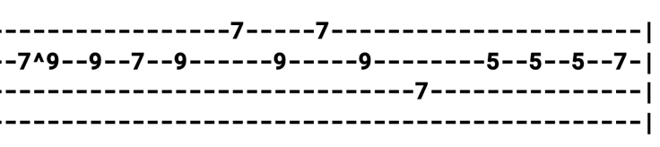
Am Riff
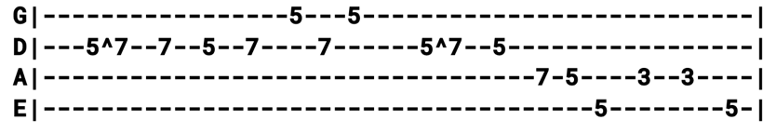

Intro Am Riff (x8) ¢ Am B⁷ E^{7#9=x7678x} Am
Verse 1 Am (riff)
I'm looking for a chateau, twenty-one rooms but one will do (x2)
B⁷ E^{7#9=x76788} Am
I don't want to buy it, I just want to rent it for an hour or two
Verse 2 Met an old mistake walking down the street today (x2)
I didn't want to be mean about it but I didn't have one good word to say
Chorus Am D C Am D C
West L.A. fadeaway, West L.A. fadeaway
B⁷
Little red light on the highway
F^{9=xx3243} E^{7#9=x76788} Am
Big green light on the speedway hey-ay-ay
Lead=Verse ¢ Chorus (solo in A Minor Pentatonic)
Verse 3 Got a steady job hauling items for the mob (x2)
The pay was pathetic
It's a shame those boys couldn't be more copacetic
Verse 4 I need a West L.A. girl, already know what I need to know (x2)
Name, address and phone number, Lord, just how far to go (Chorus)
Lead=Verse ¢ Chorus
Verse 1
Chorus (after singing chorus, repeat last two lines "little red light" x2)
Wharf Rat (D)
Intro A^{sus2=x02200} Em (x8)

Verse 1 A^{sus2} Em A^{sus2} Em A^{sus2} Em A^{sus2} Em
Old man down, way down down, down by the docks of the city
A^{sus2} Em A^{sus2} Em A^{sus2}
Blind and dirty, asked me for a dime, a dime for a cup of coffee
Em D A^{sus2} Em A^{sus2} Em
I got no dime but I got some time to hear his story
Verse 2 My name is August West and I love my Pearly Baker best more than my wine
More than my wine, more than my maker though he's no friend of mine
Verse 3 Everyone said I'd come to no good, I knew I would, Pearly, believe them
Half of my life I spent doing time for some other fucker's crime
Em D D D D A (begin 3/4 Time) D A
The other half found me stumbling around drunk on Bur-gun-dy wine

Bridge G D G D A D G D
(3/4 Time) But I'll get back on my feet someday
C G C G D D^{sus4} D
The good Lord willing, if he says I may
A A^{sus4} A Em
I know that the li- i- i- ife I'm livin's no good
A A^{sus4} A A^{/G} F^{#m} F^{#m/E} Em (switch back to 4/4 Time)
I'll get a new start, live the life I should
Riff in Em (x4)
Vocal Jam Em (riff) A^{sus2} Em A^{sus2} Em (x4)
I'll get up and fly away, I'll get up and fly away, fly away
Verse 4 “Pearly's been true, true to me, true to my dying day,” he said
^{(pulse on the beat)} I said to him, I said to him, “I'm sure she's been”
I said to him, “I'm sure she's been true to you”
Lead=Intro (solo in A Mixolydian)
Verse 5 Got up and wandered, wandered downtown, nowhere to go but just hang around
^{(pulse on the beat)} I've got a girl named Bonnie Lee, I know that girl's been true to me
I know she's been, I'm sure she's been true to me
Jam in A^{sus2} (solo in A Mixolydian)
What a Wonderful World (F)
Time signature is 4/4 but is quadruple compound meter, which gives it triplet 12/8 feel
Intro F Gm^{7/F=11033} F Gm^{7/F}
Verse 1 F Am B^{b} Am
I see trees of green, red roses too
G^{m7=353333} F A⁷ Dm
I see them bloom for me and you
D^{b} G^{m7=353333} C⁷ F F^{aug=353333} B^{bM7=x13231} C⁷
And I think to myself, what a wonderful world
Verse 2 I see skies of blue, clouds of white
The bright blessed day, the dark sacred night
And I think to myself, what a wonderful world
Bridge C⁷ F
The colors of the rainbow, so pretty in the sky
Are also on the faces of people going by
Dm Am⁷ Dm Am⁷
I see friends shaking hands saying, “How do you do?”
Dm F^{#dim7=x34242} G^{m7=353333} C⁷
They're really saying, “I love you”

Verse 3 I hear babies cry, I watch them grow
They'll learn much more than I'll ever know
And I think to myself, what a wonderful world
Instrumental=Verse

Bridge

Verse 3 (after singing verse, repeat last line "and I think to myself")

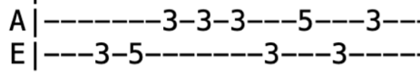
The Wheel (C) Intro Lick
Intro Lick/Jam in C
Verse 1 G C
The wheel is turning and you can't slow down
Can't let go and you can't hold on
Can't go back and you can't stand still
F B^{b} C (solo for 4 measures) B^{b}
If the thunder don't get you then the lightning will
Chorus F B^{b} C F B^{b} C (solo) B^{b}
Won't you try just a little bit harder, couldn't you try just a little bit more?
F B^{b} C F B^{b} C
Won't you try just a little bit harder, couldn't you try just a little bit more?
Break G D
Round, round, Robin, run round, gotta get back to where you belong
G D G
Little bit harder, just a little bit more, a little bit further than you gone before

Verse 1
Jam F B^{b} F B^{b} F B^{b} C B^{b} | F B^{b} F B^{b} F B^{b} C
Bridge C F
Small wheel turn by the fire and rod
Big wheel turn by the grace of God
Every time that wheel turn 'round
C (stop!)
Bound to cover just a little more ground, bound to cover just a little more ground
Verse 1

Chorus

Outro=Jam in C

When First Unto This Country (E)
Intro E
Verse 1 E B A E
When first unto this country a stranger I came
A B E A E
I courted a fair maiden, Nancy was her name
I courted her for love, her love I didn't obtain
Do you think I've any reason or right to complain?

Verse 2 I rode to see my Nancy, I rode both night and day
I stole a fine stallion from Colonel Charles Grey
I rode to see my Nancy, I rode both day and night
I courted fairest Nancy, my own heart's true delight

Verse 3 The sheriff's men they followed and overtaken me
They carted me away to the penitentiary
They opened up the door and then they threw me in
They shaved off my hair and they cleared off my chin
Verse 4 They beat me and they banged me and they fed me on dry beans
'Til I wished to my own soul, I'd never been a thief
My hands stuck in my pockets, my cap set on so bold
My coat of many colors, like Joseph's of old
Outro When first unto this country, a stranger I came
I courted a fair maiden, Nancy was her name

When I Paint My Masterpiece (G)
GD played it in G and modulated to A after second chorus. Jerry played it in Key of A and didn't modulate.
Intro G G^{sus4} G (x8)
Verse 1 G G^{sus4} G
Oh, the streets of Rome are filled with rubble
D D⁷ C G G^{sus4} G
Ancient footprints are everywhere
G^{sus4} G G^{sus4} G
You could almost think that you're seeing double
D D⁷ C G ¢
On a cold dark night on the Spanish Stairs
D C G
Gotta hurry on back to my hotel room
D C G
Where I've got me a date with Botticelli's niece
C G D G
She promised she'd be right there with me when I paint my masterpiece

Lead=Verse (only first half of a verse)

Verse 2 Oh, the hours we've spent inside the Colosseum
Dodging lions and wasting time
Oh, those mighty kings of the jungle, I could hardly stand to see 'em
Well, it sure has been a long hard climb
Train wheels running through the back of my memory
When I ran on the hilltop following a pack of wild geese
Someday life will be sweet like a rhapsody when I paint my masterpiece
Lead=Verse (after lead, GD modulates up whole step to A, JGB did not modulate) G-G#-A

Verse 3 Well, I left Rome and I landed in Brussels
^{(Key of A)} On a plane ride so bumpy that I almost cried
Clergymen in uniform, young girls pulling muscles
Well, it sure has been a long hard ride
Newspapermen eating candy had to be held down by big police
Someday everything is gonna be different when I paint my masterpiece
Someday everything is gonna be different when I paint my masterpiece
(hold this for two measures, then stop!) (tag it!) When I paint (when I paint) my masterpiece
When Push Comes to Shove (D)
Intro D A
Verse 1 D
Shaking in the forest, what have you to fear?
Here there may be tigers to punch you in the ear
G A
Gloves of stainless steel, bats carved out of brick
D G
Knock you down and beat you up and give your ass a kick
D A D
When push comes to shove you're afraid of love
Verse 2 Shaking in the desert, wherefore do you cry?
Hear there may be rattlesnakes to punch you in the eye
Shotgun full of silver, bullets made of glass
String barbed wire at your feet that do not let you pass
When push comes to shove you're afraid of love
Chorus G A D B⁷
When push comes to shove, when push comes to shove
E⁷ A⁷ D
You're afraid of love when push comes to shove
Lead=Verse
Verse 3 Shaking in the bedroom, covers on your head
Cringing like a baby at the hand beneath the bed
Rapping at the window, scratching at the door
Maybe it's mystery killer you saw on channel four
When push comes to shove you're afraid of love
Verse 4 Shaking in the garden, the fear within you grows
Hear there may be roses to punch you in the nose
Twist their arms around you, slap you till you cry
Wrap you in their sweet perfume and love you till you die
When push comes to shove you're afraid of love
Chorus (x2)

Whiskey in the Jar (C)
Jerry fingerpicked this with the Dead, played flatpick bluegrass style with Grisman
Intro=Verse ¢ Chorus
Verse 1 C Am
As I was a-going over Gilgarra mountains
F C Am
I met Colonel Pepper and his money he was counting
I drew forth my pistol and I rattled my saber
Saying, “Stand and deliver for I am a bold deceiver”
Chorus G G⁷
Musha ringum duram da
C C⁷ F C G⁷ C
Whack fol de daddy-o, whack fol de daddy-o, there's whiskey in the jar
Verse 2 The shining yellow coins did sure look bright and jolly
I took the money home and I gave it to my Molly
She promised and she vowed that she never would deceive me
But the devil's in the women and they never can be easy (Chorus)
Lead=Verse ¢ Chorus
Verse 3 When I awoke between the hours of six and seven
Guards were standing 'round me in numbers odd and even
I flew to my pistols but alas I was mistaken
I fired off my pistols and a prisoner was taken (Chorus)
Verse 4 They put me in jail without a judge or jury
For robbing Colonel Pepper in the morning so early
They didn't take my fist so I knocked down the sentry
And I bid a long farewell to that cold penitentiary (Chorus)
Lead=Verse ¢ Chorus
Verse 5 Some take delight in fishing and bowling
Others take delight in the carriage a-rollin'
I take delight in the juice of the barley
Courting pretty women in the morning so early (Chorus)

White Dove (E) 3/4 Time
Intro E B⁷ E
Verse 1 E E⁷ A
In the deep rolling hills of old Virginia
E B⁷
There's a place I love so well
E E⁷ A
Where I spent many days of my childhood
E B⁷ E
In the cabin where we loved to dwell

Chorus E E⁷ A
White dove will mourn in sorrow
E B⁷ E
The willows will hang their head
E⁷ A
I'll live my life in sorrow
E B⁷ E
Since mother and daddy are dead
Lead=Verse

Verse 2 We were all so happy there together
In our peaceful little mountain home
But the savior needs angels up in heaven
Now they sing around the great white throne (Chorus)

Lead=Verse

Verse 3 As the years roll by, I often wonder
Will we all be together someday
And each night as I wander through the graveyard
Darkness finds me as I kneel to pray (Chorus)

Wild Horses (G)
Rolling Stones played this in G, Old and In the Way played it in A
Intro G Am C D G F C D G

Verse 1 Bm G Bm G Am
Childhood living is easy to do
C D G D
The things that you wanted I bought them for you
Graceless lady you know who I am
You know I can't let you slide through my hands

Chorus Am C D G F C ¢ Am
Wild horses couldn't drag me away
C D G F C D G
Wild, wild horses we'll ride them some day

Verse 2 I watched you suffer a dull aching pain
Now you've decided to show me the same
No sweeping exits or offstage lines
Could make me feel bitter or treat you unkind (Chorus)
Lead=Verse ¢ Chorus
Verse 3 I know I dreamed you a sin and a lie
I have my freedom but I don't have much time
Faith has been broken tears must be cried
Let's do some living after we die (Chorus)
Women Are Smarter (E)
Intro=Verse
Verse 1 E B
Let us put men and women together, see which one is smarter
E
Some say men but I say, “No, women got the men like a puppet show”
Chorus It ain't me, it's the people that say, “Men are leading the women astray”
I say, “It's the women today, smarter than the men in every way”
That's right, the women are smarter (x3)
The women are smarter, that's right
Lead=Verse
Verse 2 Little boy sit on the corner and cry
Big man come and ask him, “Why?”
He said, “I can't do what the big boys do”
The man sat down and he cried too (Chorus)

Lead=Verse
Verse 3 Ever since the world began
Women been mending the ways of men
Listen up 'cause I've got a plan
Give it up, don't try to understand (Chorus)

Lead=Verse
Verse 1

Chorus
You Win Again (G) 6/8 Time
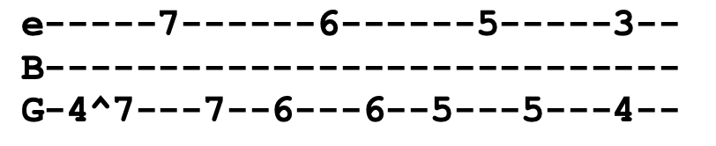
Intro Riff
Verse 1 G C
The news is out all over town
G D
That you've been seen out running 'round
G C
I know that I should leave her there
G D G (riff)
I just can't go, Lord, you win again
Chorus C G
This heart of mine could never see
A D ^{(stop!)}
What everybo-dy knows but me
G C
Just trusting you was my great sin
G D G (riff)
What can I do, Lord, you win again

Lead=Verse

Chorus

Lead=Verse

Chorus This heart of mine could never see
What everybo-dy knows but me
Just trusting you was my great sin
G D G C
What can I do, Lord, you win again
G D G
What can I do, Lord, you win again

